МІНІСТЕРСТВО ОСВІТИ І НАУКИ УКРАЇНИ
НАЦІОНАЛЬНИЙ УНІВЕРСИТЕТ ФІЗИЧНОГО ВИХОВАННЯ І СПОРТУ УКРАЇНИ

REHABILITATION

TECHNIQUES

IN SPORTS MEDICINE

Навчально-методичний посібник для самостійної роботи з англійської мови для здобувачів вищої освіти освітнього ступеня магістра зі спеціальності «Фізична культура і спорт»

Kyiv - 2016

Укладачі:

Кудря Микола Миколайович,
завідувач кафедри української та іноземних мов, доцент, кандидат педагогічних наук;
Доценко Лариса Зіннатівна,
старший викладач кафедри української та іноземних мов
Національного університету фізичного виховання і спорту України;
Хоружева Леся Евгенівна,
старший викладач кафедри української та іноземних мов
Національного університету фізичного виховання і спорту України;
Шепелюк Віра Леонідівна,
старший викладач кафедри української та іноземних мов
Національного університету фізичного виховання і спорту України.

Рецензенти:
доктор філологічних наук, директор Інституту філології КНУ імені Тараса Шевченка
Семенюк Г.Ф.;
кандидат наук з фізичного виховання та спорту, ст. викладач кафедри фізичної реабілітації Національного університету фізичного виховання і спорту України Марценюк І.М.

ПЕРЕДМОВА

Цей навчальний посібник рекомендується для використання в програмі підготовки фахівців з фізичної реабілітації у межах професійно орієнтованого навчання англійської мови у Національному університеті фізичного виховання і спорту України на базі володіння основами нормативної граматики і запасу загальновживаної лексики в межах 2000 – 2500 лексичних одиниць.

Цей матеріал розрахований на 120 годин самостійної роботи і є варіантом вивчення іноземної мови на текстовій базі оригінальної спеціальної літератури, а саме: американського університетського підручника “Rehabilitation techniques in sports medicine”, William E. Prentice, WCB/McGraw-Hill, що передбачає роботу не тільки над мовними аспектами, але і сприяє зростанню професійного потенціалу майбутнього фахівця, тобто опанування іноземної мови стає не тільки самоціллю, але і знаряддям для вдосконалення необхідних професійних навиків.

Посібник складається з таких тематичних розділів, які розташовані в логічній послідовності запропонованій автором посібника:
1. Ізокінетичні принципи в реабілітації, пліометричне
тренування і вправи з кінетично замкнутим циклом.
2. Відновлення пропріоцепції.
3. Фармакологія в реабілітаційному процесі.
4. Психологічні аспекти фізичної реабілітації.

Крім навичок розуміння текстового матеріалу і виконання лексико-грама-
тичних завдань, посібник зорієнтований на розвиток навичок усної мови із застосуванням активних й інтенсивних методів навчання на базі діалогів, побудованих з використанням спеціальної термінології, ситуативних і практичних завдань для роботи як індивідуальної, так і групової.
Кожен розділ завершується комплексом контрольних завдань для оцінювання ступеня засвоєння матеріалу.

SECTION I

ISOKINETICS, PLYOMETRIC AND CLOSE-KINETIC CHAIN EXERCISE IN REHABILITATION

UNIT I

ISOKINETICS PRINCIPLES IN REHABILITATION

I. Study, translate and learn the words below:

a) velocity, resistance, tension, force, push, pull, torque, curve, sequence, ratio, shape, deficit, advance, care, majority, tool, disadvantage, datum, property, implementation, gain, variable, output, emphasis, heat, boredom, lack, asset, awareness, consideration; relevance; blend, demand, extremity, chain, tibia, hip, flexion, hamstring, majority, extension, threat, axe, translation, bottom, femur, surface, death, cell, consumption, workload, liver, adipose, duration, exertion, source, nutrient, breakdown, carbohydrate, dietary, feedback, outburst, fat, protein, vessel, obstacle, capability, capacity, benefit, calisthenics, evaluation,
appreciation, implication, spindle, posture, input, consciousness, controversy, perception, device, threshold, touch, susceptibility, recurrence, differentiation;

b) to describe, to occur, to generate, to match, to achieve, to apply, to remain, to evaluate, to interfere, to afford, to precede, to emerge, to augment, to trace, to establish, to supervise, to facilitate, to supply, to fix, to reduce, to comprise, to quantify, to constraint, to pivot, to exert, to negate, to flex, to tolerate, to handle, to miss, to substitute, to maintain, to monitor, to estimate, to fill up, to derive, to store, to convert, to metabolize, to deplete, to rely, to determine, to incur, to predict, to incorporate, to necessitate, to subserve, to splint, to adjust, to alter, to emanate, to initiate, to appreciate, to encourage, to encompass, to restrain;

c) constant, angular, variable, accommodating, rotational, multiplied, consistent,
familiarized, specific, primary, substantial(ly), quantifiable, interchangeable,
rare(ly), ensuing, inherent, numerous, dependent, contradictory, prescribed, sound, knowledgeable, multiple, distal, mobile, anterior, rigid, compressive, overlapping, safe, immovable, predictable, proximal, shear, resistive, rapid(ly), extended, alternative, extended, immediate, ultimately, venous, gradual, apparent, approximately, dietary, available, adipose, submaximal, sudden, usable, simultaneously, (in)sufficient, mediated, afferent, distinct, partial, cognitive, voluntary, conscious(ly), articular, insidious;

d) once, throughout, although, respectively, while, in particular, conversely, thus,
toward, regardless of, therefore, a great deal, predominantly, to a large extent;

е) average range; yielding muscle contraction; specialized proficiency; to take advantage; common sense, circuit training; time frame; exercise set; high-energy put activities; closed-kinetic chain system; ACL (anterior cruciate ligament); patellofemoral joint; a means; by definition; relatively little consideration is given; pumping mechanism; oxygenated blood; pulmonary vessels; carbon dioxide; heart rate; V0₂, max., stroke volume; cardiac output; surrounding environment; ATP (adenosine troposphere); oxygen debt; lactic acid; brain stem; motor cortex; basal ganglia; cerebellum.
II. Read, translate and analyse the text.
ISOKINETIC EXERCISE

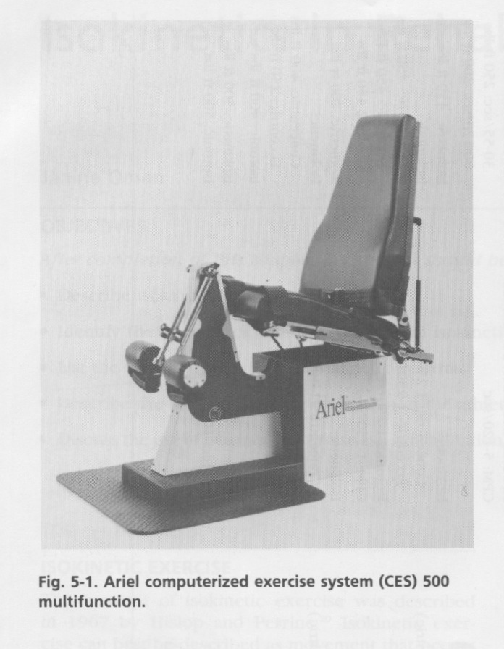
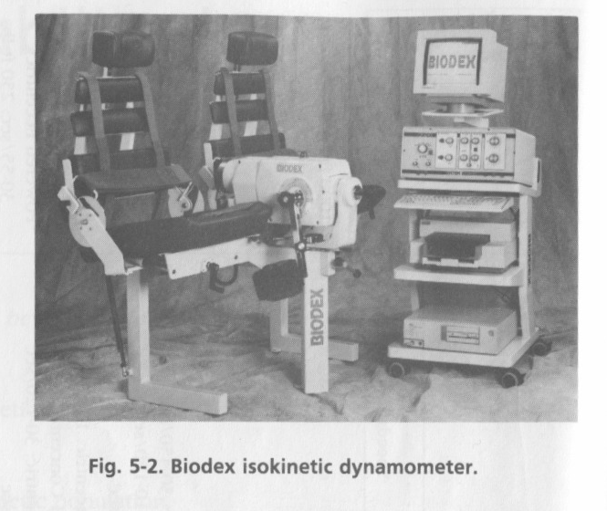
The concept of isokinetic exercise was described in 1967 by Hislop and Perrine. Isokinetic exercise can best be described as movement that occurs at a constant angular velocity with accommodating resistance. Maximum muscle tension can be generated throughout the range of motion because the resistance is variable to match the muscle tension produced at the various points in the range of motion. Isokinetic machines allow the angular velocity to be preset. Once the specified angular velocity is achieved, the machine provides accommodating resistance throughout the specified range of motion.
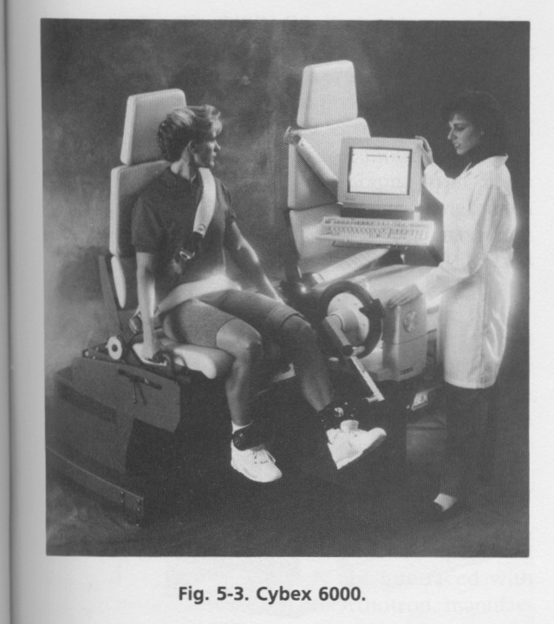
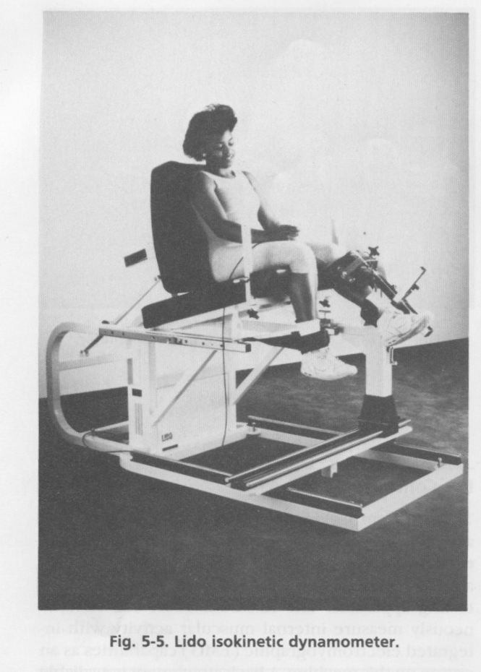
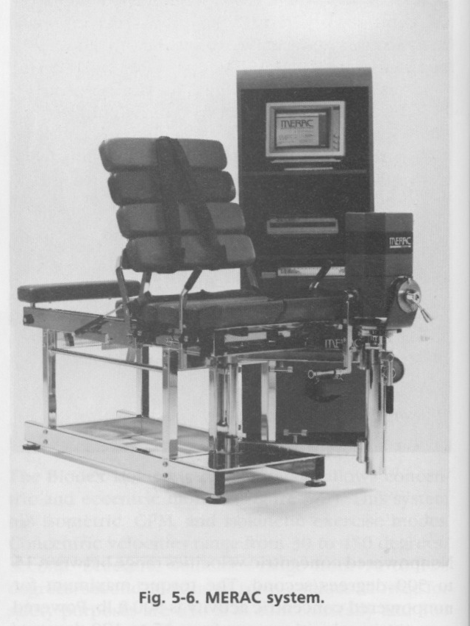

2.2. Answer the questions on the text.

- When was the concept described? 2. Can isokinetic exercise be described as
movement that occurs at a constant angular velocity with accommodating resistance? 3. How much muscle tension can be generated throughout the range of motion? 4. What do isokinetic machines allow? 5. What occurs when the specified angular velocity is achieved?

2.3. Match the words or phrases in both columns

1 | machine | A | протягом, під час
2 | range of motion | B | концепція
3 | preset | C | кутова швидкість
4 | angular velocity | D | постійний
5 | to occur | E | описувати
6 | maximum muscle tension | F | супроводжується опір
7 | to allow | G | відбуватися, траплятися
8 | accommodating resistance | H | тренажер
9 | to describe | J | дозволяти, давати можливість
10 | constant | K | заздалегідь встановлений, попередньо заданий
11 | concept | L | амплітуда руху
12 | throughout | M | максимальне м'язове напруження
2.4. Write a short story on what kind of isokinetic machines are used in your country.

III. Oral topic.
ISOKINETICS IN REHABILITATION
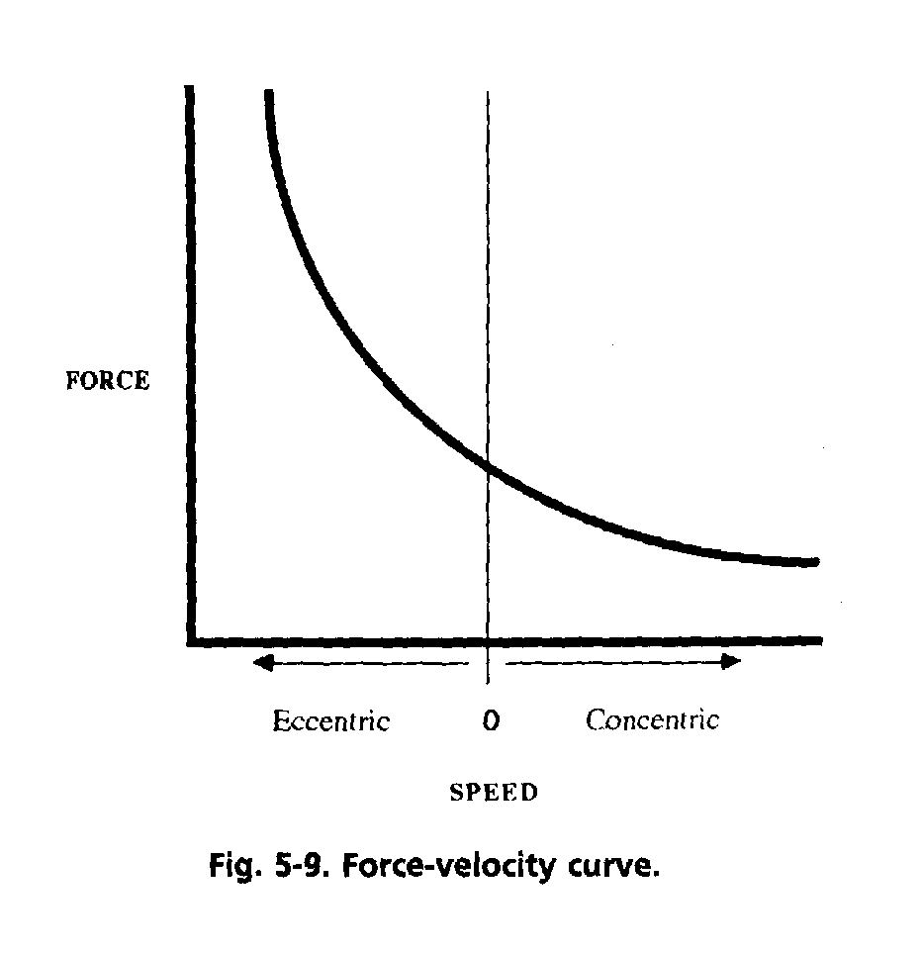
Isokinetic exercise is described as movement that occurs at a constant angular velocity with accommodating resistance. Force can be best described as a push or pull produced by the action of one object on another. Torque is defined as the moment of force applied during rotational motion. Work is defined as force multiplied by displacement. Work is measured as the area under the torque curve. Power is defined as the rate of performing work. The sports therapist needs to be consistent with isokinetic testing from one session to another.

3.1. Read and translate the oral topic “Isokinetics in Rehabilitation”.

3.2. Answer the questions to the text.

- What kind of movement can isokinetic exercise be described? 2. What is
force here? 3. How is torque defined? 4. What is work here? 5. How is work measured? 6. What is defined as the rate of performing work? 7. What principles should a sports therapist follow while isokinetic testing the athlete? 8. What parameters are used to evaluate the results of isokinetic testing? 9. What can be an evidence of consistent abnormalities? 10. What should be the basis for designing specific isokinetic programs to correct specific deficits?

3.4. Find English equivalents for the following:

відбуватися, постійна кутова швидкість, з доданим зусиллям, сила, поштовх/напруження, зусилля/тяга, момент обертальний, рухаються, помножений на, переміщення/продуктивність, вимірюватися, дуга/крива лінія, простір/площа, потужність, темп/швидкість, виконувана робота, постійний/послідовний, зберігатися, той же, практичне заняття, ізокінетичне тестування, освоїтися/ознайомитися, послідовник / -ність, пропорційне співвідношення, середній, загальновживаний, оцінювати, форма/обрис, стійкі аномалії/відхилення, щоб виправити виявивлені недоліки.

3.5. Change the words in italic for their equivalents from the text.

1. Isokinetic exercise is defined as movement that occurs at a constant angular velocity with accommodating resistance. 2. Work is calculated as the area under the torque curve. 3. The sports therapist needs to be logical with isokinetic testing from one session to another. 4. Speed and position of the athlete should remain similar. 5. The athlete may need a practice session before isokinetic testing to be aware of the testing order and the isokinetic dynamometer. 6. The sports therapist needs to evaluate the form of the torque curve for consistent abnormalities.

  - Complete the sentences with logical ending.

1 | Isokinetic exercise is described as movement that occurs at … | A | … the area under the torque curve.
2 | Force can be best described as … . | B | … the rate of performing work.
3 | Torque is defined as … | C | ... a constant angular velocity with accommodating resistance.
4 | Work is defined as … . | D | … a push or pull produced by the action of one object on another.
5 | Work is measured as … . | E | … the moment of force applied during rotational motion.
6 | Power is defined as … . | F | … force multiplied by displacement.

3.7. Complete the sentences with words from a box.

allow, technological advances, resistance, variable

1. Isokinetic evaluation and rehabilitation is limited by the … of isokinetic dynamometers. 2. Isokinetic dynamometers now provide concentric and eccentric … . 3. Velocities are … depending on the machine, although the average range is from zero to 300 degrees/second. 4. Some machines … velocities greater than 400 degrees/second.

3.8. Insert articles if necessary.

1. Historically, … two primary advantages associated with isokinetic exercise are … ability to work maximally throughout … range of motion and … ability to work at various velocities to simulate functional activity. 2. Care should be taken, however, when inferring functional capacity based on … results of dynamic isokinetic testing. 3. Velocities achieved during functional activity greatly exceed … velocity capacities of isokinetic dynamometers. 4. Velocities measured at … hip and knee during … soccer kick exceeded 400 degrees/second and 1200 degrees/second, respectively. 5. … majority of isokinetic testing is done in … nonweight—bearing position that is not representative of functional activities. 6. However, given these limitations, isokinetic exercise can be … very powerful tool for … sports therapist in evaluation and rehabilitation of sports-related injuries.

3.9. Fill in the gaps with prepositions if necessary.

1. Several manufacturers have isokinetic equipment available … the market that is not interfaced … computer-driven software. 2. The Orthotron, manufactured … Cybex, and Hydrafitness equipment are the two most widely used types … noncomputerized isokinetic exercise equipment. 3. The major advantage … this type … equipment is that the cost is substantially lower, yet they may still be used … training and strengthening. 4. The disadvantage is that they do not afford the sports therapist the capacity to produce quantifiable, objective evaluation data … an individual athlete.

3.10. Write the conversation in indirect speech.

PARAMETERS WHILE ISOKINETIC EVALUATION

- | What are the criteria for isokinetic evaluation?
- | Primarily, various parameters of force and torque are used to compare the results of specific isokinetic tests with normative data.
- | How is force defined in the isokinetic literature?
- | Force can best be described as the push or pull produced by the action of one object on another. Force is measured in pounds or Newtons.
- | And what is torque here?
- | Torque is the moment of force applied during rotational motion. Torque is measured in foot-pounds or Newton-meters.
- | Are there any other parameters?
- | Either parameter can be used in isokinetic testing, but force and torque are not interchangeable terms. Most of the isokinetic dynamometers use torque as the  measured parameter.

3.11. Write a short essay on “Isokinetics in Rehabilitation”.

IV. Text I.
BIOMECHANICALAND PHYSIOLOGICAL PRINCIPLES OF PLYOMETRIC TRAINING

The goal of plyometric training is to decrease the amount of time required between the yielding eccentric muscle contraction and the initiation of the overcoming concentric contraction. Normal physiological movement rarely begins from a static starting position but rather is preceded by an eccentric pre-stretch that loads the muscle and prepares it for the ensuing concentric contraction. The coupling of this eccentric-concentric muscle contraction is known as the stretch-shortening cycle. The physiology of this stretch-shortening cycle can be broken down into two components: proprioceptive reflexes and the elastic properties of muscle fibers. While both of these components work together to produce a response, they will be discussed separately for the purpose of understanding.

4.1. Read and translate the text “Biomechanical and Physiological Principles of Plyometric training”.

4.2. Answer the questions on the text.

1. What is the goal of plyometric training? 2. What does normal physiological movement begin with? 3. What is known as the stretch-shortening cycle? 4. What can physiology of this stretch-shortening cycle be broken down into? 5. Do both of these components work together or not? 6. Why will they be discussed separately?

4.3. Find the English equivalents in the text for the following:

мета, зменшити, кількість, необхідний, виробляти ексцентричне м'язове скорочення, ініціація, переважне концентричне скорочення, рідко, статичний, передувати, навантажувати, попереднє ексцентричне розтягнення, наступний/випливає з цього, з'єднання/спаровування, цикл розтягування-скорочення, можна розбити на, проприоцептивні рефлекси, еластичні властивості, м'язові волокна, так як обидва ці компоненти, створення рефлексу, з метою розуміння.

4.4. Insert articles if necessary.

1. In sports training and rehabilitation of athletic injuries, … concept of specificity has emerged as … important parameter in determining … proper choice and sequence of exercise in … training program. 2. … jumping movement is inherent in numerous sports activities such as … basketball, volleyball, gymnastics, and aerobic dancing. 3. Even running is … repeated series of jump-landing cycles. 4. Therefore jump training should be used in … design and implementation in … overall training program.

4.5. Fill in the prepositions if necessary.

1. Peak performance … sports requires technical skill and power. 2. Skill … most activities combines natural athletic ability and learned specialized proficiency … an activity. 3. Success ... most activities is dependent … the speed at which muscular force or power can be generated. 4. Strength and conditioning programs … the years have attempted to augment the force production system to maximize the power generated. 5. Since power combines strength and speed, it can be increased … increasing the amount … work or force that is produced … the muscles or … decreasing the amount … time required to produce the force. 6. While weight training can produce increased gains in strength, the speed … movement is limited. 7. The amount … time required to produce muscular force is an important variable … increasing the power output. 8. A form … training that attempts to combine speed … movement … strength is plyometrics.

4.6. Ask questions to the words or phrases in italic.

1. While the term plyometric training may be relatively new, the concept of plyometric training is not new. 2. The roots of plyometric training can be traced to eastern Europe, where it was known simply as jump training. 3. The term plyometrics was coined by an American track and field coach, Fred Wilt. 4. The development of the term is confusing. 5. Plyo comes from the Greek word plythein, which means to increase. 6. Plio is the Greek word for more, and metric literally means to measure. 7. The practical definition of plyometrics is a quick, powerful movement involving prestretching the muscle and activating the stretch-shortening cycle to produce a subsequently stronger concentric contraction. 8. It takes advantage of the length-shortening cycle to increase muscular power.

4.7. Convert the conversation below into indirect speech.

- | What does plyometric training rely on?
- | Effective plyometric training relies more on the rate of stretch rather than the length of stretch.
- | Where should emphasis be put here?
- | Emphasis should centre on the reduction of the amortization phase.
- | What occurs if the amortization phase is slow?
- | If the amortization phase is slow, the elastic energy is lost as heat and the stretch reflex is not activated.
- | When is the response most powerful?
- | The quicker the individual is able to switch from yielding eccentric work to overcoming concentric work, the more powerful the response.

4.8. Write a short essay on “Biomechanical and Physiological Principles of Plyometric training”.

V. Text II.
PLYOMETRIC EXERCISES IN REHABILITATION
While the effects of plyometric training are not yet fully understood, it still
remains a widely used form of combining strength with speed training to functionally increase power. While the research is somewhat contradictory, the neurophysiological concept of plyometric training is on a sound foundation.
A successful plyometric training program should be carefully designed and implemented after establishing an adequate strength base. The effects of this type of high intensity training can be achieved safely if the individual is supervised by a knowledgeable person who uses common sense and follows the prescribed training regimen.
The plyometric training program should use a large variety of different exercises, since year-round training often results in boredom and a lack of motivation. Program variety can be manipulated with different types of equipment or kinds of movement performed.
Continued motivation and an organized progression are the keys to successful training. Plyometrics are also a valuable asset in the rehabilitation program after a sports injury. Used after lower quarter injury, plyometrics are effective in facilitating joint awareness, strengthening tissue during the healing process, and increasing sport-specific strength and power. The most important considerations in the plyometric program are common sense and experience.

5.1. Read and translate the text “Plyometric Exercise in Rehabilitation”.

5.2. Answer the questions.

1. Is it all clear with the effects of plyometric training? 2. How wide is it used?
3. What forms of training does it combine? 4. What is the aim of plyometric training? 5. What is contradictory here? 6. What kind of foundation is the neurophysiological concept of plyometric training on? 7. After what should a successful plyometric training program be designed and implemented? 8. How can the effects of this type of high intensity training be achieved safely? 9. Why should the plyometric training program use a large variety of different exercises? 10. What can program variety be manipulated with? 11. What is the key of successful training? 12. How valuable are plyometrics for rehabilitation programs? 13. When are plyometrics especially effective? 14. Which are the most important considerations here?
5.3. Find the English equivalents for the following:

вплив, повністю/цілком, зберігатися/залишатися, широко викорис- зуемое форма, поєднувати/комбінувати, хоча наукові дослідження дещо суперечать, концепція, здорова/правильна основа, успішний, ретельно складений, втілювати в життя, встановлювати, досягати, безпечний, знаходитися під спостереженням, компетентний, здоровий глузд, слідувати, приписаний, режим, цілорічний, приводити в результаті до, нудьга, втрата мотивації, урізноманітнити програму можна за допомогою, безперервна/тривала мотивація, ключ, цінний внесок, рухливість суглобів, сприяти- вать, зміцнювати тканини, досвід, важливе міркування/обставина.

5.4. Complete the sentences.

circuit training, maximal, anaerobic in nature, ratio, the goal, used

1. Recovery is the rest time … between exercise sets. 2. Manipulation of this variable will depend on whether … … is to increase power or muscular endurance. 3. Since plyometric training is … … … , a longer recovery period should be used to allow restoration of metabolic stores. 4. With power training, a work rest ratio of 1:3 or 1:4 should be used. 5. This time frame will allow … recovery between sets. 6. For endurance training, this work: rest … can be shortened to 1:1 or 1:2. 7. Endurance training typically uses … … , where the individual moves from one exercise set to another with minimal rest in between.

Three component model
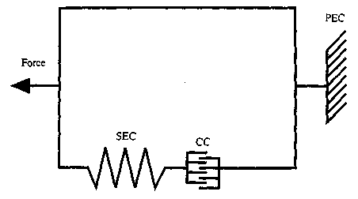
  - Describe a three-component model represented in the picture above.
5.6. Read, translate and have a text below as a dictation.
THE ENERGY SYSTEMS

Various sports activities involve specific demands for energy. For example, sprinting and jumping are high-energy output activities, requiring a relatively large production of energy for a short time. Long-distance running and swimming, on the other hand, are mostly low-energy production for a prolonged time. Other physical activities demand a blend of both high- and low-energy. These various energy demands can be met by the different processes by which energy can be supplied to the skeletal muscles.
Jump-down  exercises | 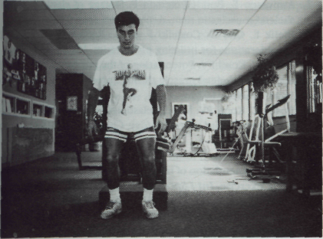
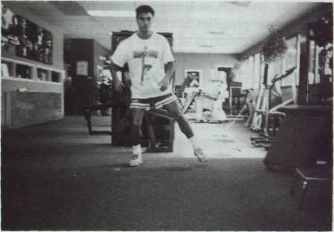 |  | Lateral bounding  drills

5.7. Put the verbs in brackets into appropriate tense form.

1. The beginning plyometric program (should, emphasize) the importance of eccentric vs. concentric muscle contractions. 2. The relevance of the stretch-shortening cycle with decreased amortization time (should, be stressed). 3. Initiation of lower quarter plyometric training (begin) with low intensity in-place and multiple response jumps. 4. The in- dividual (should, be instructed) in proper exercise technique. 5. The feet (should, be) nearly flat in all landings, and the individual (should, be encouraged) to "touch and go." 6. An analogy (would, be landing) on a hot bed of coals. 7. The goal (be) to reverse the landing as quickly as possible, spending only a minimal amount of time on the ground.
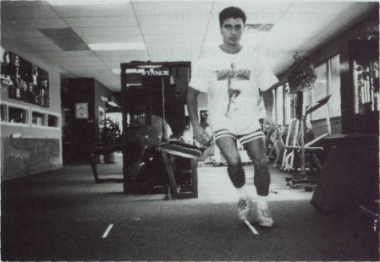
Lateral sliding activities
5.8. Convert the conversation below into indirect speech.
PLYOMETRIC EXERCISE

- What kind of technique is plyometric exercise?
- Plyometric exercise is a technique that is being increasingly incorporated into later stages of the reconditioning program by the sports therapist.
- Does plyometric training include specific exercises that encompass a rapid
stretch of a muscle eccentrically?
- Sure. It followed immediately by a rapid concentric contraction of that muscle
to facilitate and develop a forceful explosive movement over a short period of
time.
- You mean that the greater the stretch put on the muscle from its resting length
immediately before the concentric contraction, the greater the resistance the
muscle can overcome.
- That is so. Plyometrics emphasize the speed of the eccentric phase. The rate of
stretch is more critical than the magnitude of the stretch.
- What is their advantage in?
- An advantage to using plyometric exercises is that they can help to develop
eccentric control in dynamic movements.
- Could you tell me what plyometric exercises involve?
- Plyometric exercises involve hops, bounds, and depth jumping for the lower extremity and the use of medicine balls and other types of weighted equipment for the upper extremity.
- Is depth jumping an example of a plyometric exercise?
- You are quite right. An individual jumps to the ground from a specified height and then quickly jumps again as soon as ground contact is made.
- Do plyometrics impact the musculoskeletal system?
- Plyometrics tend to place a great deal of stress on the musculoskeletal system. The learning and perfection of specific jumping skills and other plyometric exercises must be technically correct and specific to one's age, activity, physical, and skill development.

5.9. Translate the following into English.

При правильному використанні (When used judiciously), кліометрія може стати цінним внеском (a valuable asset) у програму спортивної реабілітації. Велика частина функціонування нижньої частини тіла у спорті (The majority of lower quarter sport function) відбувається в тісному кінетичному взаємозв'язку (in the closed kinetic chain). Пліометрія нижніх кінцівок (lower extremities) є функціонально ефективною самодостатньою вправою (an effective functional closed - chain exercise), яку можна вводити (incorporate) у спортивні реабілітаційні програми. Маніпулюючи (By manipulating) обсягом, частотою та інтенсивністю можна змінювати програму в потрібному напрямку (can be advanced appropriately). Дуже важливо при використанні пліометріі дотримуватися правильної прогресії , щоб не посилити травму.

5.10. Study the following plyometric prerequisites.

STRABILITY TESTING

Plyometric Static Stability Testing

- Single Leg Stance – 30 sec.
- Eyes open
- Eyes closed

- Single Leg 25% Squat – 30 sec.
- Eyes open
- Eyes closed

- Single Leg 50% Squat – 30 sec.
- Eyes open
- Eyes closed
SIX CATEGORIES OF PLYOMETRIC TRAINING

- In-place jumping
- Standing jumps
- Multiple response jumps and hops
- In-depth jumping and box drills
- Bounding
- High stress sport specific drills

5.11. Test yourself using the recommendations above.

5.12. Write a short essay on “Plyometric Exercise in Rehabilitation”.

VI. Text III.

CLOSED-KINETIC CHAIN EXERCISE

A closed-kinetic chain exercise is one in which the distal segment of the
extremity is fixed or stabilized. In an open-kinetic chain, the distal segment is mobile and is not fixed. Closed-kinetic chain exercises in the lower extremity decrease the shear forces, reducing anterior tibial translation, and increase the compressive forces, which increases stability around the knee joint.
Biomechanically, closed-kinetic chain exercises function to decrease the knee flexion moment and increase the hip flexion moment. Closed-kinetic chain exercises induce co-contraction of the hamstrings, which helps to decrease the shear forces at the knee joint. The majority of functional activities involve a closed-kinetic chain system. Closed-kinetic chain exercises have become the recommended strengthening technique of injuries involving in particular the ACL (anterior cruciate ligament). Mini-squats, leg press, stepping exercise, lateral step-up, terminal knee extension using rubber tubing, and stationary bicycling are all examples of closed- kinetic chain activities for the lower extremity. Closed-kinetic chain activities, such as push-ups and weight-shifting, are strengthening exercises used primarily for improving shoulder stabilization in the upper extremity.
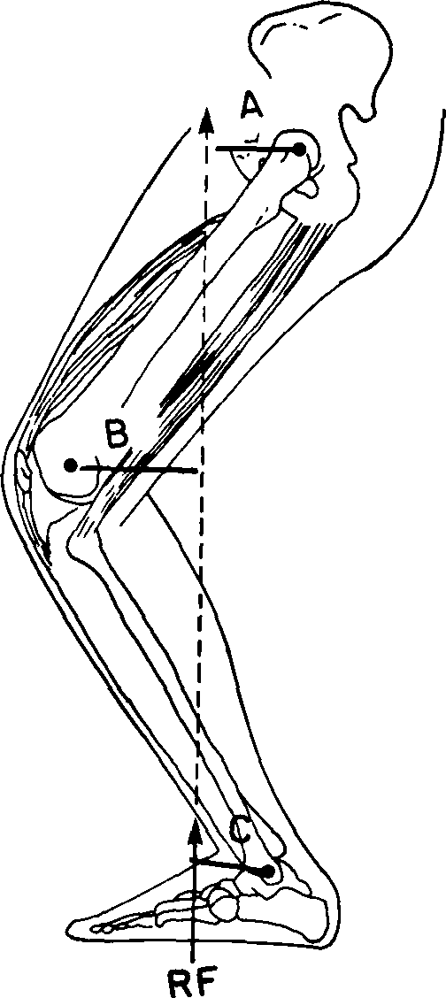 | Closed-kinetic chain exercises induce hamstring contraction by creating  a flexion moment at both A, hip; B, knee; and C, ankle.

6.1. Read the text “Closed-Kinetic Chain Exercise” and translate it in writing.

6.2. Ask 15 questions of all types to the text.

6.3. Find English equivalents in the text for the following:

вправи з кінетично замкнутим циклом, периферичний сегмент, кінцівки, фіксований, стійкий, кінетично відкритий ланцюг, рухливий, зменшувати, поперечна сила/зсувне зусилля, скорочувати, перенесення/переміщення, передня, велика гомілкова, що стискає сила/стискальне зусилля, колінний суглоб, момент згинання коліна, збільшувати, момент згинання стегна, викликати/стимулювати, скорочення, підколінне сухожилля, більшість, залучати, особливо, передня хрестоподібна зв'язка коліна, у напівприсяді, жим ногами, вправи на степ-тренажерах, вправи на латеральних степ-тренажерах, повне розпрямлення коліна, гумовий шланг, вело-тренажер, віджимання, переміщення важких речей, силові вправи, в основному/головним чином, стійкість, плече, верхня кінцівка.

6.4. Complete the sentences with logical endings.

1. A closed-kinetic chain exercise is one in which the distal segment of the extremity ... . 2. In an open-kinetic chain, the distal segment is … . 3. Closed-kinetic chain exercises in the lower extremity decrease ..., reducing anterior tibial translation, and increase ... . 4. Biomechanically, closed-kinetic chain exercises function to decrease ... and increase the ... . 5. Closed-kinetic chain exercises induce ... . 6. Closed-kinetic chain exercises have become the recommended strengthening technique of injuries involving ... .

Standard leg press exercise | 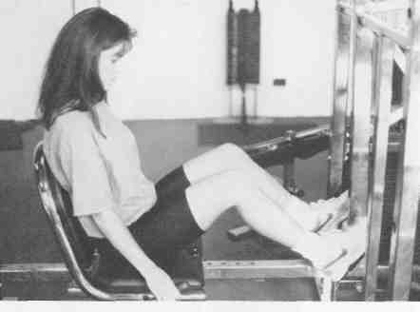

6.5. Find the predicate in the following sentences and define the tense and
voice form of the verb in it.

1. In closed-kinetic chain exercise, the flexion moment increases as the knee flexes, once again causing increased quadriceps and patellar tendon tension thus an increase in patellofemoral joint reaction forces. 2. However, the patella has a much larger surface contact area with the femur, and contact stress is minimized. 3. Closed-kinetic chain exercises may be better tolerated in the patellofemoral joints since contact stress is minimized.

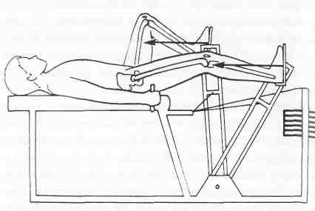 | Modified and recommended leg press positioning

6.6. Complete the sentences with the words from a box.

the distal segment, extremity, closed-kinetic chain exercise, stabilized or fixed, kinetic, machine

1. In recent years the concept of …-… … … has received considerable attention as a useful and effective technique of rehabilitation, particularly for injuries involving the lower extremity. 2. The ankle, knee, and hip joints comprise the kinetic chain for the lower … . 3. When the distal segment of the lower extremity is … or …, as is the case when the foot is weightbearing on the ground, the … chain is said to be closed. 4. Conversely, in an open kinetic chain, … … … is mobile and is not fixed. 5. Traditionally, rehabilitation strengthening protocols have used open-kinetic chain exercises such as knee flexion and extension on a knee … .

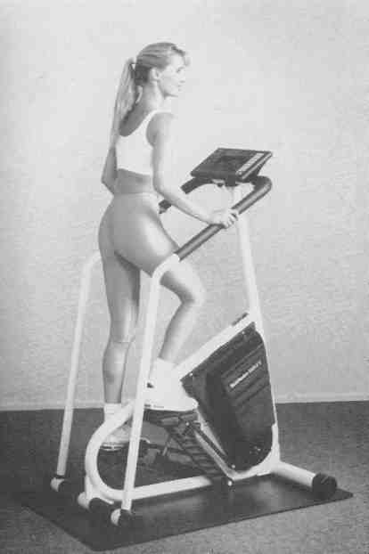 | Stairmaster stepping machine

6.7. Put questions to the words in italics.

1. Closed-kinetic chain exercises have two distinct advantages over open-kinetic chain exercises. 2. From a biomechanical perspective, they are safer and produce stresses and forces that are potentially less of a threat to healing structures. 3. They are also more functional than open-kinetic chain exercises since they involve weight-bearing activities. 4. While closed-kinetic chain exercises are more often used in lower extremity rehabilitation, they may also be useful in rehabilitation protocols for certain upper extremity activities as well.

6.8. Insert articles if necessary.

CONCEPT OF THE KINETIC CHAIN

1. The concept of … kinetic chain was first proposed in … 1970s and was initially referred to as … link system by mechanical engineers. 2. In this link system, pin joints connect … series of overlapping, rigid segments. 3. If both ends of this system are connected to an immovable frame, translation of … proximal or distal ends is impossible. 4. In this closed link system, movement at one joint produces … predictable movement at all other joints. 5. This type of closed link system does not exist in either … upper or lower extremities.

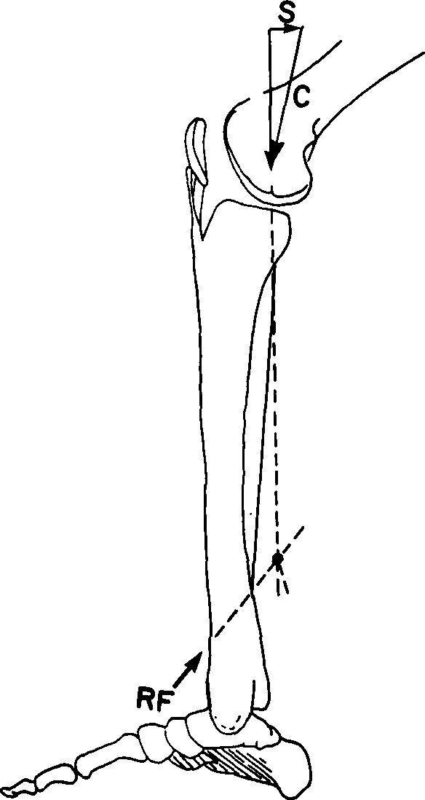 | Mathematical model showing shear and compressive force vectors.  S = shear, C = compressive.

6. However, when … distal segment in the extremity (that is, … foot or hand) meets resistance, muscle recruitment patterns and joint movements are different than when … distal segment moves freely. 7. Thus two systems, … open and … closed system, were proposed. 8. Whenever foot or … hand meets resistance, … closed kinetic chain exists. 9. … true closed kinetic chain can only exist during isometric exercise, since neither … proximal nor distal segments can move in … closed system.
6.9. Fill in the gaps with the prepositions if necessary.
BIOMECHANICS OF CLOSED-KINETIC CHAIN EXERCISES
IN THE LOWER EXTREMITY

1. Open- and closed-kinetic chain exercises have different biomechanical effects … the lower extremity and … particular … the knee joint. 2. It is essential … the sports therapist to understand forces that occur … the knee joint. 3. Palmitier et al. have proposed a biomechanical model … the lower extremity that quantifies two critical forces … the knee joint. 4. A shear force occurs … a posterior direction that would cause the tibia to translate anteriorly if not checked … soft tissue constraints (primarily the anterior cruciate ligament). 5. The second force is a compressive force directed … a longitudinal axis … the tibia. 6. Weight-bearing exercises increase joint compression, which enhances joint stability.

6.10. Open the brackets and use a verb in a proper tense and voice form.

- In an open-kinetic chain seated knee joint exercise, as a resistive force
(apply) to the distal tibia, the shear and compressive forces (would, maximize). 2. When a resistive force (apply) more proximally, shear force (reduce) significantly, as (be) the compressive force. 4. If the resistive force (apply) in a more axial direction, the shear force (be) also smaller. 5. If a hamstring co-contraction (occur), the shear force (minimize).

LATERAL STEP-UP EXERCISE  Lateral step-ups are another widely used closed-kinetic chain exercise. Lateral step-ups seem to be used more often clinically than do forward step-ups. Step height can be adjusted to patient capabilities and generally progress up to about 8 inches. Heights greater than 8 inches create a large flexion moment at the knee, increasing anterior shear force and making hamstring co-contraction more difficult. | 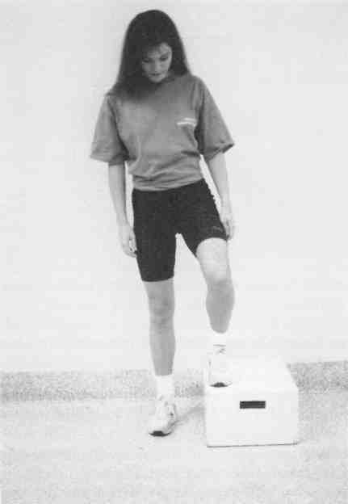

6.11. Make the sentences below negative.

1. Closed-kinetic chain exercises induce hamstring contraction by creating a flexion moment at both the hip and knee with the contracting hamstrings stabilizing the hip and the quadriceps stabilizing the knee. 2. A moment is the product of force and distance from the axis of rotation. 3. Also referred to as torque, it describes the turning effect produced when a force is exerted on the body that is pivoted about some fixed point. 4. Co-contraction of the hamstring muscles helps to counteract the tendency of the quadriceps to cause anterior tibial translation. 5. Co-contraction of the hamstrings is most efficient in reducing shear force when the resistive force is directed in an axial orientation relative to the tibia, as is the case in a weight-bearing exercise. 6. Several studies have shown that co-contraction is useful in stabilizing the knee joint and decreasing shear forces.

6.12. Put general questions to the following sentences.

1. The tension in the hamstrings can be further enhanced with slight anterior flexion of the trunk. 2. Trunk flexion moves the centre of gravity anteriorly, decreasing the knee flexion moment and thus reducing knee shear force and decreasing patellofemoral compression forces. 3. Closed-kinetic chain exercises try to minimize the flexion moment at the knee while increasing the flexion moment at the hip. 4. A flexion moment is also created at the ankle when the resistive force is applied to the bottom of the foot. 5. The soleus stabilizes ankle flexion and creates a knee extension moment, which again helps to neutralize anterior shear force. 6. Thus the entire lower extremity kinetic chain is recruited by applying an axial force at the distal segment.
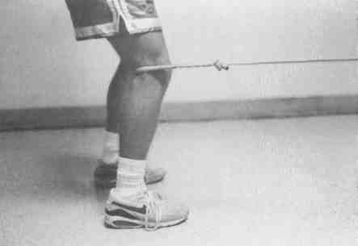  Terminal knee extensions using rubber tubing. | 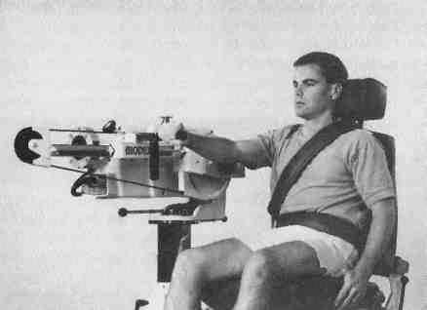  Closed-kinetic chain isokinetic testing. Closed-kinetic chain isokinetic testing attachment from Biodex.
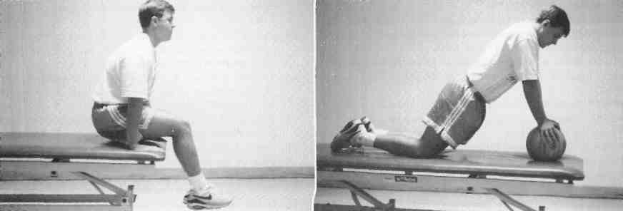

Closed-kinetic chain exercises for upper extremity.
A, Seated push-ups. B, Weight-shifting exercises.

6.13. Use the sentences below in one of the Past Tenses.

1. In an open-kinetic chain exercise involving seated leg extensions, the resistive force is applied to the distal tibia, creating a flexion moment at the knee only. 2. This negates the effects of a hamstring co-contraction and thus produces maximal shear force at the knee joint. 3. Shear forces created by isometric open-kinetic chain knee flexion and extension at 30 and 60 degrees of knee flexion are greater than with closed-kinetic chain exercises. 4. Decreased anterior tibial displacement during isometric closed-kinetic chain knee flexion at 30 degrees when measured by knee arthrometry has also been demonstrated.

6.14. Put disjunctive questions to the sentences below.

1. The effects of open- vs. closed-kinetic chain exercises on the patellofemoral joint must also be considered. 2. In open-kinetic chain knee extension exercise, the flexion moment increases as the knee tends from 90 degrees of flexion to full extension increasing tension in the quadriceps and patellar tendon. 3. Thus the patellofemoral joint reaction forces are increased with peak force occurring at 36 degree joint flexion. 4. As the knee moves toward full extension, the patellofemoral contact area decreases, causing increased contact stress per unit area.
6.15. Write a brief essay on “Closed-Kinetic Chain Exercise”.

VII. SELF-ASSESSMENT TEST

These tasks are designed to assist you in determining if you have mastered the
materials and competencies presented here.

1. Describe isokinetic exercises.
2. Identify the use of isokinetic exercises as a rehabilitation tool in the athletic
population.
3. Describe how plyometrics can be integrated into rehabilitation program.
4. Explain what is the main purpose of plyometric training.
5. Describe how plyometrics can be integrated into rehabilitation program.
6. Give biomechanical and physiological principles of plyometric training?
7. Differentiate between the concepts of the open kinetic chain and a closed kinetic chain.
8. Prove that closed-kinetic chain exercises are particularly useful in
rehabilitation of injuries involving the anterior cruciate ligament.
SECTION II

REESTABLISHING PROPRIOCEPTION

UNIT I

REESTABLISHING PROPRIOCEPTION, KINESTHESIA, JOINT POSITION SENSE, AND NEUROMUSCULAR CONTROL IN REHABILITATION

I. Study, read, translate and remember the key words and phrases on the unit:

a) | mobilization, traction, pendulum, regimen, flexion, advent, spin, glide, axis, plane, extremity, extension, abduction, adduction, rotation, surface, condyle, compression, oscillation, surface, femur, malignancy, stiffness, guarding, awareness, continuum, laxity, taping, splinting, bracing, severity, thrust, brain, indication, looseness, relief, sensitivity, approach, inhibition, discharge, recruitment, stimulus, spasticity, excitability, phenomenon, disability, sequence, implementation, anxiety, apprehension, deprivation,  precursor, fatigue, confidence, environment, assessment, succession, resumption, swelling, setback, reinforcement, enhancement, susceptibility;
b) | to incorporate, to attribute, to initiate, to regain, to govern, to articulate, to emphasize, to reduce, to restore, to surround, to inhibit, to facilitate, to quantify, to measure, to compose, to respond, to remain, to complain, to avoid, to tighten, to eliminate, to mediate, to deal, to rely, to relieve, to strive, to enhance, to endure, to predict, to overlap, to evaluate, to curtail, to gauge, to hamper, to disturb, to retrain, to minimize, to roll, to glide;
c) | slight, accessory, longitudinal, radial, humeroradial, femoral, congruent, curved, concave, convex, congenital, stationary, virtually, simultaneous, conversely, reflexogenic, postural, precise, surrounding, accessory, slack, oscillating, alternating, straightforward, initial, intermittent, cutaneous, bony, auditory, subliminal, facilitory, inhibitory, excessive, afferent, excitatory, inhibitory, apparently, subsequent, complete, encountered, solid, sudden, immediate, crucial, opportune, appropriate, postural, alternating;
d) | as well as, nevertheless, since, whereas, thus, either, beyond, within, however, thus, therefore, likewise, towards, rather than, straightforward;
e) | PNF (proprioceptive neuromuscular techniques); in conjunction with; to attain goals; bony arrangement; the spinal cord; corticospinal tract, muscle spindles; spinal cord; voluntary contraction; reciprocal inhibition; SAID principle (specific adaptation to imposed demands); in clinical setting; the imposed demands; high-velocity tackle; to perform athletic endeavors; to meet the demands; preset criteria; use of sensory cues; on the ratio; subliminal fringe area; alpha motor neurons.

II. Oral topic.
REESTABLISHING PROPRIOCEPTION

The sensory function of articular structures provides awareness of the body and its relationship with the surrounding environment. This awareness is a specialized variation of the sensory modality of touch known as proprioception.
Proprioception encompasses the sensations of kinesthesia and joint position sense and is mediated by joint, muscle, and cutaneous mechanoreceptors responsible for afferent transmission of joint motion and position. These afferents modulate muscle function and initiate reflex joint stabilization.
After injury to articular structures, partial differentiation has resulted in deficits in the proprioceptive mechanisms. These deficits may lead to an insidious pathological degeneration of joints because of the lack of muscle stabilization and resultant recurrence of injury.
The effects of training on the afferent deficits remain unclear, yet it seems reasonable that clinically stimulating these mechanisms should enhance the dynamics of joint kinematics and decrease the susceptibility to reinjury.

2.1. Read and translate the text.

2.2. Answer the questions on the text.

1. What provides awareness of the body and its relationship with the surrounding environment? 2. What does proprioception mean? 3. What kinds of sensations does proprioception encompass? 4. Do these afferents modulate muscle function or initiate reflex joint stabilization? 5. When has partial deafferentation resulted in deficits in the proprioceptive mechanisms? 6. Why may these deficits lead to an insidious pathological degeneration of joints? 7. How clear do the effects of training on the afferent deficits remain? 8. What seems reasonable here? | Shoulder proprioception exercise  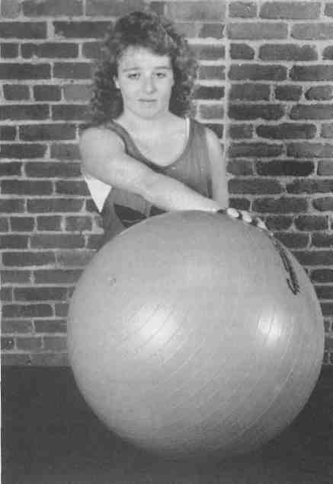

2.3. Find English equivalents for the following:

проприоцепція (здатність реєструвати сигнали, що у м'язах, сухожиллях і капсулах суглобів), кінестезія (почуття руху, сприйняття руху, м'язову почуття), почуття/сприйняття, суглобової), сенсорний (що стосується чутливості), усвідомлення, взаємозв'язок, навколишнє середовище, вид відчуття, дотик, окру-жать/заключать, відчуття/почуття сприйняття (сприйняття свідомістю сенсор -ної інформації при впливі на будь-який з органів почуттів), положення суглоба, займати проміжне положення/служити сполучною ланкою, шкірний, механорецептер (рецептор, реєструючий механічні зсуву), несучий відповідальність за, аферентний (що знаходиться або рухається в напрямку центру системи, доцентрові, що приносить), передача/проведення/перенесення, стимулювати, частковий, приводити до (2), безсимптомно розвивається/прихований, відсутність/нестача, що виходить в результаті, рецидив, неясний, вагомий/прийнятний/розумний, посилювати/підвищувати, зменшувати, сприйнятливість.
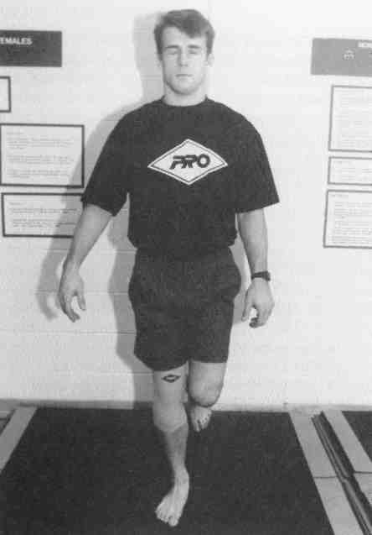 | Modified Rhomberg test.  Modified Rhomberg test on foam surface for balance training wearing a neoprene compression sleeve. | 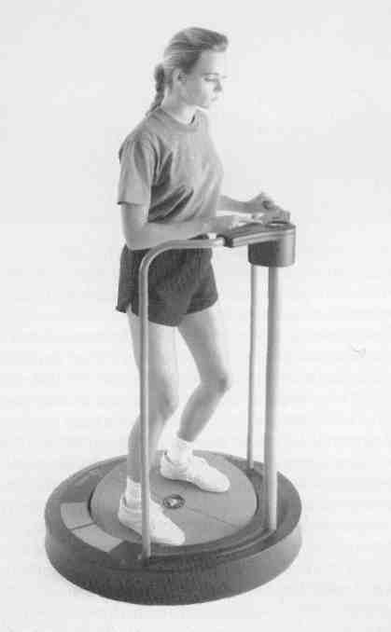  Kinesthetic ability trainer (KAT)

2.4. Insert articles if necessary.

1. Ligaments play … major role in normal joint kinematics, providing mechanical restraint to abnormal joint movement when … stress is placed on … joint. 2. … primary concern of … orthopedic surgeon has been … biochemical restoration of these ligaments after injury in … attempt to restore … joint's stability and therefore its kinematics. 3. In restoring normal joint kinematics it is speculated that … recurrent injury will be minimized and progressive joint degeneration can be avoided.
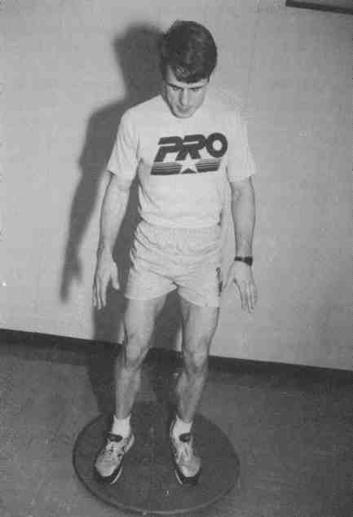  Lower extremity kinesthetic training.  Lower extremity kinesthetic training on an unstable platform.  A, Both feet. | 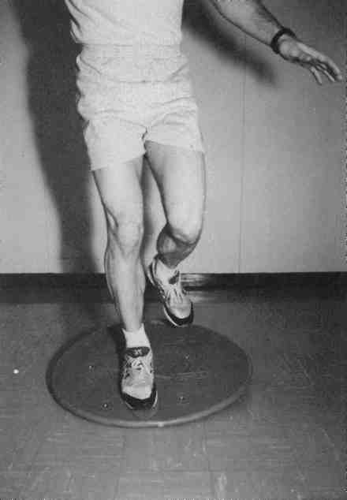  B, One foot

2.5. Put questions to the words in italic.

1. Kennedy et al. however, observed that in addition to their mechanical restraining function, articular ligaments provide important neurological feedback that directly mediates muscular reflex stabilization about the joint. 2. The neuromuscular controlling mechanism is mediated by articular mechanoreceptors and provides the individual with the proprioceptive sensations of kinesthesia and joint position sense. 3. The neurological feedback for the control of muscular actions protects against excessive strain on passive joint restraints and provides a prophylactic mechanism to recurrent injury. 4. After the joint injury, disruption to these articular mechanoreceptors inhibits normal neuromuscular reflex joint stabilization and contributes to repetitive injuries and the progressive decline of the joint.

2.6. Fill in the gaps with the prepositions if necessary.

1. A rehabilitation program that addresses the need … restoring joint stability cannot be designed until one has a total appreciation … both the mechanical and sensory function … articular structures. 2. Simply restoring mechanical restraints or strengthening the associated muscles neglects the coordinated neuromuscular controlling mechanism required … joint stability during the sudden changes … joint position common to sports activity. 3. A lag time … the neuromuscular reaction time can result in recurrent joint subluxation and deterioration. 4. This chapter will address the issues central to the role of articular structures … providing neuromuscular control … joint stability. 5. The role … joint mechanoreceptors will be specifically elucidated as it pertains to the mediation … the sensations … proprioception, kinesthesia, and joint position awareness.

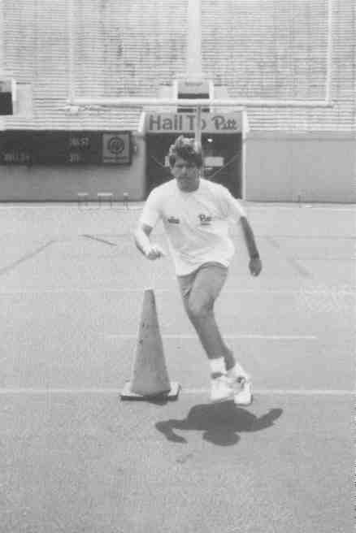  Reaction cutting manoeuvre | 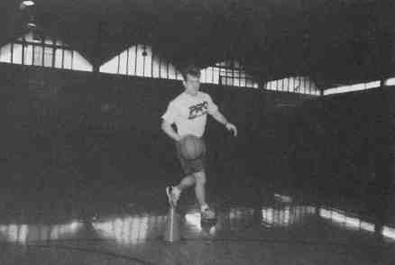  Four-corner sport-specific dribbling drill.  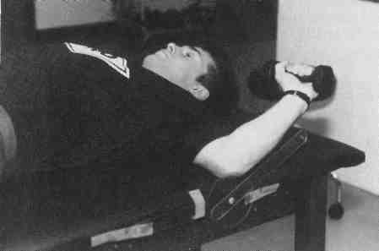  Shoulder joint repositioning exercise

2.8. Intepret the conversation below in indirect speech.

PROPRIOCEPTION AND INJURED ATHLETE

- | What is important for an injured athlete?
- | It is essential that an injured athlete redevelop the feel of awareness of where the body part is located at all times.
- | How can it be achieved?
- | Depending on the injury, this can be accomplished in many ways.
- | How is it?
- | The wobble or tilt board may be used for leg injuries.
- | And what else can help proprioception?
- | Other balance activities, such as standing on one foot and springing upward on a bouncer, can help proprioception.
- | Should you keep any succession in activities here?
- | It is necessary that proprioception be restored before coordination, agility, and speed activities are attempted.

2.9. Write a brief essay on “Isokinetics Principles in Rehabilitation”.

Proprioceptive testing device

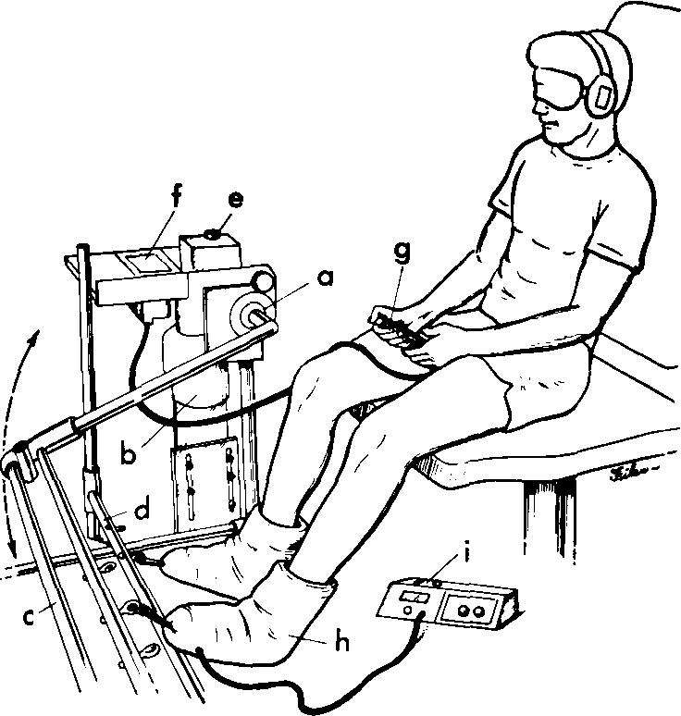

a = rotational transducer; b = motor; c = moving arm; d = stationary arm; e = control panel;/ = digital microprocessor; g == hand-held disengage switch; h = pneumatic compression boot; i = pneumatic compression device; TTDPM (threshold to detection of passive motion) is assessed by measuring the angular displacement until the subject senses motion in the knee.

III. Text I.
HISTORY OF SENSATION

Awareness of the body and its relationship to the surrounding environment is mediated by the phenomenon of sensation. The history of sensation dates back to the Greek philosopher Aristotle, who was the first to describe the five senses. Sir Charles Bell termed sensation as it relates to limb position and motion as the "sixth sense." This material will address articular sensation in its entirety since it mediates the perception of joint position and joint motion that regulates muscle contraction for movement and joint stabilization.
The relevance of articular sensation has been observed by a select few scientists over the past two centuries. The French neurologists Duchenne and Charcot drew attention to articular sensations in 1865, while Sherrington and Adrian received the Nobel prize in 1932 for their work on the mechanisms of sensation and were the first to describe proprioception. Abbott et al., in 1944, were the first to suggest that knee articular sensations were the first step in a kinetic chain that accounted for dynamic joint stabilization. More recently, Palmer demonstrated the role of proprioceptive input from knee ligaments in mediating the reflex contraction of the hamstrings and vastus medialis with resultant weakening of the reflex after ligament trauma. Also, current investigators, including Barrack et al., Barrett, and Lephart et al., have demonstrated that joint position perception is altered after articular pathology.

Notes:
1. | sensation | - відчуття, почуття
2. | awareness | - усвідомлення, обізнаність
3. | to mediate | - служити посередником
4. | to term | - висловлювати, називати
5. | articular | - суглобової
6. | in its entirety | - повністю, в цілому; в усій повноті
7. | relevance | - доречність
8. | to draw attention | - привертати увагу
9. | proprioception | - здатність реєструвати сигнали, що виникають в м'язах, сухожиллях, суглобах тощо
10. | kinetic chain | - кінетичний (руховий) ланцюг
11. | input | - уведення
12. | resultant | - надання відомостей, даних
13. | to alter | - виходить в результаті

3.1. Read and translate the text “History of Sensation”.

3.2. Answer the questions to the text.

1. What is the phenomenon of sensation by the definition from the text? 2. Who was the first one to describe the sensation? 3. In what way did Bell define the sensation? 4. In what meaning has sensation been addressed here? 5. Did many scientists study articular sensation over the past two centuries? 6. What are the merits of the French Neurologists in this field? 7. What reward did Sherrington and Adrian receive for their achievements? 8. Who was the first to describe proprioception? 9. Did Abbot or Palmer make the first step in a kinetic chain? 10. Current investigators have demonstrated that joint position perception is altered after articular pathology, haven’t they?

3.3. Complete the sentences with appropriate ending.

1. The Greek philosopher Aristotle described the sensation as … . 2. Sir Charles Bell termed sensation as … . 3. The French neurologists Duchenne and Charcot drew attention to … . 4. Sherrington and Adrian received the Nobel prize in 1932 for their work on … . 5. Abbott et al., in 1944, were the first to suggest that … . 6. Palmer demonstrated … . 7. Current investigators, including Barrack et al., Barrett, and Lephart et al., have demonstrated that … .

3.4. Write an essay on “History of Sensation”.

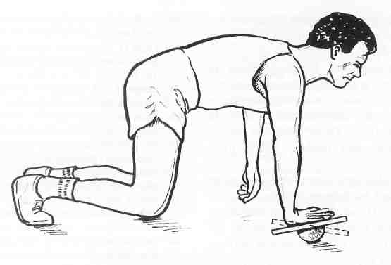 | Shoulder wobble board exercise.

IV. Text II.
TERMINOLOGY OF JOINT SENSATION

The terminology related to joint sensation is often misunderstood and used inappropriately, which has led to confusion and a lack of appreciation for these mechanisms during rehabilitation. Articular sensations are described as proprioception and kinesthesia. There is considerable discrepancy in the definitions of these two terms as related to their physiological functions. Mountcastle and Willis define proprioception as the conscious awareness of limb position, while they define kinesthesia as the aware- ness of joint motion. On the other hand, Bastian defines the kinesthetic mechanism as a complex of sensations including those in which movement is not featured, while Sherrington describes the proprioceptive sense as including vestibular sensations and inputs from muscles and joints that are not necessarily perceived. We define proprioception as a specialized variation of the sensory modality of touch that encompasses the sensations of joint movement (kinesthesia) and joint position (joint position sense).
Conscious proprioception is essential for proper joint function in sports, activities of daily living, and occupational tasks. Unconscious proprioception modulates muscle function and initiates reflex stabilization. Much effort has been dedicated to elucidate the mechanical function of articular structures and the corresponding mechanical deficits that occur secondary to disruption of these structures. Articular structures also have a significant sensory function that plays a role in dynamic joint stability, acute and chronic injury, pathological wearing, and rehabilitation training.

4.1 Read and translate the text “Terminology of Joint Sensation”.

4.2. Answer the questions to the text “Terminology of Joint Sensation”.

1. What could be the reason to confusion and a lack of appreciation for joint sensation mechanisms during rehabilitation? 2. How are articular sensations described as? 3. There is not considerable discrepancy in the definitions of proprioception and kinesthesia, is there? 4. Do different researchers share the similar opinion while defining proprioception? 5. What is the definition of proprioception here? 6. Where is conscious proprioception essential? 7. What does unconscious proprioception modulate and initiate? 8. How much effort has been dedicated to elucidate the mechanical function of articular structures? 9. What kind of function do articular structures have?

4.3. Find English equivalents for the following:

відмінність, суглобові структури, укладати в собі, дотик, вторинний, відчуття/почуття, повсякденна діяльність, відчутний/усвідомлений, термін, значний, плутанина, розуміння/оцінка, усвідомлення/обізнаність, кінцівка, фігурувати/відводити важливе місце, сприймати/відчувати/почувати, присвячувати, виробничі завдання, починати/ініціювати, зусилля, роз'яснювати/проливати світло, руйнування, відбуватися, іннервація/зв'язок нервових волокон з органом, в гострій формі, непорозуміння, призводити до, суглобова.

4.4. Insert prepositions if necessary.

1. The extrinsic innervation … joints follows Hilton's law. 2. It states that joints are innervated … articular branches … the nerves supplying the muscles that cross the joint. 3. The afferent innervation … joints is based … peripheral receptors located … articular, muscular, and cutaneous structures. 4. Articular receptors include nociceptive free nerve … endings and proprioceptive mechanoreceptors.

4.5. Fill in the gaps with articles if necessary.

1. Several authors have identified mechanoreceptors in … cruciate ligaments (CL) of … cat knee joint. 2. Schultz et al. were … first to identify mechanoreceptors in … human CL. 3. Using gold chloride, Bielshowky, and Bodian staining techniques, these investigators histologically examined ACL obtained from cadavers at … time of total knee arthroplasty and demonstrated … presence of mechanoreceptors in … CL. 4. Using … modified gold chloride technique Schutte et аl. and Zimny et al. further characterized these ACL receptors into three morphological types of mechanoreceptors (Ruffini endings, Ruffini corpuscles or Golgi tendon organs, and pacinian corpuscles) and free-nerve endings. 5. Others have demonstrated … similar mechanoreceptors in cat knee menisci. 6. In their extensive study of … innervation of joints, Freeman and Wyke histologically identified … three types of mechanoreceptors in … capsular and ligamentous structures of cat ankle joints. 7. … presence of mechanoreceptors in human ankle joints has not yet been demonstrated. 8. Finally, … three distinct mechanoreceptors have recently been histologically identified by Vangsness and Ennes in … glenoid labrum and … glenohumeral ligaments of … shoulder, suggesting that these structures possess .. anatomical basis for perceiving joint position and motion.

4.6. Open the brackets and use a verb in appropriate tense and voice form.

1. Developing a rehabilitation program that (to incorporate) proprioceptively mediated muscular control of joints (to necessitate) an appreciation for the central nervous system’s influence on motor activities. 2. Joint afferents (to contribute) to central nervous system function at three distinct levels of motor control. 3. At the spinal level, reflexes (to subserve) movement patterns that (to receive) from higher levels of the nervous system. 4. This action (to provide) for reflex splinting during conditions of abnormal stress about the joint and (to have) significant implications for rehabilitation. 5. The muscle spindles (to play) a major role in the control of muscular movement by adjusting activity in the lower motor neurons. 6. Partial de-afferentation of joint afferent receptors also (to alter) the musculature's ability to provide co-contraction joint stabilization by antagonistic and synergistic muscles, thus resulting in the potential for re-injury.

Proprioception testing device for shoulder testing. | 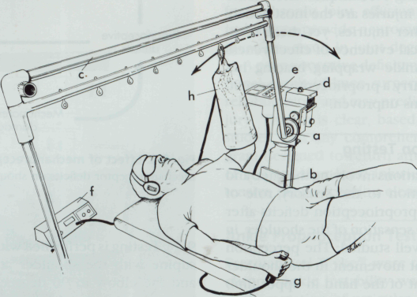

4.7. Use the sentences below in Present Perfect Tense. Give their negative and
interrogative forms.

1. The second level of motor control is at the brain stem, where joint afference is relayed to maintain posture and balance of the body. 2. The input to the brain stem about this information emanates from the joint proprioceptors, the vestibular centers in the ears, and from the eyes.

4.8. Ask questions to italic words.

1. The final aspect of motor control includes the highest level of central nervous system function (motor cortex, basal ganglia, and cerebellum) and is mediated by cognitive awareness of body position and movement. 2. These higher centers initiate and program motor commands for voluntary movements. 3. Movements that are repeated can be stored as central commands and can be performed without continuous reference to consciousness. 4. Although considerable controversy still exists relative to the role of joint and muscle receptors in the perception of joint movement, deep pressure, at the very least, can be consciously appreciated during joint motion.

4.9. Use the words from a box to fill in the gaps.

encourage; receptors; central; muscle afferents; maximally; sudden; without visual input

1. With these three levels of motor control in mind, mediated in part by joint and … … , one can begin to develop rehabilitation activities to address proprioceptive deficiencies. 2. The objectives must be to stimulate the joint and muscle … to encourage maximum afferent discharge to the respective … nervous system level. 3. At the spinal level, activities that … reflex joint stabilization should be addressed. 4. Such activities include … alterations in joint positioning that necessitate reflex muscular stabilization. 5. Balance and postural activities, both with and … … … , will enhance motor function at the brain stem level. 6. Consciously performed joint positioning activities, especially at joint end ranges, will … stimulate the conversion of conscious to unconscious motor programming.

4.10. Write a short essay on the “Terminology of Joint Sensation”.

UNIT II

MOBILIZATION AND TRACTION TECHNIQUE

AS A PART OF MANUAL THERAPY
I. TEXT I
JOINT ARTHROKINEMATICS

For the sports therapist who is supervising a rehabilitation program, some understanding of the bio-mechanics of joint movement is essential. There are basically two types of movement that govern motion about a joint. Perhaps the better known of the two types of movement are the physiological movements that result from an active muscle contraction that moves an extremity through traditional cardinal planes including flexion, extension, abduction, adduction, and rotation. The second type of motion is accessory motion. Accessory motions refer to the manner in which one articulating joint surface moves relative to another. Accessory motions are also referred to as joint arthrokinematics, which include spin, roll, and glide.
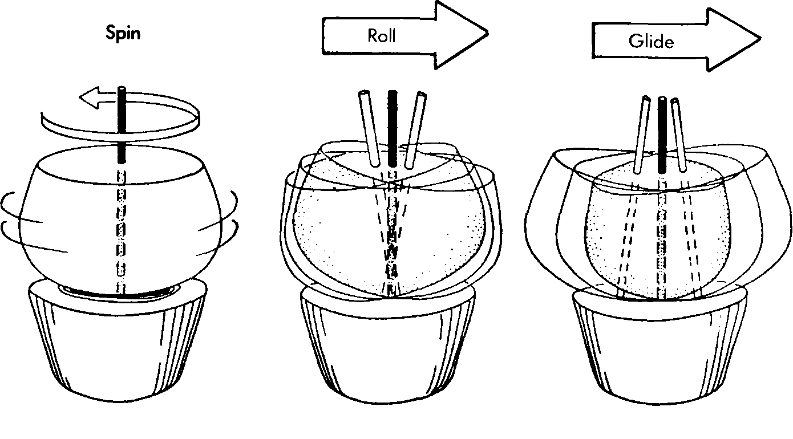
A, Spin B, Roll C, Glide

I.1. Read and translate the text “Joint Arthrokinematics”.

1.2. Answer the questions.

1. Is understanding of the bio-mechanics of joint movement essential for the sports therapist who is supervising a rehabilitation program? 2. How many types of movement that govern motion about a joint are there basically? 3. What type of movement results from an active muscle contraction that moves an extremity through traditional cardinal planes including flexion, extension, abduction, adduction, and rotation? 4. Do accessory motions refer to the manner in which one articulating joint surface moves relative to another? 5. Which motions are referred to as joint arthrokinematics, which include spin, roll, and glide?

1.3. Write a short essay on “Joint Arthrokinematics”..

II. Oral topic.
MOBILIZATION AND TRACTION TECHNIQUES
IN REHABILITTAION
Mobilization and traction techniques increase joint mobility or decrease pain by restoring accessory movements to the joint. Physiological movements result from an active muscle contraction that moves an extremity through traditional cardinal planes. Accessory motions refer to the manner in which one articulating joint surface moves relative to another. Normal accessory component motions must occur for full-range physiological movement to take place. Accessory motions are also referred to as joint arthrokinematics, which include spin, roll, and glide. The Convex-Concave Rule states that if the concave joint surface is moving on the stationary convex surface, gliding will occur in the same direction as the rolling motion. Conversely, if the convex surface is moving on a stationary concave surface, gliding will occur in an opposite direction to rolling. The resting position is one in which the joint capsule and the ligaments are most relaxed, allowing for a maximum amount of joint play. The treatment plane falls perpendicular to a line running from the axis of rotation in the convex surface to the center of the concave articular surface. Maitland has proposed a series of five graded movements or oscillations in the range of motion to treat pain and stiffness. Kaltenborn uses three grades of traction to reduce pain and stiffness. Kaltenborn emphasizes that traction should be used in conjunction with mobilization glides to treat joint hypomobility.

2.1. Read and translate the text “Mobilization and Traction Technique in Rehabilitation”.

2.3. Find in the text English equivalents for the following:

обмежена рухливість суглоба, у поєднанні з, ковзання, підкреслювати/виділяти, відновлення здатності до руху в суглобах, три ступені витягнення, знижувати больовий поріг, тугорухливість/скутість, рух назад і вперед/коливання/осциляція, пропонувати, увігнута суглобова поверхня, вісь обертання, у протилежному напрямку, нерухома вигнута поверхня, зчленована суглобова поверхня, допоміжний/додатковий, фізіологічний рух в повному обсязі, правило говорить, стан спокою, навпаки, обертання, кінцівка, головна площина, в тому ж напрямку, максимальна кількість вільного ходу суглоба.

2.3. Answer the questions to the text.

- How do mobilization and traction techniques increase joint mobility or
decrease pain? 2. From what do physiological movements result? 3. What kind of manner do accessory motions refer to? 4. What accessory motions does joint arthrokinematics include ? 5. Which rule states that if the concave joint surface is moving on the stationary convex surface, gliding will occur in the same direction as the rolling motion? 6. When will gliding occur in an opposite direction to rolling? 7. When are the joint capsule and the ligaments most relaxed? 8. How does treatment plane fall? 9. What has Maitland proposed? 10. What does Kaltenborn use? 11. What does Kaltenborn emphasize?

2.4. Open the brackets and use the verbs in a proper tense form.
JOINT MOBILIZATION TECHNIQUES

1. The techniques of joint mobilization (be used) to improve joint mobility or to decrease joint pain by restoring accessory movements to the joint and thus allowing full, nonrestricted, pain-free range of motion. 2. Mobilization techniques (may, be used) to attain a variety of treatment goals: reducing pain; decreasing muscle guarding; stretching or lengthening tissue surrounding a joint, in particular capsular and ligamen-tous tissue; reflexogenic effects that either (inhibit) or (facilitate) muscle tone or stretch reflex; and proprioceptive effects to improve postural and kinesthetic awareness. 3. Movement throughout a range of motion (can, be quantified) with various measurement techniques. 4. Physiological movement (be measured) with a goniometer and (compose) the major portion of the range.

Joint capsule resting position
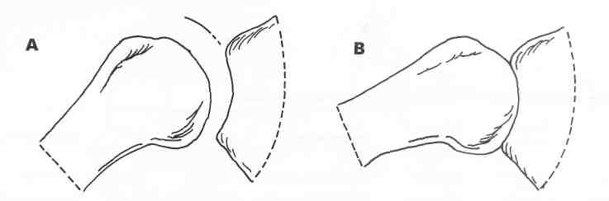

A, Loose-packed position. B, Close-packed position.

2.5. Insert prepositions if necessary.

1. Accessory motion is thought … in millimeters, although precise measurement is difficult. 2. Accessory movements may be … hypomobile, normal, or hypermobile. 3. Each joint has a range … motion continuum with an anatomical limit (AL) to motion that is determined … both bony arrangement and surrounding soft tissue. 4. In a hypomobile joint, motion stops … some point referred to as a pathological point of limitation (PL), short … the anatomical limit caused … pain, spasm, or tissue resistance. 5. A hypermobile joint moves beyond its anatomical limit because … laxity … the surrounding structures. 6. A hypomobile joint should respond well to techniques … mobilization and traction. 7. A hyper-mobile joint should be treated … strengthening exercises, stability exercises, and, if indicated, taping, splinting, or bracing.

2.6. Use the sentences below in one of the past tenses.

1. Treatment techniques designed to improve accessory movement are generally small-amplitude movements, the amplitude being the distance that the joint is moved passively within its total range. 2. Mobilization techniques use these small-amplitude oscillating motions that glide or slide one of the articulating joint surfaces in an appropriate direction within a specific part of the range.

2.7. Make the following sentences interrogative.

1. Maitland has described various grades of oscillation for joint mobilization. 2. The amplitude of each oscillation grade falls within the range of motion continuum between some beginning point (BP) and the AL. 3. The given figure shows the various grades of oscillation that are used in a joint with some limitation of motion. 4. As the severity of the movement restriction increases, the PL will move to the left, away from the AL. 5. However, the relationships that exist among the five grades in terms of their positions within the range of motion remain the same.

2.8. Convert the conversation in indirect speech.
TRACTION-MOBILIZATION TECHNIQUES

- | What kind of technique is traction?
- | Traction refers to a technique involving pulling on one articulating segment to produce some separation of the two joint surfaces.
- | Is traction performed parallel or perpendicular to the treatment plane?
- | While mobilization glides are done parallel to the treatment plane, traction is performed perpendicular to the treatment plane.
- | When is traction used?
- | Like mobilization techniques, traction may be used to either decrease pain or to reduce joint hypomobility.
- | What system has Katlenborn proposed?
- | Kaltenborn has proposed a system using traction combined with mobilization as a means of reducing pain or mobilizing hypomobile joints.
- | Do all joints have a certain amount of joint play or looseness?
- | As discussed earlier, all joints have a certain amount of joint play or looseness. Kaltenborn referred to this looseness as slack.

  - Study a picture and a text below. Give a short summary on it in writing.

JOINT TRACTION TECHNIQUE

Glide
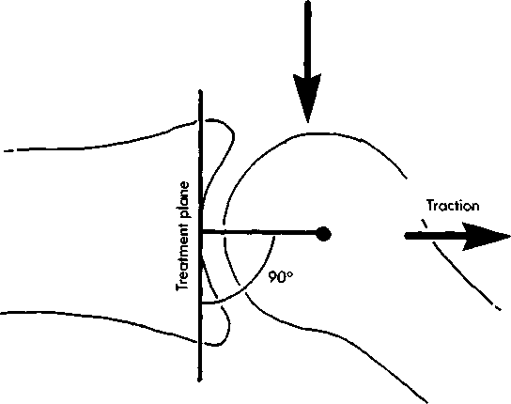
The treatment plane is perpendicular to a line drawn from the axes of rotation to the centre of the articulating surface of the concave segment.

Traction refers to a technique involving pulling on one articulating segment to produce some separation of the two joint surfaces. While mobilization glides are done parallel to the treatment plane, traction is performed perpendicular to the treatment plane. Like mobilization techniques, traction may be used to either decrease pain or to reduce joint hypomobility. Kaltenborn has proposed a system using traction combined with mobilization as a means of reducing pain or mobilizing hypomobile joints. As discussed earlier, all joints have a certain amount of joint play or looseness. Kaltenborn referred to this looseness as slack. Some degree of slack is necessary for normal joint motion. Kaltenborn's three traction grades are defined as follows:
• Grade I Traction (Loosen). Traction that neutralizes pressure in the joint without actual separation of the joint surfaces. The purpose is to produce pain relief by reducing the compressive forces of articular surfaces during mobilization and is used with all mobilization grades.
• Grade II Traction (Tighten or "Take Up the Slack"). Traction that effectively separates the articulating surfaces and takes up the slack or eliminates play in the joint capsule. Grade II is used in initial treatment to determine joint sensitivity.
• Grade III Traction (Stretch). Traction that involves actual stretching of the soft tissue surrounding the joint to increase mobility in a hypomobile joint.
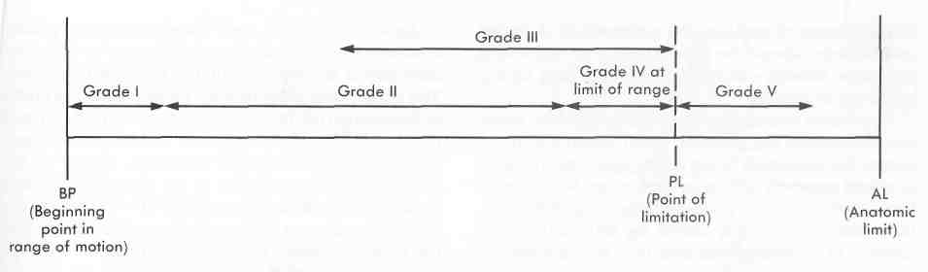
Grade I traction should be used in the initial treatment to reduce the chance of a painful reaction. It is recommended that 10-second intermittent Grades I and II traction be used, distracting the joint surfaces up to a Grade III traction and then releasing distraction until the joint returns to its resting position.
Kaltenbom emphasizes that Grade III traction should be used in conjunction with mobilization glides to treat joint hypomobility. Grade III traction stretches the joint capsule and increases the space between the articulating surfaces, placing the joint in a loose-packed position. Applying grade III and grade IV oscillations within the athlete’s pain limitations should maximally improve joint mobility.

  - Translate the following into English.

П'ять ступенів градації мобілізації за Нейтландом:

(The five mobilization grades are defined by Maitland)

Ступінь 1: Мало амплітудний рух (A small - amplitude movement) в початковій точці. Застосовується, коли біль і спазм обмежують (imit) рух у початковій точці фази (early in the range of motion).
Ступінь II: Рух з великою амплітудою в середній точці (within the midrange of movement). Використовується, коли спазм обмежує пришвидшення при швидкому коливанні, ніж при повільному (spasm limits movement sooner with a quick oscillation than with a slow one), або коли повільно зростаючий біль обмежує рух на півдорозі.
Ступінь III: Рух з великою амплітудою до точки патологічного обмеження (the PL) амплітуди. Використовується, коли біль від спазму, інертного тканинного напруження (inert tissue tension) або тканинного стиснення (tissue compression) обмежуэ рух у точці ближче до завершення амплітуди (near the end of the range).
Ступінь IV: Рух з невеликою амплітудою (small - amplitude) у кінцевій точці фази руху. Використовується, коли опір (resistance) обмежує рух, відсутність болю і спазму.
Ступінь V: Рух, що виконується швидкими ривками/поштовхами (quick thrust) з невеликою амплітудою в кінцевій точці фази, зазвичай супроводжується тріском (accompanied by a popping sound), що викликаний маніпуляцією. Використовується при мінімальному опорі, що обмежує рух наприкінці його фази. Ефективність маніпуляції, за звичай, визначається швидкістю ривка, а не його силою. Вважається, що маніпуляції повинні виконуватися тільки фахівцями, які володіють цією спеціальною технікою, так як для ефективного та безпечного лікування необхідна велика майстерність і вміння оцінювати ефект впливу.

Gliding motions
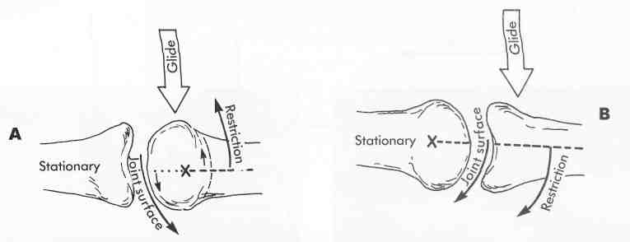

A. Glides of the convex segment should be in the direction opposite to the restriction.
B. Glides of the concave segment should be in the direction of the restriction

2.11. Ask questions to the words in italic.

INDICATIONS FOR MOBILIZATION
1. In Maitland's system, grades I and II are used primarily for treatment of pain, and grades III and IV are for treating stiffness. 2. Pain must be treated first and stiffness second. 3. Painful conditions should be treated on a daily basis. 4. The purpose of the small-amplitude oscillations is to stimulate mechanoreceptors within the joint that can limit the transmission of pain perception at the spinal cord or brain levels. 5. Joints that are stiff or hypomobile and have restricted movement should be treated 3 to 4 per week on alternating days with active motion exercise. 6. The sports therapist must continuously re-evaluate the joint to determine appropriate progression from one oscillation grade to another. 7. Indications for specific mobilization grades are relatively straightforward. 8. If the athlete complains of the pain before the sports therapist can apply any resistance to movement, it is too early, and all mobilization techniques should be avoided.

Kaltenborn'S grades of traction.

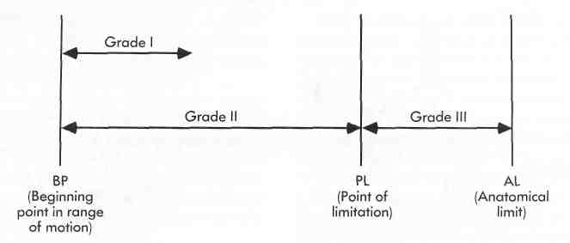
PL, point of limitation; AL, anatomical limit.

2.12. Write a short essay on “Mobilization and Traction Technique in Rehabilitation”.

III. Text II.

MANUAL THERAPY TECHNIQUES IN REHABILITTAION

Manual therapy techniques including mobilization and traction, as well as proprioceptive neuromuscular facilitation techniques, are being used more frequently in rehabilitation by the sports therapist. In recent years, the sports therapist has tended to get caught up in some of the technological advances that have been made available in rehabilitation equipment. These "high tech" devices have to a great extent taken the place of what many consider to be the greatest tool available in the rehabilitation repertoire, that being our hands. It seems however that the pendulum is beginning to swing back in the other direction, and more sports therapists are incorporating manual therapy techniques into their rehabilitation regimens.
After injury to a joint, there will always be some associated loss of motion. That loss of movement may be attributed to a number of pathological factors including contracture of connective tissue (for example, ligaments and joint capsule); resistance of the musculotendinous unit (for example, muscle, tendon, and fascia) to stretch; or some combination of the two.
In a postsurgical case, the limitation is almost always caused by capsular or ligamentous contracture. For example, the postoperative knee will typically demonstrate a position of comfort with the joint held in slight flexion. This position of comfort can very quickly become motion limiting if appropriate intervention measures are not initiated by the sports therapist. Certainly the advent of arthroscopy, the use of constant passive motion immediately after surgery, and functional postoperative bracing have attempted to minimize loss of motion after surgery. Nevertheless, there still seems to be significant difficulty in many patients in regaining normal joint motion.
3.1. Read and translate the text.

3.2. Find in the text English equivalents for the following:

техніка проприоцептивного нервово-м'язового полегшення, часто, мати
тенденцію до, скористатися досягненнями новітніх технологій, доступний, високотехнологічні прилади, значною мірою, репертуар, однак, маятник, відхилятися, включати, режим, супутній, втрата, віднести за рахунок, резистентність, післяопераційний, злегка зігнутий, відповідний/підходящий, втручання, приступати до проведення заходів, проведення артроскопії, ортопедичне фіксування, пацієнт, тим не менш, заново знайти нормальний рух суглоба, витягування, приведення до руху.

3.3. Answer the questions on the text.

- What kinds of techniques does manual therapy include? 2. What do the
sports therapists consider to be the greatest tool available in the rehabilitation repertoire? 3. Is there any tendency for sports therapists to incorporate any rehabilitation equipment? 4. What will always be after injury to a joint? 5. Why does that loss of movement occur? 6. By what is the limitation almost always caused in a postsurgical period? 7. By means of what can you minimize loss of motion after surgery? 8. Is it hard or easy to regain normal joint motion?

3.4. Open the brackets and use the verbs in a proper tense form.

1. Spin (occur) around some stationary longitudinal mechanical axis and (may, be) in either a clockwise or counterclockwise direction. 2. An example of spinning (be) motion of the radial head at the humeroradial joint as (occur) in forearm pronation / supination. 3. Rolling (occur) when a series of points on one articulating surface comes in contact with a series of points on another articulating surface. 4. An analogy (would, be) to picture a rocker of a rocking chair rolling on the flat surface of the floor. 5. An anatomical example (would, be) the rounded femoral condyles rolling over a stationary flat tibial plateau.

3.5. Insert articles if necessary.

1. Gliding occurs when . . . specific point on one articulating surface comes in contact with … series of points on another surface. 2. Returning to … rocking chair analogy, … rocker slides across … flat surface of … floor without any rocking at all. 3. Gliding is sometimes referred to as … translation. 4. Anatomically, gliding or translation would occur during … anterior drawer test at … knee when … flat tibial plateau slides anteriorly relative to … fixed rounded femoral condyles.

Traction vs. glides
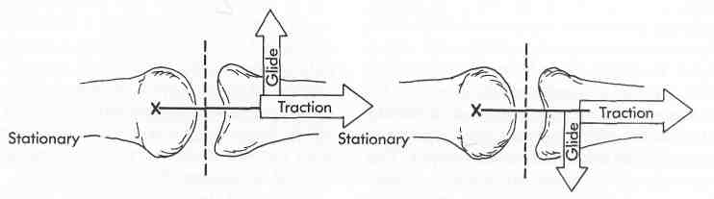
Traction should be perpendicular to the treatment plane, while glides are parallel to the treatment plane

3.6. Ask questions to the words in italic.

1. Pure gliding can occur only if the two articulating surfaces are congruent where either both are flat or both are curved. 2. Since virtually all articulating joint surfaces are incongruent, meaning that one is usually flat while the other is more curved, it is more likely that gliding will occur simultaneously with a rolling motion. 3. Rolling does not occur alone because this would result in compression or perhaps dislocation of the joint. 4. Although rolling and gliding usually occur together, they are not necessarily in similar proportion, nor are they always in the same direction. 5. If the articulating surfaces are more congruent, more gliding will occur, whereas if they are less congruent, more rolling will occur.

3.7. Complete the sentences with words from the box.

joint, in shape, the humeral head, occur, gliding component, the convex joint surface

- Rolling will always … in the same direction as the movement. 2.
For example, in the knee … when the foot is fixed on the ground, the femur will always roll in an anterior direction when moving into knee extension and conversely will roll posteriorly when moving into flexion. 3. The direction of the … … of motion is determined by the shape of the articulating surface-that is moving. 4. If you consider the shape of two articulating surfaces, one joint surface can be determined to be convex … … while the other may be considered to be concave in shape. 5. In the knee, the femoral condyles would be considered … … … …, while the tibial plateau would be the concave joint surface. 6. In the glenohumeral joint, … … … would be the convex surface, while the glenoid fossa would be the concave surface.
Convex-concave rule

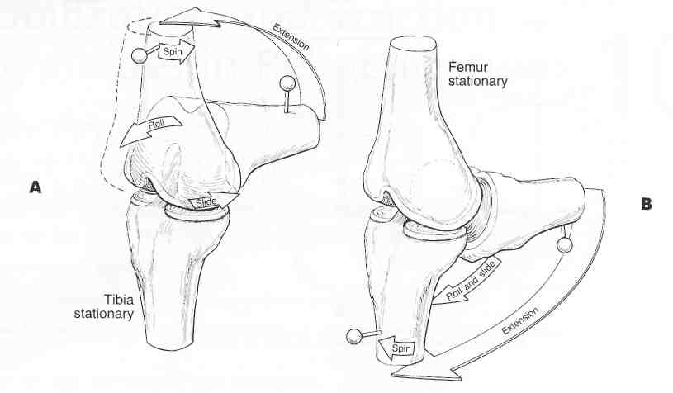

A. Convex moving on concave. B. Concave moving on convex.

3.8. Use a predicate in the following sentence in all Perfect Tenses in positive,
negative and interrogative forms.

Typical mobilization of a joint involve a series of three to six oscillations lasting between 20 and 60 seconds each with one to three oscillations per second.

3.9. Convert the conversation in indirect speech.

CONVEX-CONCAVE RULE

- | What do you mean by the Convex-Concave Rule?
- | This relationship between the shape of articulating joint surfaces and the direction of gliding is defined by the Convex-Concave Rule.
- | Which direction will gliding occur if the concave joint surface is moving on a stationary convex surface?
- | If the concave joint surface is moving on a stationary convex surface, gliding will occur in the same direction as the rolling motion.
- | What occurs if the convex surface is moving on a stationary concave surface?
- | Conversely, if the convex surface is moving on a stationary concave surface, gliding will occur in an opposite direction to rolling.
- | How are hypomobile joints treated?
- | Hypomobile joints are treated by using a gliding technique.
- | How important it to know what type of direction to use for gliding?
- | Thus it is critical to know the appropriate direction to use for gliding.

3.10. Translate the following into English.

Протипоказання ДЛЯ МОБІЛІЗАЦІї

Техніка мобілізації та маніпуляції не повинна використовуватися навмання (haphazardly). Ці техніки за звичай не використовуються у таких випадках: артрит (inflammatory arthritis), злоякісні пухлини (malignancy), кісткове захворювання (bone disease), неврологічне ураження (neurological involvement), кістковий перелом (bone fracture), вроджені кісткові деформації (congenital bone deformities) і судинні порушення хребтової артерії (vascular disorders of the vertebra artery). І, звичайно, такі маніпуляції повинні здійснюватися тільки тими спортивними лікарями, які мають спеціальну підготовку для проведення цих процедур. Для ефективного лікування та правильної оцінки стану пацієнта потрібні спеціальні знання щодо порушення хребтової артерії (vascular disorders of the vertebra artery).

3.11. Write an essay on “Manual Therapy Techniques in Rehabilitation”.

IV. Text II.
PROPRIOCEPTIVE NEUROMUSCULAR FACILITATION TECHNIQUES

The PNF techniques may be used to increase both strength and range of motion and are based on the neurophysiology of the stretch reflex. The motor neurons of the spinal cord always receive a combination of inhibitory and excitatory impulses from the afferent nerves. Whether these motor neurons will be excited or inhibited depends on the ratio of the two types of incoming impulses. The PNF techniques emphasize specific principles that may be superimposed on any of the specific techniques. The PNF strengthening techniques include repeated contraction, slow-reversal, slow-reversal hold, rhythmic stabilization, and rhythmic initiation. The PNF stretching techniques include contract-relax, hold-relax, and slow-reversal-hold-relax. The techniques of PNF are rotational and diagonal movements in the upper extremity, lower extremity, upper trunk, and the head and neck.

4.1. Read and translate the text.
4.2. Find in the text English equivalents for the following:

пропріоцептивної, полегшення (поліпшення проведення або посилення
рефлексу), методика/техніка, рефлекс розтягування, збільшувати, руховий нейрон, спинний мозок, отримувати, поєднання, інгібуючий (гальмуючий), збудливий, імпульс, аферентний (доцентровий), залежатиме від, співвідношення, що надходить, надавати особливого значення/акцентувати, конкретний/особливий, накладатися (одне на одне), зміцнювальний, включати, повторний/частий, повільне реверсування, ритмічна ініціація (стимуляція), повільно реверсувати хват, скорочення-розслаблення, обертальний, діагональний, верхні кінцівки, нижні кінцівки, верхня частина тулуба, шия.

4.3. Answer the questions to the text.

- For what purpose may the PNF techniques be used? 2. On what are the PNF
techniques based? 3. What kind of impulses do the motor neurons of the spinal cord always receive? 4. On what does the ratio of two types of incoming impulses depend? 5. What principles do the PNF techniques emphasize? 6. What components do the PNF strengthening techniques include? 7. What components do the PNF stretching techniques include? 8. What kinds of movements do the techniques of PNF use?

4.4. Complete the sentences with logical endings.

1. The PNF techniques are used to increase ... . 2. They are based on the neurophysiology of ... . 3. The motor neurons of the spinal cord always receive a combination of inhibitory and excitatory impulses from ... . 4. Whether these motor neurons will be excited or inhibited depends on the ratio of ... . 5. The PNF strengthening techniques include ... . 6. The PNF stretching techniques include ... . 7. The techniques of PNF are rotational and diagonal movements in the ... .

Diagrammatical representation of reciprocal inhibition.
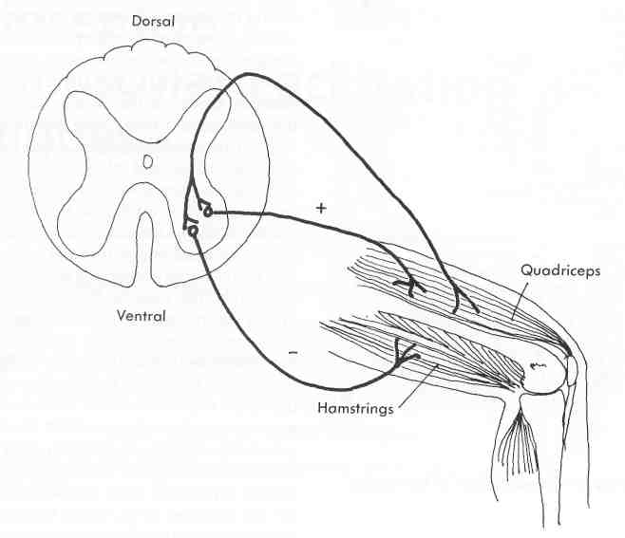

4.5. Fill in the gaps with articles if necessary.

THE NEUROPHYSIOLOGICAL BASIS OF PNF

1. … therapeutic techniques of PNF were first used in … treatment of patients with paralysis and neuromuscular disorders. 2. Most of … principles underlying modern therapeutic exercise techniques can be attributed to … work of Sherrington, who first defined … concepts of facilitation and inhibition. 3. … impulse traveling down … corticospinal tract or … afferent impulse traveling up from peripheral receptors in … muscle causes … impulse volley, which results in … discharge of … limited number of specific motor neurons, as well as … discharge of additional surrounding (anatomically close) motor neurons in … subliminal fringe area.

4.6 Make the sentences negative.

1. An impulse causing the recruitment and discharge of additional motor neurons within the subliminal fringe is said to be facilitory. 2. Conversely, any stimulus that causes motor neurons to drop out of the discharge zone and away from the subliminal fringe is said to be inhibitory. 3. Facilitation results in increased excitability. 4. Inhibition results in decreased excitability of motor neurons. 5. Thus the function of weak muscles would be aided by facilitation, and muscle spasticity would be decreased by inhibition.

4.7. Complete the sentences with words from a box.

spinal, stretch reflex, techniques, of receptors, the frequency, muscle, motor nerve impulses, an inhibitory effect

1. The principles and … of PNF described here are based primarily on the neurophysiological mechanisms involving the … … . 2. The stretch reflex involves two types … … : (1) muscle spindles that are sensitive to a change in length, as well as the rate of change in length of the muscle fiber, and (2) Golgi tendon organs that detect changes in tension . 3. Stretching a given muscle causes an increase in … … of impulses transmitted to the spinal cord from the muscle spindle, which in turn produces an increase in the frequency of … … … returning to that same muscle, thus reflexively resisting the stretch. 4. However, the development of excessive tension within the … activates the Golgi tendon organs, whose sensory impulses are carried back to the … cord. 5. These impulses have … … … on the motor impulses returning to the muscles and thus cause that muscle to relax.

4.8. Write a short essay on “Proprioceptive Neuromuscular Facilitation Technique”.

- ORAL TOPIC
PROPRIOCEPTIVE NEUROMUSCULAR
FACILITATION

Proprioceptive neuromuscular facilitation (PNF) is an approach to therapeutic exercise based on the principles of functional human anatomy and neurophysiology. It uses proprioceptive, cutaneous, and auditory input to produce functional improvement in motor output and can be a vital element in the rehabilitation process of many sports-related injuries. These techniques have been recommended for increasing strength, flexibility, and range of motion. It is important for the sports therapist to use the principles and techniques of PNF as a component of a rehabilitation program.

5.1. Read and translate the text of the oral topic “Proprioceptive Neuromuscular
Facilitation”.

5.2. Answer the questions to text “Proprioceptive Neuromuscular Facilitation”.

1. What kind of approach to therapeutic exercise is proprioceptive neuromuscular facilitation? 2. What does it use to produce functional improvement in motor output? 3. In can not be a vital element in the rehabilitation process of many sports-related injuries, can it? 4. In which cases are these techniques recommended for? 5. Should the sports therapist include principles and techniques of PNF in a rehabilitation program?

5.3. Find English equivalents in the text for the following:

компонент реабілітаційної програми, шкірний, підхід, слуховий, віддача/продукт/засіб, руховий, підвищення, гнучкість, спортивна травма, життєво-важливий, пропріоцертівне нервово-м'язове поліпшення, функціональне поліпшення , лікувальна гімнастика, сила, амплітуда рухів, ґрунтуватися , функціональна анатомія людини.

5.4. Change the italic words for those equivalents from the text.

1. Proprioceptive neuromuscular facilitation (PNF) is an approach to therapeutic exercise grounded on the principles of functional human anatomy and neurophysiology. 2. It applies proprioceptive, cutaneous, and auditory input to create functional improvement in motor output and can be a vital component in the rehabilitation process of many sports-related injuries. 3. These techniques have been recommended for enhancing strength, flexibility, and range of motion. 4. It is essential for the sports therapist to use the principles and techniques of PNF as a component of a rehabilitation program.

5.5. Insert articles if it is necessary.
TECHNIQUES of PNF

1. Each of the principles described above should be applied to the specific techniques of PNF. 2. These techniques may be used in a rehabilitation program either to strengthen or facilitate a particular agonistic muscle group or to stretch or inhibit the antagonistic group. 3. The choice of a specific technique depends on the deficits of a particular patient. 4. Specific techniques or combinations of techniques should be selected on the basis of the patient's problem.

Diagrammatical representation of the stretch reflex
 | Type II afferent nerve fibers from Golgi tendon organs
Golgi tendon organ | 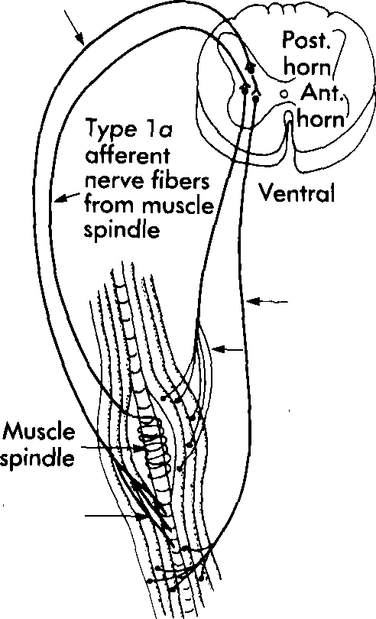 | Gamma efferent fiber  causes reflex  relaxation  Alpha motorneuron  causes reflex  contraction

5.6. Use a verb in an appropriate tense and voice form.

STRENGTHENING TECHNIQUES.

1. The following techniques most appropriately (to use) for the development of muscular strength, endurance, and coordination. 2. Repeated contraction (to be) useful when a patient has weakness either at a specific point or throughout the entire range. 3. It (to use) to correct imbalances that (to occur) within the range by repeating the weakest portion of the total range. 4. The patient (to move) isotonically against maximal resistance repeatedly until fatigue (to evidence) in the weaker components of the motion. 5. When fatigue of the weak components (to become) apparent, a stretch at that point in the range should facilitate the weaker muscles and (to result in) a smoother, more coordinated motion. 6. Again, quick stretch (may, to contraindicate) with some musculoskeletal injuries. 7. The amount of resistance to motion given by the sports therapist (should, to modify) to accommodate the strength of the muscle group. 8. The patient (to command) to push by using the agonist concentrically and eccentrically throughout the range.

5.7. Complete the sentences with words from a box.

antagonistic push, facilitates, slow reversal technique, isotonic , patient

1. Slow reversal involves an … contraction of the antagonist followed immediately by an isotonic contraction of the agonist. 2. The initial contraction of the antagonist muscle group … the succeeding contraction of the agonist muscles. 3. The … … … can be used for developing active range of motion of the agonists and normal reciprocal timing between the antagonists and agonists, which is critical for normal coordinated motion. 4. The … should be commanded to push against maximal resistance by using the antagonist and then to pull by using the agonist. 5. The initial … … facilitates the succeeding agonist contraction.
5.8. Insert prepositions if necessary.

1. Sherrington attributed the impulses transmitted … the peripheral stretch receptors via the afferent system as being the strongest influence … the alpha motor neurons. 2. Therefore the sports therapist should be able to modify the input … the peripheral receptors and thus influence the excitability … the alpha motor neurons. 3. The discharge … motor neurons can be facilitated by peripheral stimulation, which causes afferent impulses to make contact with excitatory neurons and results … increased muscle tone or strength … voluntary contraction. 4. Motor neurons an also be inhibited … peripheral stimulation, which causes afferent impulses to make contact with inhibitory neurons, thus resulting … muscle relaxation and allowing for stretching … the muscle. 5. To indicate any technique … which input from peripheral receptors is used to facilitate or inhibit, PNF should be used.
PNF stretching technique | 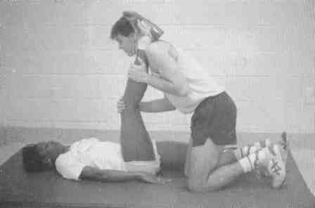

5.9. Ask questions to the words in italic.

1. Two neurophysiologic phenomena help to explain facilitation and inhibition of the neuromuscular systems. 2. The first is known as autogenic inhibition and is defined as inhibition that is mediated by afferent fibres from a stretched muscle acting on the alpha motor neurons supplying that muscle, thus causing it to relax. 3. When a muscle is stretched, motor neurons supplying that muscle receive both excitatory and inhibitory impulses from the receptors. 4. If the stretch is continued for a slightly extended period of time, the inhibitory signals from the Golgi tendon organs eventually override the excitatory impulses and therefore cause relaxation. 5. Inhibitory motor neurons receive impulses from the Golgi tendon organs. 6. The muscle spindle creates an initial reflex excitation leading to contraction. 7. The Golgi tendon organs apparently send inhibitory impulses that last for the duration of increased tension (resulting from either passive stretch or active contraction) and eventually dominate the weaker impulses from the muscle spindle. 8. This inhibition seems to protect the muscle against injury from reflex contractions resulting from excessive stretch.

5.10. Make the following sentences interrogative.

1. A second mechanism known as reciprocal inhibition deals with the relationships of the agonist and antagonist muscles. 2. The muscles that contract to produce joint motion are referred to as agonists, and the resulting movement is called an agonistic pattern. 3. The muscles that stretch to allow the agonist pattern to occur are referred to as antagonists. 4. Movement that occurs directly opposite to the agonist pattern is called the antagonist pattern. 5. When motor neurons of the agonist muscle receive excitatory impulses from afferent nerves, the motor neurons that supply the antagonist muscles are inhibited by afferent impulses. 6. Thus contraction or extended stretch of the agonist muscle must elicit relaxation or inhibit the antagonist. 7. Likewise, a quick stretch of the antagonist muscle facilitates a contraction of the agonist. 8. For facilitating or inhibiting motion, PNF relies heavily on the actions of these agonist and antagonist muscle groups.

5.11. Write a short essay on “Mobilization and Traction Technique in Rehabilitation”.

VI. SELF-ASSESSMENT TEST

These tasks are designed to assist you in determining if you have mastered the
materials and competencies presented here.

1. Discuss the basic techniques of joint rehabilitation.

2. Explain why traction and mobilization techniques should be used
simultaneously.

3. Identify the various PNF strengthening and stretching techniques.

4. Discuss the rationale for use of the techniques.

UNIT III
I. Text I.

ROLE AND BENEFITS

OF USING FUNCTIONAL PROGRESSIONS

In the athletic community, injuries and subsequent disability frequently occur. Disabilities can be described as restrictive influences that "disease and injury exert upon neuromotor performances. Thus, in an effort to reduce the lasting effects of injury, the sports therapist should direct rehabilitation toward improving neuromuscular coordination and agility, not simply to increasing strength and endurance. If rehabilitation is directed toward regaining range of motion, flexibility, strength, endurance, and perhaps primarily to increasing coordination and agility, a full return to activity is possible. However, if the program simply provides a means for the reduction of signs and symptoms associated with the injury, the athlete will not return to a safe and effective level of activity. As a result, rehabilitation of athletic injuries needs to focus on the full preinjury fitness of the athlete.

1.1. Read and translate the text “Role and Benefits of Using Functional Progressions”.

1.2. Answer the questions to the text.

- How often do injuries and subsequent disability occur in the athletic
community? 2. How can disabilities be described as? 3. Where should the sports therapist direct rehabilitation efforts toward? 4. When is a full return to activity possible? 5. What happens if the program simply provides a means for reduction of signs and symptoms associated with the injury? 6. What does rehabilitation of athletic injuries need to focus on?

1.3. Give a short written summary of the text.

II. ORAL TOPIC

FUNCTIONAL PROGRESSION IN REHABILITATION

Complete rehabilitation should strive to improve neuromuscular coordination and agility, as well as to improve strength, endurance, and flexibility. The role of the functional progression is to improve and complete the traditional rehabilitation process by providing sport-specific exercise. The functional progression is a sequence of activities that simulate sports activity. The progression will begin easily, increasing to full sports participation. Each sports activity can be divided into smaller components, allowing the athlete to progress from easy to difficult. Functional progressions are highly effective exercise therapy techniques found with the long-term rehabilitation stage. Functional progressions allow for improvements in strength, endurance, mobility/flexibility, relaxation, coordination/agility/skill, and assessment of functional stability. Functional progression can improve the athlete's psychology/social aspects by decreasing feelings of anxiety, deprivation, and apprehension. Components of a functional progression that should be addressed include development, choice of activity, implementation, and termination.

2.1. Read and translate the text of the oral topic “Functional Progression in Rehabilitation”.

2.2. Give its main idea in a few words in written.

2.3. Find the English equivalents for the following:

прагнути до, спритність, завершувати, легко, імітувати, надання/забезпечення, дозволяти, спортивні спеціальні вправи, витривалість, послідовність, збільшуючи до повного досягнення спортивного рівня, високо ефективна техніка фізичної терапії, тривалий, покращувати, оцінка, зменшувати, відчуття, занепокоєння, втрата/позбавлення, побоювання, впровадження, результат.

2.4. Answer the questions to the text.

- What should complete rehabilitation strive to improve? 2. By means of what does the functional progression facilitate the traditional rehabilitation process? 3. Is the functional progression a process that is developing gradually? 4. What allows the athlete to progress from easy to difficult? 5. Are functional progressions found with the long-term or short-term stage? 6. What do functional progressions allow for improvements in? 7. How can functional progression improve the athlete’s psychology/social aspects? 8. What do components of a functional progression include?

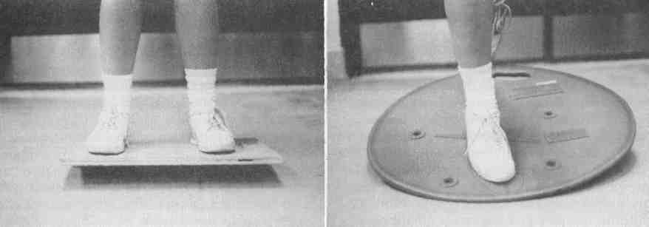
Board exercises. A, Tilt board exercise. B, BAPS board exercise.

2.5 Open the brackets and put the verbs into proper tense form.

1. Functional progressions (provide) physical and psychological benefits to the injured athlete. 2. Strength, endurance, mobility, flexibility, relaxation, coordination, and skill (can, be restored). 3. At the same time the functional stability of the joint (can, be assessed), providing the physical benefits. 4. Psychologically, the progression (can, reduce) the feelings of anxiety, apprehension, and deprivation commonly observed in the injured athlete.

2.6 Insert articles if necessary.

1. Increased strength is … physical benefit of … functional progression. 2. Strength is … ability of … muscle to produce tension or apply force maximally against resistance and occurs statically or dynamically, in relation to … imposed demands. 3. Strength increases are possible if … load imposed on … muscle maximizes that muscle's capabilities to adapt during exercise. 4. This is commonly referred to as … overload principle and is possible because of motor unit recruitment and muscle fiber hypertrophy. 5. To see these improvements, … muscle must be worked to … point of fatigue with either high or low resistance. 6. The functional progression will develop strength using … SAID principle (specific adaptation to imposed demands). 7. … muscles involved will be strengthened dynamically, under similar stresses encountered with competition.

2.7. Translate into English.

М'ЯЗОВА ВИТРИВАЛІСТЬ

М'язову витривалість, так як і кардіореспіративну витривалість, можна підвищити (can be enhanced) за допомогою функціональної прогресії. Витривалість необхідна для тривалої діяльності (for long duration activity), будь-то повсякденна активність (daily living), або повторювані рухові функції, необхідні для заняття спортом. Функціональна прогресія може підвищити м'язову витривалість шляхом повторюваної індивідуальної діяльності (through repetition of individual activities) в поєднанні зі загальною діяльністю (and by combining them into one general activity). Прогресія створює середовище (provides an environment) для вдосконалення м'язової сили і витривалості, не вдаючись до більше ніж однієї програми (without using more than one program). Кардіореспіративна витривалість може бути істотно поліпшена через повторюваність рухів , що застосовується у прогресії (because of the repetition of motion found with the progression), точно так, як підвищуються рівні фітнесу при тривалій фізичній діяльності (in the same way regular fitness levels improve with continuous exercise).

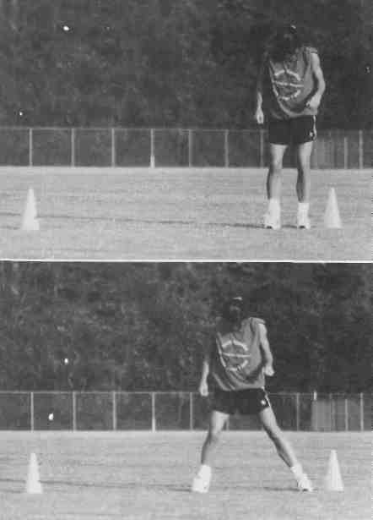  Shuffle slides.  A, Starting position. B ,Finish position  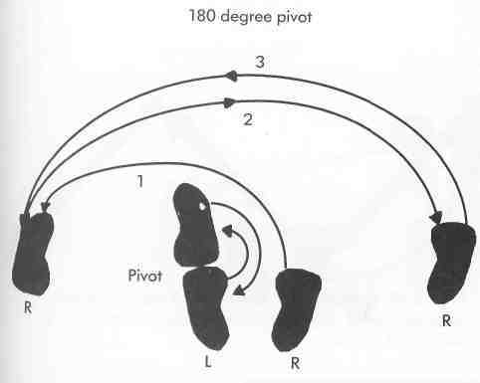  180 degree pivot. The athlete pushes off the right foot, pivoting on the left, thus rotating the body 180 degrees, landing on the right foot. Then pushing off the right foot, the body pivots on the left foot 180 degrees in the other direction, landing on the right foot. | 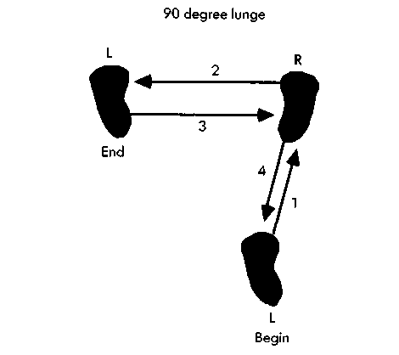  90 degree pivot. The athlete pushes off with the left foot, landing on the right foot directly in front, then steps immediately laterally landing on the left foot, then back laterally in the opposite direction landing on the right foot, then backwards onto the left foot.  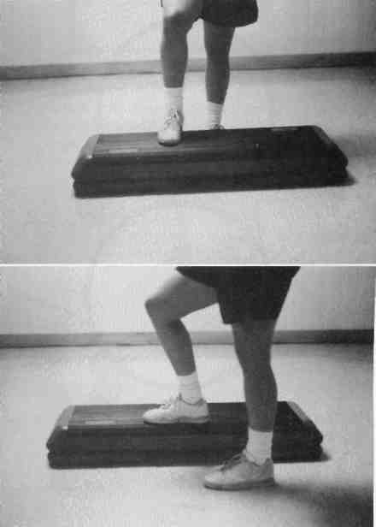  Step-ups. The athlete steps A, forward or B, laterally onto a step.

2.8. Read and translate a text below. Have it for a dictation.

APPREHENSION

Apprehension is often listed as an obstacle to performance and many times
serves as a precursor to reinjury. Functional progressions enable athletes to adapt to the imposed demands of their sports in a controlled environment, helping to restore confidence and thus decreasing apprehension. Each success builds on past success, allowing the athlete to feel in control and able to return to full activity. The table below provides a listing of all the benefits found with functional progressions. These benefits combine to allow the safe and effective return to play that all athletes and sports therapists desire.

2.9. Prepare in writing a short summary of the text “Functional Progression in Rehabilitation” with help of a Table below.
Table

Physical and psychological benefits of using functional progressions.

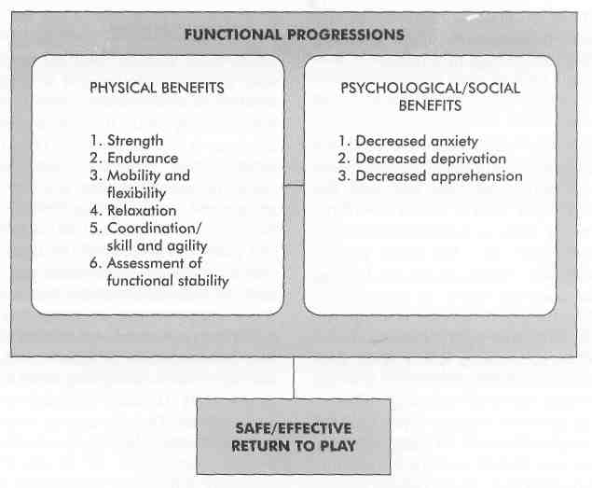I

III. Text II
FUNCTIONAL PROGRESSION
AS A COMPONENT OF PHYSICAL THERAPY

1. Sports therapists must adapt rehabilitation to the sport-specific demands required by each sport and playing position. Rehabilitation conducted in a clinical setting cannot predict the effectiveness of the injured part to endure the imposed demands of full competition. For example, a solid, high-velocity tackle cannot be simulated in the clinical setting. The role of the functional progression is to improve and complete the clinical rehabilitation. A functional progression is a succession of activities that simulate actual motor and sport skills, enabling the athlete to acquire or reacquire the skills needed to perform athletic endeavours safely and effectively.
2. The sports therapist takes the activities involved in a given sport and breaks them down into individual components. In this way the athlete concentrates on individual parts of the game or activity in a controlled environment before combining them together in an uncontrolled environment such as full competition. The functional progression places stresses and forces on each body system in a well-planned, positive, and progressive fashion, ultimately improving the athlete's overall ability to meet the demands placed upon him or her in daily activities, as well as in sports competition.
3. The functional progression is indicated since tissues not placed under performance-level stresses do not adapt to the sudden return of such stresses with the resumption of full activity. Thus the functional progression is integrated into the normal rehabilitation scheme as one component of exercise therapy rather than replacing traditional rehabilitation altogether.
4. Generally, rehabilitation of sports-related injuries has two goals: minimizing additional trauma to injured structures and safely and quickly returning injured athletes to prior levels of competition. The second rehabilitation goal is divided into three main stages: immediate, short-term, and long-term goals. The immediate goal stage begins at the time of injury and involves the treatment or management of the injury. This includes protection from further injury, restricted activity, and controls to minimize pain and swelling.
5. The short-term goal stage deals with the healing process, enabling the symptoms and level of dysfunction to subside. Also during this stage, uninvolved body parts can be exercised to maintain normal function and fitness levels. The long-term goal stage overlaps the short-term goal stage and progresses to a point of full return to activity. Once the athlete meets criteria to return to controlled activity, exercise therapy is begun. The functional progression serves as a component of exercise therapy to help the athlete meet the preset criteria for return to play.

3.1. Read and translate a text “Functional Progression as a Component of
Physical Therapy”.

3.2. Name the paragraphs of the text.

3.3. Do a written translation of Paragraphs 1 and 5.

3.4. Define the grammar tense of the predicate in Paragraph 2.
3.5. Which of the forms of Grammar Voice is used for the predicate in Paragraph 3.

3.6. Make the sentences in Paragraph 4 negative.’

S Curve. The athlete runs a set distance in a curving S pattern rather than straight ahead. | 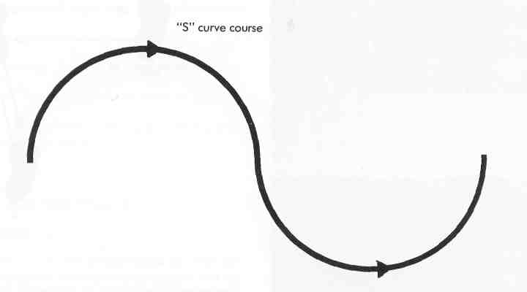
FLEXIBILITY

3.7. Complete the sentences with words from a box.

tissues, a full range, crucial, proper length, tighten, functional progression

1. With injury, tissues will shorten or tighten in response to immobilization, which can inhibit proper function. 2. With a … … , the injured area is stressed within a controlled range. 3. This stress is sinificant enough to allow the tissue to elongate, thus returning to … …. 4. This improved mobility and flexibility is … to the athlete. 5. Strength and endurance do not mean much if the injured body part cannot move through … … … of motion. 6. Tissues also become stronger with consistent stresses, so … other than muscle can be improved with the functional progression.

3.8. Read and translate a text below. Have it for a dictation.

MUSCLE RELAXATION

Relaxation involves the concerted effort to reduce muscle tension. The functional progression can teach an individual to recognize this tension and eventually how to control or remove it by consciously relaxing the muscles after exercise. This functional progression aids in total body relaxation and relaxing the injured area and may help relieve muscle guarding that inhibits the joint’s full range of motion.

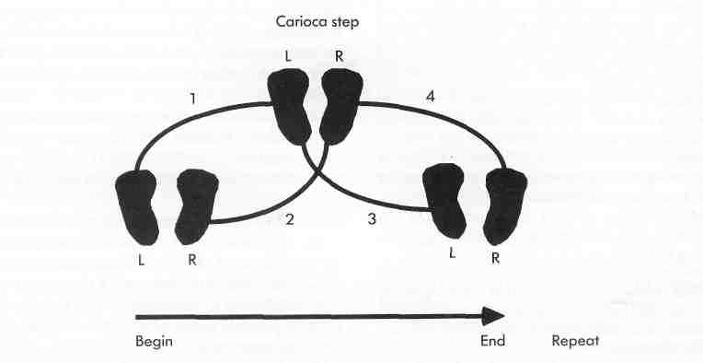
Carioca.
The athlete side steps onto the right foot, then steps across with the left foot in front of the right, then steps back onto the right foot, then the left foot steps across in back of the right, then back onto the right and so on.

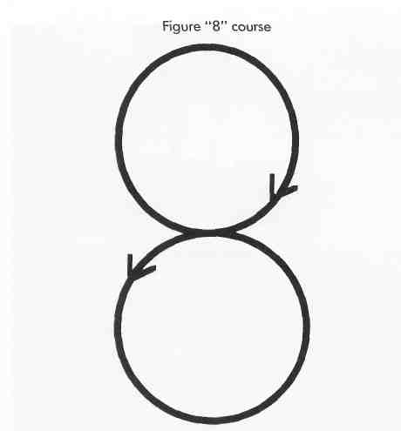  The athlete walks, jogs, or runs a figure 8 pattern around cones or markers | 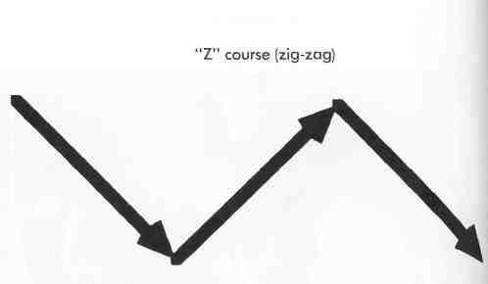  Z course. The athlete runs a zig-zag course to emphasize sharp cutting motions and quick controlled directional changes

Acceleration/deceleration course
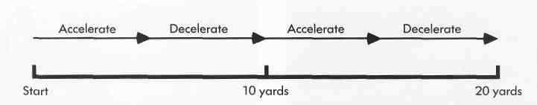

Acceleration/deceleration.
The athlete accelerates to a maximum then decelerates almost to a stop, then repeats this within a relatively short distance.
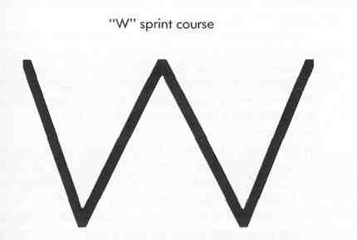 | 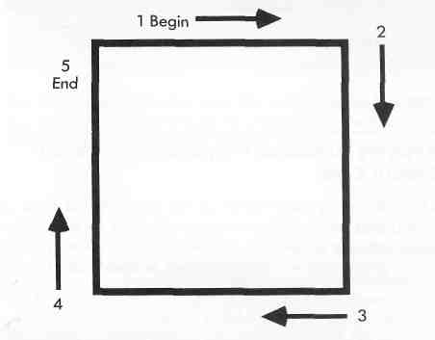
W sprints.  The athlete sprints forward to the first marker, then back pedals to the second, then forward to the third and so on. | Box runs.  Running both clockwise and counterclockwise, the athlete runs around four markers set in a box shape concentrating on abrupt directional changes at each corner.

3.9 Render the conversation below in indirect speech.

PROGRAM EVALUATION

- | How should the progression be evaluated?
- | The progression should also be evaluated at regular intervals.
- | What is the aim of such evaluation?
- | The evaluation will allow the sports therapist to curtail any activity that results in immediate instability, pain, swelling, or patient anxiety in favor of less aggressive activities.
- | How else can the sports therapist use this evaluation?
- | The sports therapist can also use this evaluation to gauge the individual’s progress.
- | When does completion of a certain skill in the progression occur?
- | Completion of a certain skill in the progression occurs when the skill can be completed at functional speed with high repetitions with no associated increase in pain, swelling, or decreased range of motion.
- | What about setbacks?
- | The sports therapist and athlete should realize that setbacks will occur and are common. Sometimes it takes two steps forward and one step back to achieve the needed level of improvement.
- | I see.

3.10. Write an essay on “Functional Progression as a Component of Physical Therapy” with a help of following Table.

TABLE

Combining components of physical fitness with components of athletic fitness in functional progression

Athletic fitness:
Functional progression
 |  | Speed  Power  Agility  Balance  Quickness  Coordination |  | → | Complete fitness
 | Flexibility  Body composition  Muscular strength  Muscular endurance  Cardiorespiratory endurance |  |  |  |  | Physical fitness:  Traditional rehabilitation and training/conditioning

IV. Text III

MOTOR SKILLS

Coordination, agility, and motor skills are complex aspects of normal function requiring appropriate contraction at the most opportune time and with the appropriate intensity. An athlete needs coordination, agility, and motor skills to transform strength, flexibility, and endurance into full-speed performance. This is especially important for an injured athlete. If he or she does not regain or improve coordination and agility, their performance is hampered and may in itself lead to further injury. Repetition and practice are important to learning motor skills. Regular motions that are consciously controlled develop into automatic reactions via motor learning. This control is possible because of the constant repetition and reinforcements of a particular skill. To acquire these automatic reactions, one needs an intact and functional neuromuscular system. This system is disturbed with injury; therefore decreases in performance will occur, leading to injury susceptibility. The functional progression can be used to minimize the loss of normal neuromuscular control by providing exercises that stress proprioception, motor-skill integration, and proper timing. The functional progression is indicated for this improvement in agility and skill because of the constant repetition of sport-specific motor skills, use of sensory cues, and progressive increases in activity level. These are all components or general principles for enhancing coordination. The practice variability seen with the functional progression allows athletes to relearn the various aspects of their sport that they may encounter in competition.
Traditional exercise programs cannot retrain the athlete to meet the demands of the sport because they lack the coordination and agility portion of the rehabilitation process. Increases in strength, endurance, and flexibility are definitely needed for safe and effective return to play, but without the neuromuscular coordination to integrate these aspects into proper function, little performance enhancement can occur. For this reason, functional progressions should become an integral part of the long-term rehabilitation stage so that each athlete receives every opportunity to get back in the game with preinjury status restored as much as possible.
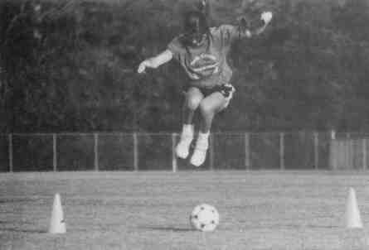 | 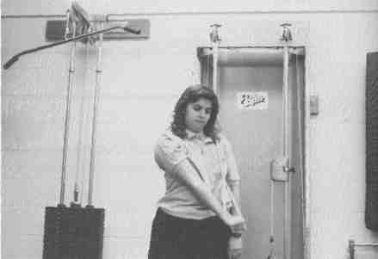
Timed exercise.  The athlete jumps side to side over a ball or other obstacle in a timed exercise | Functional strengthening of upper extremity.  Surgical tubing, THERABAND, or wall pulleys may be used in a D2 pattern for this activity

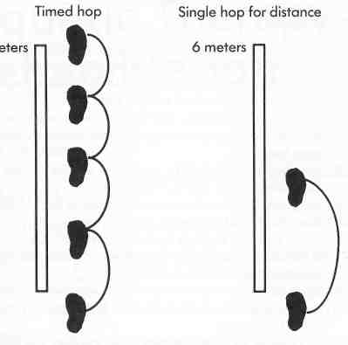 | 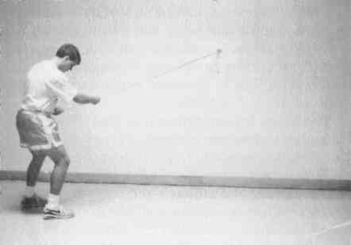
Hop tests.  A, In the timed hop test, time required to cover a б-meter distance is measured in seconds. B, The single hop for distance test measures the distance covered in a single hop. Both tests use a percentage of the injured leg compared to the uninjured leg | Cocontraction test.  The athlete moves in a sidestep or shuffle fashion around the periphery of a semicircle with resistance applied using surgical tubing

4.1. Read and translate a supplementary text “Motor Skills”.

4.2. Write a short essay on it.

V. SELF-ASSESSMENT TEST

These tasks are designed to assist you in determining if you have mastered the
materials and competencies presented here.

- Define a functional progression.
- Identify and describe the physical benefits associated with functional progression in the rehabilitation process.
- Identify and describe the psychological benefits associated with functional progression in the rehabilitation process.
- Describe the components of a functional progression.
5. What provides awareness of the body and its relationship with the surrounding environment?
6. What could be the reason to confusion and a lack of appreciation for joint sensation mechanisms during rehabilitation?
7. How do mobilization and traction techniques increase joint mobility or decrease pain?
8. Do all joints have a certain amount of joint play or looseness?

SECTION III

PHARMACOLOGICAL CONSIDAERATIONS IN REHABILITATION PROGRA

PHARMACY IN REHABILITATION

I. Study, read, translate, and remember the key words and phrases on the unit:

a) medication, performance, prevention, evaluation, pharmacology, media, abuse,
use, impact, purpose, list, substance, legality, ethics, pattern, society, pain, relief, acid, derivative, reason, clotting, inhibition, bleeding, swelling, effect, prescription, caution, irritation, dosage, dose, capability, fever, reduction, advantage, nausea, tinnitus, headache, drowsiness, vomiting, decongestant, congestion, suppression, sneezing, cough, dizziness, expectorant, sedation, constipation, alkalinity, antacid, diarrhea, onset, duration, protocol, guideline, disposition, uncertainty, consideration, inflammation, dehydration, cathartics, disorder, edema, response, anaphylaxis, hypersensitivity, enzyme, irritation, benefit, fluid, ailment, sputum;

b) to respond, to concern, to receive, to disseminate, to regard, to identify, to
establish, to ban, to include, to debate, to reflect, to belong, to select, to decrease, to impair, to create, to increase, to affect, to administer, to require, to
indicate, to substitute, to cause, to exceed, to apply, to produce, to depress, to deal, to prescribe, to vie, to clarify, to encounter, to assess, to slow, to treat, to suppress, to prevent, to empty, to subside, to detect, to avoid, to yield;

c) prescribed, average, supervising, essential, responsible, acute, possible, involved, cognizant, widespread, related, profound, familiar, indiscriminate, (un)fortunate, misused, minor, analgesic, antiinflammatory, antipyretic, cautious, irreversible, prolonged, direct, undesirable, gastric, significant, mild, somatic, similar, gastrointestinal, primary, topically, rebound, preferred, antitussive, moderate, antidiarrheals, transient, questionable, aware, accurate, simultaneously, hectic, subjunctive, banned, digestive, excessive;

d) however, regarding, as well as, regarding, although, in general, even, because
of, thus, both … and, like, through, likewise, except for, as commonly, either,
while, nevertheless, therefore, until, from time to time;

e) be of great value; under average circumstances; acid indigestions; heart burn, to give special consideration; potential effects; most commonly used; on occasion; to make decisions; side effects; over-the-counter and prescription medications; a sports-medicine environment; performance-enhancing drugs; drug testing; pain-relieving drugs; during recent years; at all levels; be based on hearsay and innuendo; WADA; to become commonplace; NSAIDs (non-steroidal antiinflammatory agents), aggregation of platelets; a bleeding risk; motion sickness; dryness of nasal mucosa; dry mouth; a chilled sensation; unproductive cough; sore throat; upset stomach; gas belching; abdominal discomfort; to maintain records; a medication administration log; initial screening; to keep the throat moist; lack of coordination, shortness of breath; post nasal drip.

II. Text I.

THE USE OF MEDICATIONS

The use of medications prescribed for various medical conditions by qualified physicians may be of great value to the athlete as with any other individual in the population. Under average circumstances an athlete would be expected to respond to medication just as anyone else would. However, because of the nature of physical activity, the athlete's situation is not average; with intense physical activity, special consideration should be given to the effects of certain types of medication.
For the sports therapist supervising a program of rehabilitation, some knowledge of the potential effects of certain types of drugs on performance during the rehabilitation program is essential. The sports therapist working under the direction of a team physician is responsible for keeping the athlete healthy and ready to train and compete under physically, mentally, and emotionally demanding circumstances. The sports therapist should be concerned not only with rehabilitation but also with prevention, acute management, and evaluation of sports-related injuries. On occasion, the sports therapist must make decisions regarding the appropriate use of medications based on knowledge of the indications for use and the possible side effects in athletes who are involved in rehabilitation programs.
The sports therapist must be cognizant of the potential effects and side effects of over-the-counter and prescription medications on the athlete during rehabilitation, as well as during competition.

2.1 Read and translate the text “The Use of Medications”.

2.2. Match the words from both columns.

E.g.: 1 - M
1 | medication |  | A | істотний, важливий
2 | under average circumstance |  | B | нести відповідальність за підтримку здоров'я спортсмена
3 | special consideration should be given |  | C | патентовані ліки
4 | potential effect |  | D | обізнане
5 | side effects |  | E | свідчення
6 | indications |  | F | результативність
7 | must make decisions |  | G | піклуватися, турбуватися
8 | most commonly used |  | H | можливий наслідок
9 | over-the-counter medications |  | I | відповідний
10 | prescription medications |  | J | особлива увага повинна бути приділена
11 | cognizant |  | K | повинні приймати рішення
12 | appropriate |  | L | найбільш широко вживані
13 | concentrates on the special considerations |  | M | ліки, препарат, медикаментозні засіби
14 | is responsible for keeping the athlete healthy |  | N | за нормальних (звичайних) умов
15 | performance |  | O | ліки, прописані за рецептом
16 | should be concerned |  | P | зосереджуватися на особливих умовах
17 | essential |  | Q | побічні ефекти.

2.3. Answer the questions to the text.

1. Do athletes need to take any medications? 2. How is an athlete expected to respond to medication? 3. Why should special consideration be given to the effects of certain types of medication? 4. What is essential for the sports therapist supervising a program of rehabilitation? 5. Who is responsible for keeping the athlete healthy and ready to train and compete under physically, mentally, and emotionally demanding circumstances? 6. Should the sports therapist take care of rehabilitation or of prevention or acute management or evaluation of sports-related injuries? 7. On base of what must the sports therapist make decisions regarding the appropriate use of medications? 8. Must the sports therapist be aware of the potential effects and side effects of over-the-counter and prescription medications on the athlete during rehabilitation, as well as during competition?

2.4. Retell the text “The Use of Medications”.

III. Text II
DRUG TESTING

Perhaps no other topic related to pharmacology has received more attention from the media during recent years than the use and abuse of drugs by athletes. Much has been written and discussed regarding the use of performance-enhancing drugs among Olympic athletes, the widespread use of "street drugs" by professional athletes, and the use of pain-relieving drugs by athletes at all levels.
Although much of the information being disseminated to the public by the media may be based on hearsay and innuendo, the use and abuse of many different types of drugs can have a profound impact on athletic performance.
To say many experts in the field of sports medicine regard drug abuse among athletes with growing concern is a gross understatement. Drug testing of athletes at all levels for the purpose of identifying individuals who may have some problems with drug abuse is becoming commonplace. Both the WADA and the International Olympic Committee have established lists of substances that are banned from use by athletes. The lists include performance-enhancing drugs and "street" or "recreational" drugs, as well as many over-the-counter and prescription drugs. The legality and ethics of testing only those individuals involved with sports are still open to debate. The pattern of drug usage among athletes may simply reflect that of our society in general.
The sports therapist who is working with an athlete who may be tested for drugs at the national level or with world-class or Olympic athletes should be very familiar with the list of banned drugs. Having an athlete disqualified because of the indiscriminate use of some over-the-counter drug during a rehabilitation program would be most unfortunate.

  - Read and translate the text “Drug Testing”.

  - Answer the questions to the text.

- Has the topic of the use and abuse of drugs by athletes received much attention during recent years? 2. About which facts has the media written and discussed lately? 3. Is all of that information quite true? 4. What kind of impact on athletic performance can the use and abuse of different types of drugs produce? 5. Experts in the field of sports medicine regard drug abuse among athletes with growing concern, don’t they? 6. Is drug testing of athletes at all levels becoming commonplace? 7. Who establishes lists of substances that are banned from use by athletes? 8. What kinds of substances do such lists include? 9. What is still open to debate? 10. May the pattern of drug usage among athletes reflect that of our society in general? 11. Why should the sports therapist be very familiar with a list of banned drugs?

  - Find English equivalents in the text for the following:

допінг-контроль, жодна інша тема, що належить до фармакології, отримувати, засоби масової інформації, зловживати, за останні роки, відносно, препарати, що підвищують результативність, широко поширене використання, знеболюючі, на всіх рівнях, більша частина інформації, що стає надбанням публіки, може грунтуватися на, непрямий натяк/інсинуація, слух/чутка, значний вплив на спортивну результативність, багато фахівців у галузі спортивної медицини, розглядати/вважати, занепокоєність, що зростає, замовчування, з метою визначення осіб, стає загальноприйнятою практикою, Всесвітнє антидопінгове агентство, встановлений перелік речовин, заборонених, патентовані і приписані рецептом ліки, легітимність, етика, займаються спортом, все ще відкритий для дискусій, приклад використання спортсменами допінгу, просто, відображати, суспільство, в цілому, бути знайомим/добре знати, нерозбірливий, невдалий/нещасний.

3.4. Complete the sentences.

Aspirin, pain relief, continuously, the most misused drug, rapid, even minor injury, non-narcotic analgesics, belong, world

1. Perhaps medications are most commonly used in a sports-medicine environment for … … . 2. The athlete is … in situations where injuries are very likely. 3. Fortunately, most of the injuries that occur are not serious and lend themselves to … rehabilitation. 4. However, pain is associated with … … …. 5. The three … … most often used are aspirin (salicylate), acetaminophen, and ibuprofen. 6. These … to the group of drugs called non-steroidal antiinflammatory agents (NSAIDs). 7. Aspirin is one of the most commonly used drugs in the … . 8. Because of its easy availability, it is also likely … … … . 9. … is a derivative of salicylic acid and is used for its analgesic, anti-inflammatory, and antipyretic capabilities.

3.5. Insert prepositions if necessary.

1. An athlete should be very cautious about selecting aspirin as a pain reliever for a number of reasons. 2. Aspirin decreases aggregation of platelets and thus impairs the clotting mechanism should injury occur. 3. Aspirin's irreversible inhibition of cyclo-oxygenase that leads to reduced production of clotting factors creates a bleeding risk not present with the other NSAIDs. 4. Prolonged bleeding at an injured site will increase the amount of swelling, which has a direct effect on the time required for rehabilitation. 5. Use of aspirin as an antiinflammatory should be recommended with caution. 6. Other anti-inflammatory medications do not produce many of the undesirable side effects of aspirin. 7. Generally, prescription anti-inflammatory are considered to be equally effective.

3.6. Fill in the gaps with articles if necessary.

1. Ibuprofen is classified as a NSAID; however, it also has analgesic and antipyretic effects. 2. Ibuprofen, like aspirin, has a number of side effects, including the potential for gastric irritation. 3. It is not as likely to affect platelet aggregation as is aspirin. 4. Ibuprofen administered at a dose of 200 mg does not require a prescription and at that dosage may be used for analgesia. 5. At a dose of 400 mg, the effects are both analgesic and antiinflammatory. 6. Dosage forms greater than 200 mg require a prescription. 7. Acetaminophen, like aspirin, has both analgesic and antipyretic effects, but it does not have significant antiinflammatory capabilities. 8. Acetaminophen is indicated for relief of mild somatic pain and fever reduction through mechanisms similar to those of aspirin. 9. The primary advantage of acetaminophen for the athlete is that it does not produce gastritis, irritation, or gastrointestinal bleeding. 10. Likewise, it does not affect platelet aggregation and thus does not increase clotting time after an injury.

3.7. Study the following table and discuss it in class.
Table

SPORTS THERAPISTS’ GUIDE TO COMMONLY USED MEDICATIONS
Generic Name |  | Trade Name | Primary use of Drug |  |  | Sports Medicine Considerations
ANALGETICS, ANTIPYRETICS, AND ANTIIFLAMMATORIES
Aspirin | Many trade names |  |  | Analgesic, antipyretic,  antiinflammatory |  |  | Gastric irritation, nausea, tinnitus, prolonged bleeding if injured in contact sports
Acetaminophen | Tylenol ®, Datril ®, others |  |  | Analgesic, antipyretic |  |  | None
(Nonsteroidal Antiinflammatories)

Flurbiprofen  Ketoprofen  Indomethacin  Ibuprofen  Naproxen  Diflunisal  Piroxicam  Tolmectin  Fenoprofen  Meclofenamate  Diclofenac  Ketrolac | Ansaid ®  Orudis ®  Indocin ®  Advil ®, Motrin ®,  Nuprin ®  Naprosyn ®, Anaprox ®  Dolobid ®  Feldene ®  Tolectin ®  Nalfon ®  Meclomen ®  Voltaren ®  Toradol ® |  |  |  | All are analgesic, antipyretic,  antiinflammatory |  | Gastric irritation less common than with aspirin except for indomethacin. These should be used on a long-term basis for reducing inflammation; should not be substituted for acetamino-phen in cases of mild head-ache or low fever.

DRUGS THAT AFFECT THE RESPIRATORY TRACT
Chlorpheniramine | Chlor-Trimeton ® |  |  | Antihistamine for allergies |  |  | Used primarily for treatment of allergic reaction. Causes drowsiness, decreased coor-dination.
Dimenhydrinate | Dramamine ® |  |  | Antihistamine used for treatment of motion sick-ness, nausea, vomiting |  |  | Should be administered before travel begins, produces drowsiness.
Oxymetazoline | Afrin ®, Dristan Long Lasting ®, Neosyneph-rine 12 Hour ®, Nos-trilla ®, Sinex Long Lasting ®, Allerest ® |  |  | Adrenergic decongestant applied topically as spray |  |  | Do not exceed recommend-ed dosage because of re-bound congestion; may cause sneezing, dryness of nasal mucosa, and headache
Pseudoephedrine | Sudafed ®, Cenafed ®,  Oranyl ®, others |  |  | Adrenergic decongestant used orally |  |  | Produces stimulation of the central nervous system; topically applied decongest-tants work faster, but oral decongestants are preferred for long-term use
Diphenhydramine | Benlin cough syrup ®, Benadryl ® |  |  | Antihistamine used primarily for allergic reaction; also used for motion sick-ness and preventing nausea and vomiting |  |  | Produces drowsiness and dry mouth; found in over-the-counter sleeping medi-cation
Dextromethorphan | Benylin DM ®, Romi-lar CF®, Coughettes ®, Sucrets Lozenge ®, Ro-bitussin DM ® |  |  | Nonnarcotic antitussive used for suppression of cough |  |  | Very effective in case of unproductive cough; doesn’t produce drowsiness and other side effects as com-monly
Tertenadine | Seldane ® |  |  | Antihistamine |  |  | Nonsedating
Benzonatate | Tessalon ® |  |  | Peripherally acting antitussive that acts as an anesthetic |  |  | May produce dizziness and a chilled sensation
Codeine | Robitussin AC ® |  |  | Narcotic antitussive that depresses the central cough mechanism |  |  | Used in combination with decongestant, an antihista-mine, or expectorant; can produce sedation, dizziness, constipation, nausea
Guaifenesin | Robitussin AC ® |  |  | Expectorant used for sym-ptomatic relief of unpro-ductive cough |  |  | Used for treating a dry or sore throat; may cause drowsiness and nausea

DRUGS THAT AFFECT THE GASTROINTESTINAL TRACT
Sodium bicarbon-ate | Soda Mint ®,  Bell/ans ® |  |  | Antacid used for quick relief of upset stomach |  |  | Produces gas belching and tension; may cause systemic alkalinity
Aluminum Hydro-xide | Amphogel ®,  Dialume ® |  |  | Antacid used for upset stomach |  |  | May produce constipation; moderate acid neutralizer
Calcium carbonate  Dihydroxyaluminum sodium carbonate | Mallamint ®, Amitone ®, Chooz ®, Titralac  Rolaids ® |  |  | Antacid used for upset stomach  Antacid used for upset stomach |  |  | May produce constipation and acid rebound; high acid neutralizing capability  May cause constipation, rapid neutralizing capabili-ties but transient
Magnesium hydro-xide, carbonate oxi-de | Milk of Magnesia ® |  |  | Antacid used for upset stomach |  |  | May cause diarrhea and lasting neutralization of acid without rebound
Cimetidine | Tagamet ® |  |  | Used for relief of upset stomach |  |  | May produce drowsiness and either constipation or diarrhea
Common combina-tion antacids | Alka-Seltzer ®, Di-Gel ®, Gaviscon®, Gelu-sil®, Maalox®, Myla-nta®, Tempo®, Titra-lac ®, Wingel®, others |  |  | Over-the-counter combi-nation drugs used for controlling gastric upset |  |  | May produce either diarrhea or constipation
Promethazine | Phenergan ® |  |  | Antiemetic used for preventing motion sick-ness, nausea, and vomiting |  |  | Causes sedation and drowsi-ness
Diphenoxylate HCI | Lomotil ®, Uni-Lim® |  |  | Narcotic antidiarrheal |  |  | Causes dry mouth, nausea, drowsiness
Loperamide | Imodium A-D ® |  |  | Systemic antidiarrheal |  |  | Abdominal discomfort and drowsiness
Common over-the-counter antidiarr-heals | Donnagel ®, Kaopec-tate ®, Pepto-Bismol® |  |  | Relief of diarrhea |  |  | All are relatively safe with few side effects, although their effectiveness is ques-tionable

3.8. Read, translate a text below. Ask questions to the underlined words.
RECORD KEEPING

Those involved in any health-care profession are acutely aware of the necessity of maintaining complete up-to-date medical records. Again the sports-medicine setting is no exception. If medications are administered by a sports therapist, maintaining accurate records of the types of medications administered is just as important as recording progress notes, treatments given, and rehabilitation plans. The sports therapist may be dealing with a number of different patients simultaneously while trying to get a team ready for practice or competition. At times things become hectic, and stopping to record each time a medication is administered is difficult. Nevertheless, the sports therapist should include the following information on a type of medication administration log.

  - Use the conversation below in indirect speech.
PROTOCOLS FOR USE OF DRUGS BY SPORTS THERAPISTS

- | Who is responsible for screening of athlete’s injuries?
- | The sports therapist is often responsible for initial screening of athletes who present various illnesses/injuries.
- | Do sports therapists prescribe any medications to injured athletes?
- | Frequently, the sports therapists must make decisions regarding the appropriate use of over-the-counter medications for their athletes.
- | I see, that is why subjunctive findings such as onset, duration, medication taken, and known allergies must be included in the screening evaluation.
- | You have said it. The following protocols should be vied as guidelines to the disposition of the athlete.
- | What are the protocols aimed at?
- | The protocols are aimed at clarifying the use of over-the-counter drugs in the treatment of common problems encountered by the sports therapist while covering or travelling with a particular team.
- | Do these guidelines concern all the athlete’s physical problems?
- | These guidelines do not cover every situation the sports therapist encounters in assessing and managing the athlete’s physical problem.
- | Is there any need in consultation with a physician here?
- | Therefore physician consultation is recommended whenever there is uncertainty in making a decision regarding the appropriate care of the athlete.

  - Translate the following into English.
ЦІЛЯМИ ВСЕСВІТНЬОЇ АНТИДОПІНГОВОЇ ПРОГРАМИ ТА КОДЕКСУ Є:

• Захищати фундаментальне право спортсменів брати участь у змаганнях, вільних від допінгу і, таким чином, захищати здоров'я, забезпечувати чесний підхід і рівні умови для спортсменів усього світу і
• Проводити в життя гармонійні, узгоджені та ефективні антидопінгові програми на міжнародному та національному рівнях з метою виявлення, викорінення і профілактики вживання допінгу.
Всесвітня антидопінгова програма вміщує всі елементи, необхідні для забезпечення максимальної узгодженості та передової практики в міжнародних і національних антидопінгових програмах. Основними складовими програми є:
Рівень 1 : Кодекс; Рівень 2 : Міжнародні стандарти; Рівень 3: Кращі зразки практичної реалізації.
Кодекс - це основоположний і універсальний документ, на якому базується Всесвітня антидопінгова програма у спорті. Метою кодексу є розвиток антидопінгових програм за допомогою приведення у відповідність основних антидопінгових документів. Він складений таким чином, щоб бути достатньо специфічним у питаннях, що потребують єдиних стандартів, і, разом з тим, досить загальним в інших областях, що дозволить досить гнучко вводити в дію узгоджені антидопінгові принципи.

3.12. Write a short essay on “Drug Testing”.

IV. ORAL TOPIC XV
PHARMACOLOGICAL CONSIDERATIONS IN A REHABILITATION PROGRAM

An athlete who requires an analgesic for pain relief should be given acetaminophen because aspirin may produce gastric upset and slow clotting time. For treating inflammation, NSAIDs (nonsteroidal antiflammatory agents) are recommended because they do not produce many of the side effects associated with aspirin use. Antihistamines are used primarily in the treatment of allergic reactions and may produce drowsiness and sedation. Decongestants are used to reduce nasal congestion and may be used orally or topically. Antitussives and expectorants are used to suppress coughing and keep the throat moist. They generally produce drowsiness, gastric irritability, and some lack of coordination. Antacids neutralize acidity in the upper GI tract and may produce diarrhea or constipation. Antiemetics are used to treat nausea and vomiting and should be used with large quantities of fluid to prevent dehydration. Antidiarrheals act to reduce peristaltic action in the lower GI tract and may produce drowsiness, nausea, dry mouth, and constipation. Cathartics are used to empty the GI tract and reduce constipation. Antibiotics are used to treat various infections and may produce hypersensitivity reactions in the athlete. Generally an athlete who is using an antibiotic should avoid training and competition until the infection subsides. The use of medication in a sports-medicine setting should be subject to strict preestablished guidelines and protocols and monitored closely by the sports therapist supervising a rehabilitation program. The sports therapist should maintain a log that documents all medications being administered during a rehabilitation program. The sports therapist must be aware of medications commonly used in treatment of various disorders that may be detected in a drug test as banned substances.

  - Read and translate the text of the oral topic “Pharmacological Considerations in a Rehabilitation Program”.

  - Find English equivalents for the following:

антидопінговий контроль, виявити, різні порушення, заборонені речовини, усвідомлювати, призначені/прийняті ліки, документувати, вести журнал обліку, спортивний лікар, який здійснює реабілітаційну програму, застосування лікарських препаратів в контексті спортивної медицини, дотримуватися суворо встановлених приписів і протоколу, до тих пір доки не, уникати, пронос, нейтралізувати кислотність, спадати/вщухати, інфекція, підвищена чутливість/алергія, шлунково-кишковий тракт, зменшити/скоротити, запор, сухість у роті, нудота, сонливість, нижній, катартичний/викликає активну перистальтику кишечника, спорожнити, діяти, перистальтичний, деяке порушення координації, загалом, придушувати кашель, зволожувати горло, протикашльову, відхаркувальну, місцевий, протинабряковий/протизастійний засіб, носової, закупорка/застій, болезаспокійливу, шлункове нездужання/порушення, заспокоєння, перш за все/головним чином, побічні ефекти, виробляти/надавати, для лікування запалень, знижувати/сповільнювати, згортання/згущення, нестероїдні антизапальні агенти, супутній/асоційований, велика кількість рідини, запобігати, зневоднення, орально, шлункова подразливість.

  - Answer the questions.

- What analgesic is usually given to an athlete for pain relief? 2. Why is aspirin not preferable here? 3. Why are NSAIDs recommended for treating inflammation? 4. For what kind of treatment are antihistamines generally used? 5. What side effects may they produce? 6. By means of what remedies can nasal congestion be reduced? 7. What is used to suppress coughing and to keep the throat moist? 8. What side effects do they commonly produce? 9. What neutralizes acidity in the upper GL? 10. What side effects may they produce? 11. What pharmacology is used to treat nausea and vomiting? 12. Why should large quantities be used here? 13. How do antidiarrheals act? 14. For what treatment are cathartics used? 15. Antibiotics are used to treat various infections, aren’t they? 16. May they produce hypersensitivity reactions in the athlete or not? 17. How long should an athlete avoid training and competition there? 18. How should the use of medication in a sports-medicine consider? 19. Why should the sports therapist maintain a log? 20. Why must the sports therapist be aware of medications commonly used in treatment of various disorders?

  - Complete the sentences with words from a box.

basophils, receptor sites, neurotransmitter, major, in response to

1. Antihistamines reduce the effects of the chemical histamine on various tissues by selectively blocking … … to which histamines attach. 2. Histamine is abundant in the mast cells of the skin and lungs and in the … of blood. 3. It is also found in the gastrointestinal tract and in the brain, where it acts as …. 4. Histamine is released … … … some toxin, physical or chemical agent, drug, or antigen that has been introduced into the system. 5. Thus it has a … function in many allergic or hypersensitivity reactions.

  - Open the brackets and use the verb in a proper tense form.

1. Antihistamines most typically (use) in the treatment of allergic reactions but (may, use) also as an antiemetic in the prevention of nausea and vomiting. 2. Histamine (produce) a number of systemic responses: (1) swelling and inflammation in the skin or mucous membranes (angioedema), spasm of smooth bronchial muscle (asthma), (3) inflammation of nasal membranes (rhinitis), and (4) the possibility of anaphylaxis. 3. These responses in varying degrees (be) typical of allergic reactions to insect stings, food reactions, drug hypersensitivities, and anything else that (may, facilitate) the release of histamine. 4. Histamine (produce) these reactions by binding with the cells that (compose) the various tissues at specific receptor sites. 5. An antihistamine medication (can, block) competitively these receptor sites and thus prevent the typical histamine response.

  - Insert the articles if necessary.

- Drugs that suppress coughing are … antitussives. 2. Coughing is … reflex
response to some irritation of the throat or airway. 3. … cough is productive if some material is brought up. 4. This type of … cough is beneficial in clearing excessive mucus or sputum. 5. … unproductive cough may be caused by post-nasal drip, dry air, … sore throat, or anything else that may irritate … throat. 6. … unproductive cough is of no benefit and should be treated with medication. 7. If … cause of the cough is … dry or … sore throat, … expectorant medication may be used to increase production of fluid in … respiratory system to coat … dry and irritated mucosal linings.

  - Fill in the gaps with prepositions if necessary.

1. The gastrointestinal tract is subject … numerous disturbances and disorders that are probably among the most common human ailments. 2. The ailments include indigestion, nausea, diarrhea, and constipation problems that virtually everyone has experienced … one time or another. 3. Because … factors such as the stress associated … competition, inconsistent travel schedules, eating patterns on road trips, and even motion sickness during travel, the athlete is even more likely to experience gastric upset.

  - Ask questions to the words in italic.

1. The primary function of an antacid is to neutralize acidity in the upper GI tract by raising the pH, inhibiting the activity of the digestive enzyme pepsin, and thus reducing its action on the gastric mucosal nerve endings. 2. Antacids are effective not only for relief of acid indigestion and heart burn but also in the treatment of peptic ulcer. 3. Antacids available in the market possess a wide range of acid neutralizing capabilities and side effects. 4. The sports therapist has to be aware of these side effects when selecting a specific antacid preparation. 5. One of the commonly used antacid preparations is sodium bicarbonate or baking soda, which quickly neutralizes hydrochloric acid and yields carbon dioxide gas and water.

  - Do a written translation of the following.
DRUGS FOR ASTHMA

Asthma, also known as exercise-induced bronchial obstruction, is one of the more common respiratory diseases. The problem may result from a number of respiratory stressors but is always characterized by spasm of smooth muscle, inflammation of mucous linings, and edema, each of which leads to shortness of breath. The medications used for the treatment of asthma are classified as sympathomimetic drugs administered most often as aerosols. Sympathomimetics are bronchodilators that generally reverse the symptoms. Perhaps the greatest side effect of the sympathomimetics is that they may cause some problems in hot environments.

  - Translate the following into English.

Для контролю над нудотою (nausea) і блювотою (vomiting) використовуються різноманітні засоби (antiemetics), такі як фенотіацінові (phenothiazines), антигістамінні (antihistamines) і антихолінергічні (anticholinergic drugs) препарати для запобігання руховій слабкості (motion sickness), а також седативні. Основним побічним ефектом цих ліків є надзвичайна сонливість (extreme drowsiness). Спортивні лікарі повинні боротися (should deal with) з нудотою і блювотою, насамперед використовуючи рідин (by using fluids), які мають заспокійливий (calming) ефект на шлунок, слідом за прийомом (followed by the administration) одних з ліків місцевої дії (locally acting medications). Якщо блювота продовжується (persists), спортсмен стає сонним (drowsy), що, можливо, завадить спортсмену взяти участь у змаганнях, не кажучи вже про проблеми, які супроводжують такий стан як, наприклад, зневоднення (dehydration) та інші. Протиблювотні засоби можуть також посилювати дію депресантів центральної нервової системи (potentiate central nervous system depressants).

4.11. Write a short essay on “Pharmacological Considerations in a Rehabilitation Program”.

V. SELF-ASSESSMENT TEST

These tasks are designed to assist you in determining if you have mastered the
materials and competencies presented here.

- Discuss the reasons for use of various medications as an adjunct form of
treatment in rehabilitation program.
- Identify the potential side effects and reactions of medications..
- Discuss the importance of record keeping when administering medications in a
sports-medicine environment.
- Be aware of the legalities of dispensing vs. administering medications by
sports-medicine personnel..
- Discuss the impact of drug testing programs on the use of various medications in a rehabilitation setting.

SECTION IV

PSYCHOLOGICAL CONSIDERATIONS IN REHABILITATION

PSYCHOLOGICAL CONSIDERATIONS

I. Listen, read, translate, and remember the key words and phrases on the unit:

a) injury, distress, lack, acceptance, pain, condition, competitor, opponent, patient,
welfare, whim, command, failure, staff, anger, frustration, response, restriction,
detriment, guidelines, effort, negligence, sign, challenge, concern, slogan, scheme, behaviour, praise, reward, consideration, adjustment, attitude, performance; personnel; maturation, denial, anger, depression, acceptance, empathy, thinking, adherence, establishment, opportunity, commonplace, consequence, value, disbelief, brunt, release, frustration, blotter, treatment, outsider, stands, anxiety, success, resolution; commitment, attitude, soul, self-concept, self-confidence, support, encouragement, nightmare, doubt, emergence, escape, courage, identity, embarrassment, fear;
b) to sustain, to recover, to worry, to fail, to lay, to cause, to attend, to maintain, to
get through, to reach, to accept, to deal, to encourage, to demand, to result in, to
deserve, to lash out, to head off, to point, to push, to believe, to enhance, to view, to negate, to foster, to interpret; to plague, to incorporate, to misinterpret, to revamp, to reinforce, to monitor, to remain, to manage, to determine, to adjust, to require, to guide, to cope with, to achieve, to vent, to bear, to seek, to aggravate, to reason, to regain, to swing, to interrelate, to bargain, to slack off, to solidify, to drop, to avoid, to comprise, to ignore, to cure, to suffer, to adapt, to hurt, to revolve, to discourage, to relish;
c) ruptured, recent, considerable, hectic, dependent, firmly, inappropriate, proud,
continual, available, literally, painful, severe, obvious, vulnerable, intimidated,
legal, awful, intolerable, far, ached, occasional, chronic, healthy, excited, same, certain, possible, integral, irrational, extremely, speedy, prolonged, minimal, early, anxious, isolated, lonely, imminent, merely, further, initial, rarely, shrugged, upset, alike, exact, evident, current, self-confident, mild, moderate, proper, inner, ready, career-threatening, disastrous, high-salaried;

d) ahead, because of, within, through, whereas, versus, between, whenever, toward, however, whoever, wherever, whom, whereas, nowhere, within;
e) Achilles tendon; floor exercise; physical therapy session; to take\assume responsibility; to take care; to be responsible; to meet need; to take advantage; at the sacrifice; in terms of; with wishful thinking; overuse injuries; as opposed to; to set goals; “no pain, no gain”; “Train hard and smart”; life’s stressful events; to take into consideration; on the part of; to have a direct bearing; injury management; relaxation training; though stoppage; visual rehearsal; emotional rehearsal; body rehearsal; interpersonal relationships; short-and long-term realistic goals; to come down; to exert power; to have access; You have said it; if needs arise above the abilities; It goes without saying;

II. Text I.
PRESENTING PROBLEM

Shelley is a 17-year-old gymnast who sustained a ruptured Achilles tendon while performing on the floor exercise during a recent international competition. With this being the first serious injury of her career, Shelley was worried. She had seen other gymnasts try to recover from injuries and could only remember the ones who failed to return to competition. Early in her rehabilitation, Shelley had no idea of what lay ahead for her. It was causing her considerable distress because of her lack of understanding of rehabilitation. She had already started to give up on the program by not attending all her physical therapy sessions. Shelley was also wearing herself out trying to maintain her usual hectic school schedule and social life. Shelley thinks she has lost any chance of making the Olympic team next year.

2.1. Read and translate the text “Presenting the Problem”.

2.2. Answer the questions on the text:

1. What sport does Shelley take up? 2. How did she sustain an injury? 3. Why was Shelly worried? 4. How can you increase her understanding of what rehabilitation will involve? 5. How can you make rehabilitation seem more realistic and attainable? 6. What can you do to ensure that she adheres to her rehabilitation program? 7. How can you impress upon her the importance of adjusting her lifestyle to be sure that she has the energy to rehabilitate? 8. What can you do to change her negative perspective about rehabilitation?

2.3. Find the English equivalents for the following:

втратити/упустити шанс, вільні вправи, розрив ахіллового сухожилля, стурбований/стривожений, виснажувати, підтримувати звичний напружений ритм життя, не мати уявлення, що чекає її, відновлюватися після травм, сеанси фізіотерапії, потрапити до олімпійської збірної, приводити у відчай, зазнати невдачі, виконувати, відступати від програми, відвідувати, одержувати (травму/ушкодження), намагатися.
2.4. Write a short essay on Shelly’s problem.

Participation in sports and stress.  Sports participation is often the one positive aspect of life that helps the athlete get through times of extreme stress. | 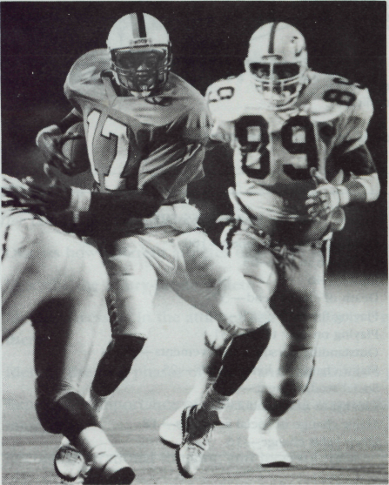

III. Text II
IT IS THE ATHLETE'S INJURY

The athlete who has reached the acceptance phase should take the responsibility for the injury. It is not the sports therapist's injury. The athlete has to accept the responsibility for the pain and the condition and deal with it. At this time the athlete is
encouraged to transfer the time and energy given to the sport into the rehabilitation process. The athlete has to become an active and not a passive participant. The knee injury is now the competitor rather than the next week's opponent. Care should be taken so the athlete does not become a dependent patient. Some athletes want the sports therapist to be responsible for their welfare and to meet their every need at their whim and command. They demand more time be spent on them. Failure of one staff member to meet their demands results in their selecting a staff member who will meet their demands. Staff members with the greatest need to help others will be easily taken advantage of at the sacrifice of time needed for other athletes.
When these dependent patients no longer receive the special attention they feel they deserve, they often lash out in anger or frustration. The sports therapist needs to head off this response by firmly explaining the restrictions on time and what is required of the athlete in terms of rehabilitation. This response should be pointed out to the athlete as inappropriate and needs examination on the part of the sports therapist and the athlete if it becomes a continual problem, since it is only a detriment to recovery.
The athlete is guided in rehabilitation but must push within these guidelines. The athlete has to be encouraged and believe in future success. All efforts should point toward a positive result with the athlete working with what is available and not with wishful thinking.

3.1. Read and translate the text “It is the Athlete’s Injury”.

3.2. Answer the questions on the text.

1. Should the athlete who has reached the acceptance phase take the responsibility for the injury? 2. Where is the athlete encouraged to transfer the time and energy to? 3. What kind of participant does the athlete have to become? 4. Is the knee injury now a problem of the competitor or the next week's opponent? 5. What should be taken so the athlete does not become a dependent patient? 6. What do some athletes expect from the sports therapist? 7. What happens with dependent patients if they no longer receive the special attention? 8. In what way can the sports therapist help such athletes? 9. Where should all efforts point toward?

3.3. Find English equivalents from the text for the words below:

переносити/переміщати, залежний, травма коліна, суперник/конкурент, обережність, легко, прийняття бажаного за дійсне, реакція, бути спрямованим на, нести відповідальність, приймати/допускати/визнавати, заохочувати/підтримувати, зусилля, обмеження, недоречний/невідповідний, з боку, перешкоджати/заважати, біль, пожертвувавши чим-небудь, дотримуватися меж рекомендацій, керувати/спрямовувати, вибухнути гнівом або впасти у відчай, не отримувати особливої уваги, користуватися перевагами, невдача/провал, персонал, відповідати вимогам, благополуччя/благоденство, призводити до, дотримуватися обережності, примха, заслуговувати, наполегливо пояснювати, збиток/шкода.

Physical and emotional aspects of return to performance

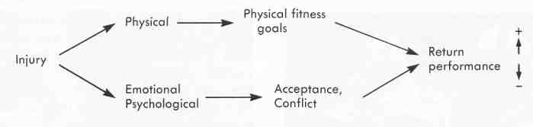

The return to performance is either enhanced or negated by the physiological and psychological results of both elements.
3.4. Complete the sentences logically.

1. The athlete has to accept the responsibility for … .
2. The knee injury is now the competitor rather than … .
3. Care should be taken so the athlete does not become … .
4. Some athletes want the sports therapist to be responsible for their … .
5. When the dependent patients no longer receive the special attention they often
lash out in … .
6. This response should be pointed out to the athlete as … .
7. This response needs examination on the part of … .
8. The athlete has to be encouraged and believe in … .
9. All efforts should point toward a … .

3.5. Insert articles if it is necessary.

1. Certain attitudes toward sports have fostered … injury and, more important, reinjury. 2. … phrase "you have to play with pain" has been interpreted more literally to mean that … athlete has to play through … injury. 3. … difference is that some injuries may be mild and only somewhat painful, resulting in no reinjury in competition, whereas … more severe injury is made worse by continuing to compete. 4. The importance of … certified sports trainer to make this decision is obvious.

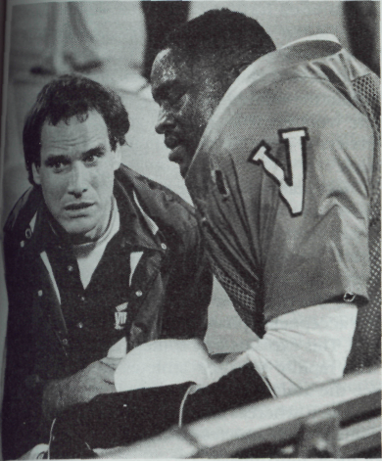 | Competent medical care.  Courts expect competent medical care to be provided to athletes by a d athletic trainer or physician.

3.6. Fill in the gaps with prepositions if necessary.

1. Unfortunately, untrained personnel, such is coaches, assume this responsibility when no spore therapist is present or when the sports therapist easily intimidated … the coach and not backed up … the athletic director. 2. Either situation results … poor medical care and leaves the management vulnerable to legal action as a result … negligence. 3. Courts expect competent medical care to be pro- vided … the athletes. 4. That care can be provided on … a qualified sports therapist or a physician. 5. Players who feel that a missed practice or game will relegate them to the bench … the year or those who have been encouraged to play no matter what are candidates … injury and reinjury.

3.7. Translate the following into English.

1. Психологічні чинники впливають на поширеність травм, реакції на травми і процес відновлення. 2. Такі психологічні чинники, як стрес, можуть бути передумовами травм спортсменів і тих, хто займається спортом. 3. Фахівці в галузі фізичної культури і спорту повинні з’ясовувати умови, що призводять до травми, особливо у людей з низьким рівнем соціальної підтримки і недостатніми рівнями розвитку умінь і навичок справлятися з життєвими стресовими ситуаціями. 4. При виявленні високих рівнів стресу необхідно використовувати спеціальні методи, спрямовані на зняття стресу, а також внести відповідні зміни в тренувальний процес. 5. Спортсмени повинні навчитися відрізняти природний дискомфорт, обумовлений тренувальними навантаженнями, від болю, зумовленого ушкодженням. 6. Вони повинні розуміти, що ставлення до занять за принципом «без болю немає успіху» може призвести до травм.

38. Give a talk on the text “It is the Athlete’s Injury”.

IV. Text III
INJURY PAIN AND TRAINING DISCOMFORT

Sharon Taylor coaches a swimming team that over the years has been plagued by overuse injuries. Yet her team is proud of its hard work ethic. Incorporating swimming psychologist Keith Bell's guidelines (1980), Sharon has taught the team to view the normal discomfort of training (pain) as a sign of growth and progress, as opposed to something awful or intolerable. For her team, normal training discomfort is not a signal to stop but a challenge to do more.
Because Sharon's swimmers have taken their training philosophy too far and misinterpreted Bell's point, Sharon set a goal of having her swimmers distinguish between the discomfort of training and injury pain. At the start of the season she discussed her concerns and asked swimmers who had received overuse injuries the season before to talk about the differences between pushing through workouts (overcoming discomfort) and injury pain (e.g., not stopping or telling the coach when a shoulder ached). She changed the team slogan from "No pain, no gain" to "Train hard and smart." She also revamped the training cycling scheme to include more off days and initiated a team rule that no one could swim or lift weights on the off days. She discussed injury versus discomfort with her swimmers periodically during the season and reinforced correct behavior with praise and occasional rewards. Sharon also informed parents of the need to monitor their children's chronic pains.
As the season progressed, the swimmers began to understand the difference between injury pain and the normal discomfort of hard training. By the end of the season, most of her swimmers remained healthy and excited about the State meet.

4.1. Read and translate the text “Injury Pain and Training Discomfort”.

4.2. Answer the questions to the text.

1. What team does Sharon Taylor coach? 2. Over the years she has been plagued by overuse injuries, hasn’t she? 3. How doe Sharon consider training pain? 4. Is normal training discomfort a signal to stop or a challenge to do more for her team? 5. Do her swimmers distinguish between the discomfort of training and injury pain? 6. How has Sharon Taylor changed the team slogan? 7. Why did she revamp the training cycle scheme? 8. What did she discuss with her swimmers periodically? 9. What did Sharon Taylor inform parents about? 10. How do swimmers feel by the end of the season? 11. Do you share Sharon Taylor’s approach to pain?

4.6. Match the words from both columns.

E.g.: 1 - Q

1 | to monitor |  | A | порівняно, на противагу
2 | a sign |  | B | травми, викликані перетренирован-ністю
3 | intolerable |  | C | відрізняти, розрізняти
4 | slogan |  | D | звинувачувати, таврувати
5 | to plague |  | E | пишатися
6 | to lift weights |  | F | нагорода
7 | to reinforce |  | G | час від часу
8 | praise |  | H | виклик, проблема
9 | to revamp |  | I | піднімати тяжкості
10 | reward |  | J | нестерпний
11 | occasional |  | K | зміцнювати
12 | to distinguish |  | L | розглядати
13 | to be proud of |  | M | гасло
14 | overused injuries |  | N | переглядати, переробляти
15 | to view |  | O | похвала, схвалення
16 | as opposed to |  | P | ознака
17 | challenge |  | Q | контролювати, перевіряти

4.7. Write a short essay on “Injury Pain and Training Discomfort”

V. ORAL TOPIC
PSYCHOLOGICAL CONSIDERATIONS FOR REHABILITATION

Athletes do not deal with injuries in the same way. The sports therapist has to understand their views of injury. The manner in which the sports therapist manages these athletes often determines their time away from the sport. Life's stressful events play an important role in the adjustment to a certain system or coach. The successful program takes this factor into consideration and adjusts to the individual player whenever possible. Attitudes on the part of coaches and staff have a direct bearing on the performance of the athlete. These personnel direct the athlete in the right direction for successful maturation and athletic competition. After injury the athlete must adjust to denial, anger, depression, and acceptance. Each phase requires empathy on the part of all rehabilitation personnel. The athlete must take responsibility for the injury and deal with it as such. Guiding the athlete toward this goal is an integral part in injury management. Irrational thinking on the part of the athlete is natural after injury. The role of rehabilitation personnel is to change this thinking through such strategies as relaxation training, thought stoppage, visual rehearsal, emotional rehearsal, and body rehearsal. The interpersonal relationships of the athlete and sports therapist are highly important and often the key to the return for the athlete. Coping with the injury and adherence to the rehabilitation program are extremely important, is the establishment of short- and long-term realistic goals.

5.1. Read and translate the text “Psychological Considerations for Rehabilitation”.

5.2. Make up 10 questions to the text.

5.3. Find English equivalents in the text for the following.

мати справу з, коли б не, конкретний/певний, успішний, точка зору/сприйняття, визначати/вирішувати, час відлучення від спорту, пристосовність, стресові явища, довготривалий, надзвичайно важливий, персонал, брати до уваги/враховувати, ставлення з боку тренерів, невід'ємна частина, ставлення, виступ, ухиляння/відмова, злість, депресія, прийняття, вимагати, мета, співчуття/співпереживання, приймати відповідальність, спрямовувати/вести, хід думки, візуалізація або ідеомоторні акти, тренування релаксації, позитивна внутрішня мова, однаково, можливий, досягнення успішного повного розвитку, міжособистісні стосунки, впоратися, прихильність/дотримання, стресові життєві ситуації, організація лікування травми.

5.4. Complete the sentences.

possible situations, feels, closely, four, speedy, the best opportunity, career, commonplace, will be fine, the injury

PHASES OF INJURY

1. The athlete has to deal with … phases of injury: denial, anger, depression, and acceptance. 2. These … follow Elisabeth Kubler-Ross's model of the stages of death and dying. 4. After injury, the athlete faces three … … . 3. The injury may be minimal and allow a … return, the athlete may have a prolonged period of rehabilitation, or the playing … may be at an end. 5. The athlete must be encouraged along positive avenues to have … … … to achieve complete rehabilitation, both emotionally and physically. 6. Early denial of the injury is …, since the athlete attempts to rationalize that everything will be all right. 7. The athlete feels that the injury … … … the next day and that the early diagnosis is wrong. 8. However, when the next day arrives and … … is not better, the athlete begins to have difficulty dealing with recovery not being imminent. 9. As a consequence, the athlete often … anxious, isolated, and lonely.

The value of listening  Listen to determine how the athlete is feeling rather than to what he or she is saying. | 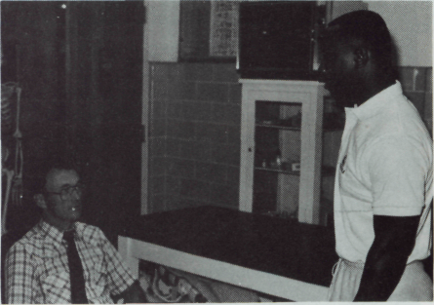

5.5. Fill in the gaps with prepositions if necessary.

1. Anger may soon replace this feeling … disbelief as the injured player vents feelings. 2. Whoever happens to be around the athlete often bears the brunt … the anger. 3. Anger cannot be reasoned …, and the athletic health-care personnel must understand and not react to the anger … the athlete. 4. This response is merely emotional, a release … frustration. 5. The sports therapist must act as an emotional blotter and, if possible, not further aggravate the situation … attempting to exert power to calm down the athlete. 6. The sports therapist should listen to what the athlete is feeling … rather than to what is said. 7. This active listening requires … time and effort. 8. The athlete has lost control … the situation and is seeking to regain it.

5.6. Open the bracket and use verbs in proper Tense and Voice.

1. Next, moods of anger, bargaining, and depression often (to interrelate), with the athlete swinging from one to the other and back. 2. Bargaining also (may, to begin) after the initial phase of denial, with the athlete saying the injury isn't real. 3. The athlete (may, to put) a concentrated effort into treatment and rehabilitation for a brief period to get back into competition for the game. 4. When this effort fails, the athlete often (to drop) into depression and (to slack) off on rehabilitation effort. 5. In this phase the athlete (to lose) control of the physical situation and often the emotional control that goes with it. 6. Team and individual identity (to go), and the athlete (to be) an outsider watching from the sidelines or often from the stands. 7. Being in the stands often further (to isolate) the athlete. 8. This action alone often (to solidify) the phase of depression and (should, to avoid) wherever possible. 9. Success or failure of the team (may, to produce) anxiety within the injured athlete. 10. If the team wins, the athlete (to wonder) what role is left; if the team loses, the anxiety (to be) great for the athlete to return to help the team.

5.7. Ask questions to the words in italics.

1. Acceptance is a phase many well-managed athletes move into with ease. 2. Fortunately, this group comprises most of the athletes with whom the competent sports therapist will work. 3. The positive interest, energy, and empathy shown by the sports therapist make the transition from initial injury and denial to the acceptance phase a quicker recovery for the athlete. 4. This explains why some rehabilitation personnel who rapidly get their athletes to acceptance rarely see the athlete who is not psychologically adjusting to injury. 5. Whereas some sports therapists who poorly manage their athletes continually see a great number of these individuals.

5.8. Translate the following into English.

У травмованих осіб спостерігаються різні психологічні реакції, які, як правило, включають 5 етапів: заперечення, гнів, «укладання угоди», депресію, прийняття і реорганізацію. У них часто спостерігають також підвищену тривожність і почуття страху, знижену впевненість у собі, зниження рівня фізичної активності. Працюючи з травмованим спортсменом, стежте за появою симптомів «ненормальної» реакції на травму.
Психологічне підґрунтя реабілітації вміщує такі аспекти: встановлення взаємовідносин з травмованою людиною, її інформування про сутність травми і протікання процесу відновлення, навчання спеціальним психологічним навичкам і прийомам, таким, як визначення цілей, ідеомоторні акти, релаксація, підготовка травмованої людини до можливих рецидивів у процесі реабілітації і забезпечення соціальної підтримки.
Фахівці в галузі фізичної культури і спорту повинні проводити спеціальні заняття, спрямовані на профілактику травм, допомогу травмованим та забезпечення психологічних умов, які б сприяли процесу відновлення.

5.9. Convert the conversation below into indirect speech.

PSYCHOLOGICAL ASPECTS WITH INJURED ATHLETES

- | What is injury for an athlete?
- | Injury is a foreign, emotional, and unpleasant experience for the athlete. Tradition says that injuries are to be shrugged off and the battle continued.
- | When can an athlete begin to feel psychological discomfort?
- | When injuries cannot be ignored, the athlete can become psychologically upset.
- | What is recommended to do in such case?
- | In such case all teams should have access to the skills of a sports psychologist, when and if needs arise above the abilities of the coach, team physician, or sports therapist.
- | You have said it.
- | You see, rehabilitation is a physical and mental process. No two injuries are alike, and no two individuals necessarily react alike, do they?
- | It goes without saying. Often attitudes and strategies for a rehabilitation process must be addressed for the troubled athlete.
- | Who can help an injured athlete?
- | Only the sports therapist, with the necessary commitment, skills, and empathy, will be able to guide the athlete to a successful resolution of the symptoms and to a successful return to active status.

5.10. Write a short essay on “Psychological Considerations for Rehabilitation”.

VI. Text IV
SPORTS MEDICINE AND ATHLETIC TRAINING

Sports medicine and athletic training are still in exact sciences, and nowhere within this area is this more evident than in the psychological phase of recovery from injury. Plato mentioned never attempting to cure the body without curing the soul. Current clinicians have found that people with negative self-concepts suffer more injuries.
Most athletes have the self-confidence to adapt to a mild or moderate injury, and most have the support, understanding, and proper encouragement to adapt to more severe injury, but even the most self-confident have their doubts. One athlete put it this way:
The best competitors like to compete and to me this is just a game — an inner game. It's an inner soul game. Can I beat my knee back? But he also expressed doubts about the real test when a tackier "takes a whack at the knee" and how I haven't thought about it, but I've had nightmares about it. My buddy told me he broke his ankle. He said once you get that real good hit and you pop up and it pops up with you, then everything is going to fall into place and you're going to be rolling. You're going to go out there like it's never been hurt and just play.
This quote expresses the positive aspects of return to competition but also some of the doubts involved.
With the emergence of sports psychology, more mention is paid to getting the mind ready to return to competition to match the adjustment of the body. Athletes have begun to describe the nightmares, fears, «id anxiety of returning to competition. Also, in the current trend of high-salaried athletes, some describe their knee or other injuries and surgery as the most important things in their lives since they will either make or break them. These operations can allow the athletes to make either millions of dollars in a sports career or only thousands in a regular job if their careers end.
Athletes don't all deal with injury in the same manner. Rotella describes how one may view the injury is disastrous, another may view it as an opportunity to show courage, and another athlete may relish the injury since it prevents his or her embarrassment over poor physical performance, provides an escape from a losing team, or discourages a pushy parent. If the injury is career-threatening, the athlete whose whole life has revolved around a sport may have an identity crisis.

  - Read and translate the text “Sports Medicine and Athletic Training”.

  - Answer the questions to the text.

1. What kind of sciences are sports medicine and athletic training? 2. What did Plato recommend? 3. Who suffers more injuries? 4. How do different athletes adapt to injuries? 5. Do the athletes have any doubts on their return to competitive performance? 6. What does sports psychology deal with? 7. Is the attitude of different athletes the same to injuries? 8. What feel athletes if the injury is career-threateing?

6.3 Write a short essay on “Sports Medicine and Athletic Training”.

VII. SELF-ASSESSMENT TEST

These tasks are designed to assist you in determining if you have mastered the
materials and competencies presented here.

1. How do different athletes deal with similar injuries?
2. What kind of individual is called an injury-prone athlete?
3. What can be identified as stressors in the athlete’s life?
4. Describe the methods which can be effective to cope with them.
5. What are the four phases of injury and the athlete’s perception of them?
6. Is it important for an athlete to take responsibility for the actions in regard to injury?
7. Identify the problems associated with long-term rehabilitation.

