Національний університет фізичного виховання і спорту України
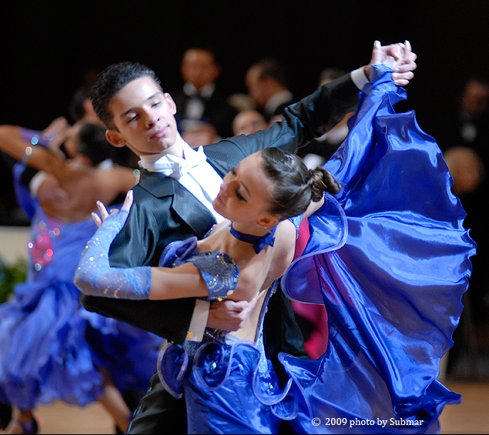
DANCE SPORT
(Спортивні танці )
Навчальний посібник
з англійської мови
для студентів ІІ курсу вищих навчальних закладів фізичного виховання та спорту
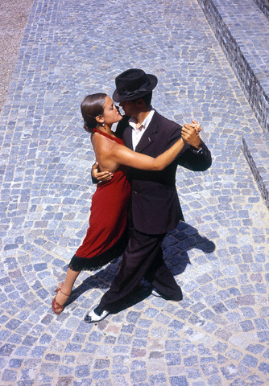 | 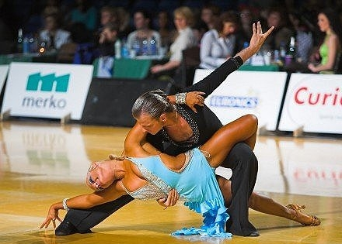 | 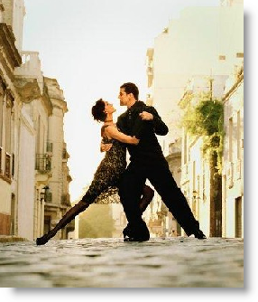
Київ – 2012.
УДК 793.38
Субботіна Т.Б., Вятчаніна С.В., Рожкова Т.А. Sport Dances. Навчальний посібник з англійської мови для студентів ІІ курсу вищих навчальних закладів фізичного виховання та спорту. – К.: НУФВСУ, 2012. – 100 с.

Автори : Субботіна Тетяна Борисівна
Вятчаніна Світлана Володимирівна
Рожкова Т.А.

Рецензенти: Коновалова Т. І., кандидат філологічних наук, доцент,
Київський славістичний університет
Бойченко О.П., кандидат філологічних наук, викладач,
Національний університет фізичного
виховання і спорту України

Посібник підготовлено на базі аутентичних текстів зі спортивних танців. Теоретичний та практичний матеріал закріпляється системою вправ. Матеріали посібника спрямовані на формування у студентів мовленнєвих навичок, читання та розуміння спеціальної літератури. В кінці посібника наводиться англо-українсько-російський словник спортивних термінів.
Посібник призначається для студентів вищих навчальних закладів фізичного виховання та спорту.

Рекомендовано до друку
Вченою радою НУФВСУ
Протокол № 3 від 07.11.2012 р.

© НУФВСУ, 2012
© Субботіна Т. Б., Вятчаніна С.В.,
Рожкова Т.А., 2012

Contents
Unit 1. Posture…………………………………………...........................................4
Unit 2. Positions of the Feet………………………………………………………10
Unit 3. The Forward Walk………………………………………………………..16
Unit 4. Directional Movements…………………………………………………...21
Unit 5. The Line of Dance………………………………………………………..27
Unit 6. Slow Waltz ………………..………………..………….............................36
Unit 7. Movement in Slow Waltz………………………………………………...41
Unit 8. Viennese Waltz…………………………………………………………...47
Unit 9. Tango …………………………………………………………………….52
Unit 10. Slow Foxtrot …………………………………………………………….58
Unit 11. Samba …………………………………………………………………...63
Unit 12. Paso Doble……………………………………………………………....68
Unit 13. Cha Cha Cha ……………………………………………………………73
Unit 14. Salsa……………………………………………………………………..77

TEXTS FOR SELF INDEPENDENT STUDENTS’ WORK
Quickstep………………………………………………………………………….81
Jive………………………………………………………………………………...83
Rumba……………………………………………………………………………..84
The Principles of Communication………………………………………………...85
The Basic One-Hand Connection…………………………………………………86
Hand Positioning………………………………………………………………….87
The Concept of "Push & Pull"…………………………………………………….88
Leading Directional Movement…………………………………………………...90
Study the active vocabulary……………………………………………………….92
References………………………………………………………………………...99
Unit 1. Posture
I. Pre-text Exercises.
Exercise1. Study the active vocabulary.
 | English | Ukrainian | Russian
 | essential | суттєвий | существенный
 | posture | позиція; постава | позиция; осанка
 | achieve | досягати | достигать
 | proper | відповідний | соответствующий
 | alignment | поєднання | соединение
 | relative | відносний | относительный
 | various | різний | различный
 | include | включати | включать
 | pelvis | таз | таз
 | upright | прямо | прямо
 | careful | обережний | осторожный
 | lengthen | розтягувати | вытягивать
 | particular | особливий | особый
 | shorten | скорочуватися | сокращаться
 | thrust | виштовхувати | выталкивать
 | vertebrate | хребець | позвонок
 | rib cage | грудна клітина | грудная клетка
 | curve | вигин | изгиб
 | excessive | надмірно | чрезмерно
 | remain | залишатися | оставаться
 | bend | згинати | сгибать
 | slightly | злегка, трохи | слегка
 | range | простягатися | простираться
 | distribution | розподіл | распределение

Exercise 2. Read and translate without using the dictionary.
Comfortable, effective, dancing, position, manner, parallel, vertical, to lift, normal, natural, constant, standing position, mechanics, specific, block.

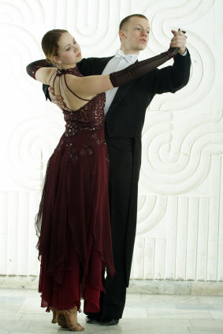
II. Read and Translate the Text:
POSTURE
Essential to comfortable and effective dancing is good posture, achieved through the proper alignment of the various body parts in correct relative position with one another. The various body parts, including the head, chest/torso, pelvis/hips, legs, and feet, are properly aligned when they are placed directly on top of one another in a natural and upright manner.
Head
The head should be held upright with the chin parallel to the floor. The neck should stretch upward, but be careful not to lengthen any one side of the neck at the expense of the opposite side. All sides of the neck should stretch upward. Pay particular attention to the back of the neck, which is often shortened when the chin is held too high. Be careful not to thrust the head forward from the neck, as the vertebrate in the neck should continue upward as an extension of the spine.
Chest / Torso
The chest and hips must always be in good, vertical alignment. The rib cage should feel as though it is being lifted off of the hips, in such a way as to lengthen the spine. Any lifting of the chest, however, should always be accomplished in such a way as to allow for normal, comfortable breathing. Never allow the chest to pitch forward or slouch back in relationship to the hips.

Pelvis / Hips
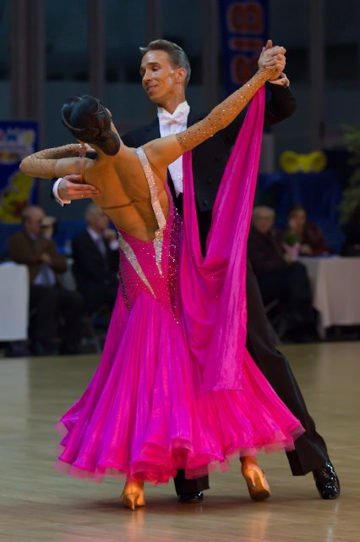
The position of the hips must allow for a natural curve of the spine. The pelvis should therefore be held in a midway position, neither tucking excessively under, nor sticking out backward.
Legs
When the legs are straight, the knees will be positioned directly between the hips and the feet. When the knees bend forward, the alignment of the hips and feet should remain constant, so that the body can remain upright. Always try to feel that you lengthen your torso as you bend your knees, so that your posture does not "deflate". Never allow your pelvis to stick out backward, even slightly, as the knees bend.
Feet
It is very important for a good dancer to become aware of the placement of the body weight over the feet. In a normal, standing position, the body weight should remain slightly forward of the middle of the feet, between the heel and the ball of the foot. In motion, this position is variable, based on the mechanics of the specific movement. It will range from the back of the heel to the front of the big toe, but this distribution of weight should not affect the alignment of the upper blocks of weight, from hips to head.

III. Post-text Exercises.
Exercise 1. Answer the following questions.
- What is essential for comfortable and effective dancing?
- How can you achieve a good posture?
- Which body parts are properly aligned?
- How should the head be held?
- What are the mistakes in head position?
- Which body parts must be always in good vertical alignment?
- Why should the pelvis be held in a midway position?
- What must you remember about leg position?
- Is the placement of the body weight over the feet important?
- What can you say about body weight in motion?

Exercise 2. Find the equivalents in your native language to the following.
- good posture
- proper alignment of the body parts
- correct position
- in a natural and upright manner
- chin parallel to the floor
- be careful
- at the expense of the opposite side
- pay particular attention
- back of the neck
- as an extension of the spine
- in such a way as to lengthen the spine
- normal, comfortable breathing
- be held in a midway position
- legs are straight
- knees bend forward
- never allow your pelvis to stick out backward
- important for a good dancer
- between the heel and the ball of the foot
Exercise 3. Match synonyms from both columns.
essential |  | connection
stretch |  | trunk
various |  | movement
torso |  | extend
alignment |  | important
motion |  | different

Exercise 4. Match antonyms from both columns.
forward |  | outward
horizontal |  | downward
lengthen |  | over
upward |  | vertical
inward |  | backward
under |  | shorten

Exercise 5. Agree or disagree with the following.
- The head should be held upright with the chin parallel to the floor.
- You must not pay any attention to the back of the neck.
- Any lifting of the chest should always be accomplished as to allow for normal breathing.
- You may allow the chest to pitch forward or slouch back in relationship to the hips.
- Your pelvis can stick out backward.
- It’s not important that your body weight is over the feet.
- In a normal the body weight should be between the heel and the ball of the foot.

Exercise 6. Complete the sentences and translate them into your native language.
- Essential to comfortable and effective dancing is good …
- The various body parts are properly…
- The head should be held …
- Be careful not to thrust the head …
- The chest and hips must always be in …
- Never allow the chest to pitch forward or …
- The pelvis should be held in a midway …
- Always try to feel that you lengthen …
- It is very important for a good dancer …
- In motion the position is based on…

Exercise 7. Retell the text.
Unit 2. POSITIONS OF THE FEET
I. Pre-text Exercises.
Exercise1. Study the active vocabulary.
 | English | Ukrainian | Russian
 | describe = outline | описувати | описывать
 | foot positioning | позиція стоп | позиция стоп
 | involve | включати в себе | включать в себя
 | angle | кут | угол
 | refer to | стосуватися | относиться к
 | apart | окремо | врозь
 | establish | установлювати | устанавливать
 | nonetheless | проте, однак | тем не менее
 | on occasion | у разі | в случае
 | turnout | розгортати | разворачивать
 | rotate | обертання | вращение
 | point away from | спрямовані в різні боки | направлены в разные стороны
 | degree | градус | градус
 | breakdown | розбивка | разбивка
 | assume | сприймати | воспринимать
 | majority | більшість | большинство
 | desirable | бажаний | желаемый
 | strive | прагнути | стремиться
 | on the other hand | навпаки, з другого боку | наоборот, с другой стороны
 | thus | таким чином | таким образом

Exercise 2. Read and translate without using the dictionary.
Method, fundamental, originally, ballet, ideally, ballroom dancing, step forward, take forth position, speak in terms, instruction, process, standard style, Latin dances.

II. Read and Translate the Text:
POSITIONS OF THE FEET
There are many ways to describe foot positioning. Some methods involve describing the angle or position of a single foot, while others describe the positions or angles of the feet relative to each other. The following article will give you a basic understanding of the most common methods for describing the various positions of the feet.
The most fundamental method is to refer to one of five basic foot positions:
FIRST POSITION SECOND POSITION
Feet together. Feet apart, side by side.
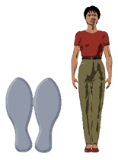
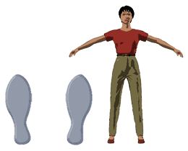

THIRD POSITION FOURTH POSITION
Feet together, heel to instep. Feet apart, one foot
in front of the other.
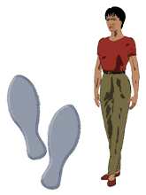
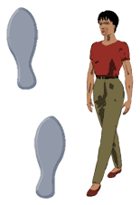

FIFTH POSITION
Feet together, one foot in front of the other, toe to heel.
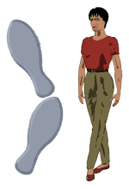
These five foot positions were originally established for the teaching of ballet, and as a result, are not always ideally suited for ballroom dancing. You are more likely to hear a ballroom dance teacher say "Step forward" than "Take fourth position", simply because ballroom dancers prefer to speak in terms of directions of movement. Nonetheless, instructors will refer to these positions on occasion (especially 5th position), so you should get to know them.
Turnout
Turning out is the process of rotating the feet outward to an angle, so that the toes point away from each other. The angle that results between the feet is known as the degree of turnout. When the feet are held without any turnout, they are referred to as parallel.

Fig 1 - Feet parallel.
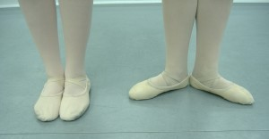

Fig 2 - Feet turned out.

For Smooth and Standard style ballroom dancing, the feet are normally held parallel. Some turnout is used in very specific situations, as outlined in the technical breakdown of a figure. When turnout is not specified, it is assumed that feet are parallel.
Turnout in the Latin and Rhythm dances is recommended for the majority of situations. The desirable amount of turnout is somewhere between 45 and 90 degrees. Ballet dancers strive to achieve turnout entirely through the rotation of the legs so that the knees always point to the same angle as the toes. Latin dancers, on the other hand, will allow the feet to turn out at the ankles. Thus the knees, when bent, point straight forward (or even roll slightly inward) in spite of the turned-out angle of the feet.

III. Post-text Exercises.
Exercise 1. Answer the following questions.
- Are there many ways to describe foot positioning?
- How many foot positions do you know?
- Describe, please, every position.
- What for were 5 foot positions originally established?
- How do ballroom dancers prefer to speak at the training?
- What does turning out mean?
- How do we call the angle that results between the feet?
- How are the feet normally be held for the smooth and standard style ballroom dancing?
- In which case is the turnout recommended?

Exercise 2. Find the equivalents in your native language to the following.
- the angle of the feet relative to each other
- basic understanding
- common methods
- various positions of the feet
- feet together
- feet apart
- one foot in front of the other
- heel to instep
- feet together, one foot in front of the other, toe to heel
- not ideally suited for ballroom dances
- directions of movement
- toes point away from each other
- to outline the technical breakdown of a figure
- majority of situations
- bent knees
- point straight forward

Exercise 3. Match synonyms from both columns.
to describe |  | usual
to hear |  | manner
common |  | fundamental
style |  | every
basic |  | to outline
each |  | to listen

Exercise 4. Match antonyms from both columns.
feet together |  | minority
turned out feet |  | general
turn inward |  | parallel held feet
specific |  | feet apart
in front of |  | turn outward
majority |  | behind

Exercise 5. Agree or disagree with the following.
- There are eight basic foot positions in ballroom dancing.
- The first position is feet apart, side by side.
- The third position is feet together, heel to instep.
- These 5 positions were established for the teaching of ballroom dancing.
- The fifth position is feet together, one foot in front of the other, toe to heel.
- The angle that results between the feet is known as parallel position.
- For smooth , style dancing, the feet are normally turned out.
- The amount of turnout is somewhere between 45 and 90 degrees.
- Latin dancers allow the feet to turn out at the ankles.
- The knees, when bent, always point to the same angle as the toes.

Exercise 6. Complete the sentences and translate them into your native language.
- The text will give you a basic understanding of the most common …
- The forth position is feet apart…
- Five foot positions are not always ideally…
- Ballroom dancers prefer to speak in …
- Turning out is the process of rotating …
- When the feet are held without any…
- Some turnout is used in very specific…
- The desirable amount of turnout is somewhere…
- Latin dancers will allow the feet …
- Thus the knees, when bent, point…

Exercise 7. Retell the text.

Unit 3. THE FORWARD WALK
I. Pre-text Exercises.
Exercise1. Study the active vocabulary.
 | English | Ukrainian | Russian
 | improve | покращити | улучшить
 | slowly | повільно | медленно
 | starting position | вихідне положення | исходное положение
 | compression | стиснення, відхилення | сжатие, отклонение
 | flex | зігнутий | согнутый
 | standing foot | опорна нога | опорная нога
 | toward | у напрямку | в направлении
 | at the same time | одночасно | одновременно
 | swing forward | повертатись уперед | поворачиваться вперед
 | whole | увесь | весь
 | extension | продовження, випростання | продолжение, выпрямление
 | release | звільнення | освобождение
 | mid-stride | середина кроку | середина шага
 | full | повністю | полностью
 | equally | однаково | одинаково
 | vice-versa | навпаки | наоборот
 | follow-through | завершення | завершение
 | approach | наближатися | приближаться
 | follow behind | іти слідом за | следовать за
 | lower | опускатися | опускаться
 | simultaneously | одночасно | одновременно
 | throughout | весь час | всё время

Exercise 2. Read and translate without using the dictionary.
Work, phase, action, daily warm-up exercises, body weight, foot, leg, heel, speak to contact, move forward, new, floor.

II. Read and Translate the Text:
THE FORWARD WALK
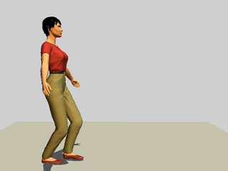
To improve your own dancing, work slowly through the phases of the walking action as a daily warm-up exercise.
STARTING POSITION
Begin standing upright with feet together.
1. COMPRESSION
While flexing the knees, begin to move the body weight toward the ball of the standing foot. At the same time, allow the free leg to swing forward from the hip, causing the free foot to move forward. When the free foot first begins to move, the whole foot will be in contact with the floor.
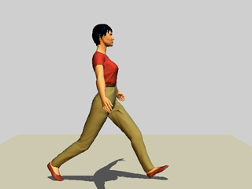
2. EXTENSION
Continue to swing the moving leg forward from the hip. Release the toe of the moving foot, but keep the heel in contact with the floor. The body weight should continue to move forward between the feet, with the heel of the standing foot beginning to release from the floor.

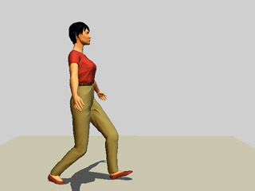
3. MID-STRIDE
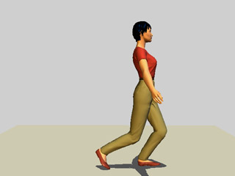
At the full extent of the stride, the body weight is equally divided between the feet, with the forward toe and back heel up. At this point, the moving foot will become the standing foot (and vice-versa).

4. FOLLOW-THROUGH
As the body weight approaches the new standing foot, the toe may now lower to the floor. The new moving foot follows closely behind, with the heel now lowering towards the floor, and both knees flexing equally and simultaneously throughout.

III. Post-text Exercises.

Exercise 1. Answer the following questions.
- What must a dancer do to improve his/her own dancing?
- How many main parts does the forward walk consist of?
- Where must you begin to move the body weight while flexing the knees?
- What does the free leg do at the same time?
- Will the whole foot be in contact with the floor?
- How must you move the leg forward during the phase of extension?
- When does the heel of the standing foot begin to release from the floor?
- How is the body weight divided at the full extend of the stride?
- When the moving foot becomes the standing foot?
- What can you tell about the new moving foot during the phase of follow-through?
Exercise 2. Find the equivalents in your native language to the following.
- improve your dancing
- starting position
- stand upright
- move the body weight
- ball of the standing foot
- free leg swings forward
- be in contact with the floor
- release the toe
- heel of the standing foot
- back heel up
- equally divide the body weight
- toe lowers to the floor
- foot follows closely behind
- both knees are flexing equally

Exercise 3. Match synonyms from both columns.
simultaneously |  | to bend
to begin |  | to be in contact with
to flex |  | step
to touch |  | similar
stride |  | at the same time
equal |  | to start

Exercise 4. Match antonyms from both columns.
slowly |  | free foot
starting position |  | stop
begin |  | to release
standing foot |  | quickly
to touch |  | follow-through position

Exercise 5. Agree or disagree with the following.
- To improve your own dancing, work as quickly as you can.
- Begin standing upright with feet together.
- Allow the free leg to swing forward from the hip.
- When the free foot first begins to move, the whole foot will be in contact with the floor.
- Release the heel of the moving foot, but keep the heel in contact with the floor.
- There are 5 main phases in the forward walk.
- The body weight is equally divided between the feet.
- As the body weight approaches the new standing foot, the toe may lower to the floor.

Exercise 6. Complete the sentences and translate them into your native language.
- At the starting position begin standing …
- During compression phase, begin to move the body weight toward …
- At the same time, allow the free leg …
- When the free foot first begins to move …
- At the extension phase continue to swing …
- Release the toe of the moving foot, but …
- During the mid-stride, the body weight is …
- At this point, the moving foot will …
- As the body weight approaches the new standing foot, the toe …
- The follow-through is the last phase…

Exercise 7. Retell the text.

Unit 4. DIRECTIONAL MOVEMENTS
I. Pre-text Exercises.
Exercise1. Study the active vocabulary.
 | English | Ukrainian | Russian
 | describe | описувати | описывать
 | placement | розміщення | расположение
 | primary direction | основний напрямок | основное направление
 | require | вимагати | требовать
 | explanation | пояснення | объяснение
 | to be familiar  to be acquainted | бути знайомим | быть знакомым
 | distinguish | відрізняти | отличать
 | CBMP (Contra Body Movement) | позиція проти руху корпусу | позиция противо-движения корпуса
 | take on | набувати | приобретать
 | separate | окремий | отдельный
 | albeit | хоч | хоть
 | narrow track | вузький напрямок | узкое направление
 | roughly  approximately | приблизно | приблизительно
 | alignment | пряма лінія | ровная линия
 | common | простий, широко розповсюджений | простой, широко распространённый
 | novice dancer | танцюрист-початківець | танцор-новичок
 | along | вздовж | вдоль
 | hybrid | змішаний | смешанный
 | however | проте | однако
 | incorporate | включати в | включать в
 | slightly | трохи | слегка
 | imply | мати значення | означает
 | whereby | за допомогою чого | посредством чего
 | across | через, впоперек | через, поперёк

Exercise 2. Read and translate without using the dictionary.
Normally, in terms, specified direction, forward, back(ward), side, movements, diagonals, step, phrase, total.

II. Read and Translate the Text:
DIRECTIONAL MOVEMENTS
In ballroom dancing, steps are normally described in terms of the placement of the feet in a specified direction.
Primary Directions
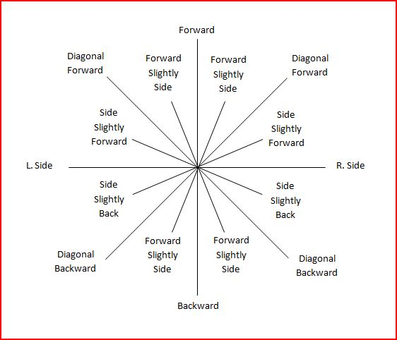
The primary directions require very little explanation. Forward, side, and back (ward) are movements with which we are all familiar. It should be noted, however, that forward and backward movements should be distinguished from those taken "in CBMP" by the fact that they are taken on separate, albeit narrow tracks.

Diagonals
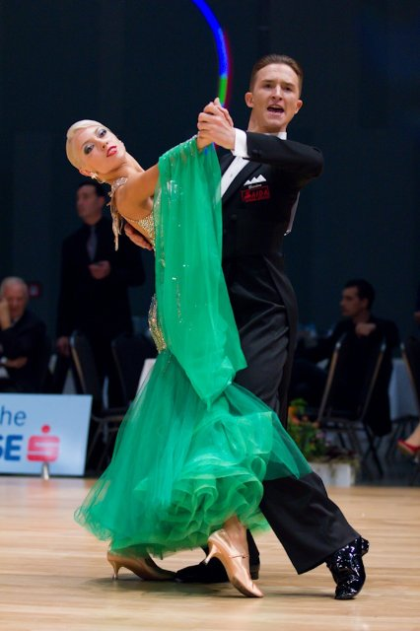
Each foot can move in one of two diagonal directions: diagonally forward, and diagonally back. When a step is described as diagonal, it should be taken at roughly 45 degrees from the alignment of both the body and feet. Because our bodies are so well acquainted with primary directional movements, it is very common for novice dancers to turn their feet to point along the diagonal direction of travel. However, when the toe points in this direction, the step is no longer described as diagonal. It has simply become a forward (or back) step taken on a diagonal alignment. A movement only qualifies as "diagonally forward" or "diagonally back" when the foot and body are turned approximately 1/8 away from the direction of travel.
Hybrid Diagonals
Hybrid diagonals are those movements which incorporate the phrase "...and slightly" in their description. The direction is diagonal, but, as the descriptions imply, only slightly. There are a total of four hybrid diagonals: (1) Side & slightly forward, (2) Side & slightly back, (3) Forward & slightly leftward/rightward, and (4) Back and slightly leftward/rightward.
CBMP
CBMP stands for Contra Body Movement Position. It is the foot position whereby one foot is placed along or across the track of the other. A step is described as "Forward or Back in CBMP" when it is placed along the track of the supporting foot. When placed across the track of the supporting foot, it is described as "Forward and Across in CBMP".

III. Post-text Exercises.
Exercise 1. Answer the following questions.
- How are steps normally described in ballroom dancing?
- Do primary directions require much explanation?
- What are the primary directions which we are all familiar?
- How many diagonal directions can each foot move?
- Why is it very common for novice dancers to turn their feet to point along the diagonal direction of travel?
- When does the movement qualify as diagonally forward or diagonally back?
- How can you describe hybrid diagonals?
- How many hybrid diagonals do you know?
- What does the term CBMP mean?
- How is the step described when it is placed along or across the track of the supporting foot?

Exercise 2. Find the equivalents in your native language to the following.
- ballroom dancing
- the placement of the feet
- it should be noted
- forward movement
- backward movement
- narrow track
- diagonal direction
- primary directional movement
- turn the feet to the point
- turn approximately 45 degrees
- away from the direction of travel
- only slightly
- place along the track
- supporting foot
- place across the track

Exercise 3. Match synonyms from both columns.
move |  | to be acquainted
little |  | small
to be familiar |  | way
track |  | a little bit
slightly |  | step
approximately |  | roughly

Exercise 4. Match antonyms from both columns.
along |  | wide
familiar |  | difficult
narrow |  | experienced dancer
common |  | backward
novice dancer |  | unknown
forward |  | across

Exercise 5. Agree or disagree with the following.
- The primary directions require much explanation.
- Forward, side, and back are movements with which we are all familiar.
- Each foot can move in many diagonal directions.
- A movement qualifies as diagonally forward or diagonally back when the foot and body are turned approximately 1/8 away from the direction of travel.
- Hybrid diagonals are those movements which incorporate the phrase “… slightly”.
- There are a total of 6 hybrid diagonals.
- CBMP is a foot position whereby one foot is placed along or across of the other.
- A step is “Forward or Back CBMP” when it is placed across the track of the supporting foot.

Exercise 6. Complete the sentences and translate them into your native language.
- In ballroom dancing, steps are normally …
- The primary directions require very …
- Forward and backward movements should be distinguished from …
- Each foot can move in one of …
- When a step is described as diagonal, it should be …
- When the toe points in the diagonal direction, the step …
- A movement only qualifies as “diagonally forward” or “diagonally back” when…
- There are a total of 4 hybrid …
- Contra Body Movement position is the foot position whereby …
- A step placed along the track of …
- A step placed across the track of …

Exercise 7. Retell the text.

Unit 5. THE LINE OF DANCE
I. Pre-text Exercises.
Exercise1. Study the active vocabulary.
 | English | Ukrainian | Russian
 | line of dance | лінія танцю | линия танца
 | imaginary | уявлюваний | воображаемый
 | represent | представляти | представлять
 | counterclockwise direction | рух проти стрілки годинника | движение против часовой стрелки
 | flow of traffic | плавність лінії руху | плавность линии движения
 | traveling dance = progressive dance | танець з переміщенням | танец с перемещением
 | in order to | для того, щоб | для того, чтобы
 | spot dance | танець на місці | танец на месте
 | throughout | протягом | в течение
 | cause | змушувати | заставлять
 | remain | залишатися | оставаться
 | continuously | безперервно | непрерывно
 | apply | застосовувати | применять
 | latter | останній | последний
 | exception | виняток | исключение
 | rectangle | прямокутник | прямоугольник
 | circle | коло, круг | круг
 | no accident | не випадково | не случайно
 | reach | досягати | достигать
 | exactly | точно | точно
 | weave in/out | відхилятися туди-сюди | отклоняться туда-сюда
 | wiggle | перехід | переход
 | afford | дати змогу | предоставить возможность
 | environment | оточення | окружающая среда
 | reserve | залишати | оставлять
 | pronounced | виразний | выразительный

Exercise 2. Read and translate without using the dictionary.
Dance floor, minimize, characterize, movements, category, classify, illustration, area, short period of time, factor, size, change, figure, pose.

II. Read and Translate the Text:
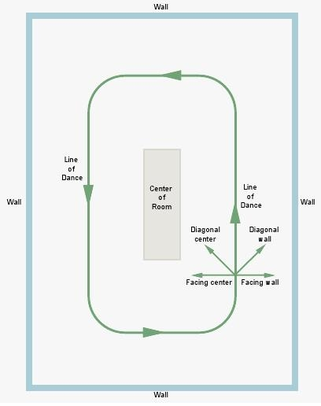
THE LINE OF DANCE
The Line of Dance is an imaginary line which represents the counterclockwise flow of traffic around the dance floor. During traveling dances such as Waltz and Tango, all dancers will move in the same general counterclockwise direction, in order to minimize collisions.
Every dance style from Tango to Cha Cha can be categorized as either a Spot Dance or a Progressive Dance. Spot dances are characterized by movements which cause the dancers to remain in one general area of the floor throughout the dance, whereas Progressive dances contain movements that cause dancers to travel continuously. The Line of Dance only applies to the latter category.
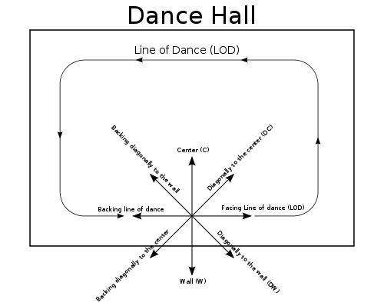
Spot Dances
(no line of dance)
Cha Cha
Rumba
Bolero
Swing/Jive
Mambo/Salsa
Merengue

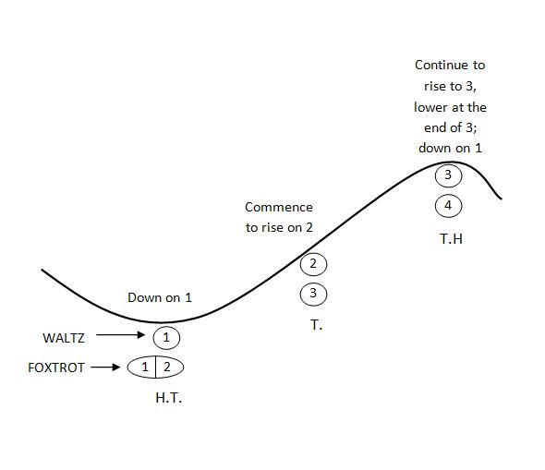
Progressive Dances
(travel along line of dance)
Waltz
Tango
Viennese Waltz
Foxtrot
Quickstep
Samba*
Paso Doble*
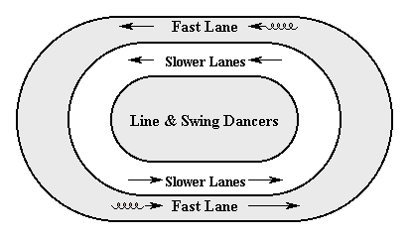
* Note that all ballroom dances are classified as progressive dances, while most Latin dances are classified as spot dances. The two exceptions to this are Samba and Paso Doble, which have the distinction of being the only Latin dances that travel around the line of dance.
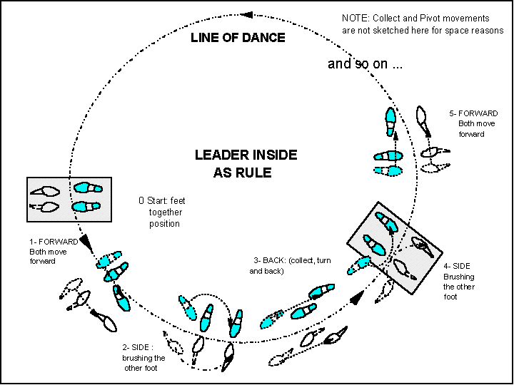
Movement Around L.O.D.
The line of dance is more of a rectangle than a circle (This is no accident, as most rooms are rectangular). This divides the line of dance into two distinct areas: Sides and Corners. When dancing at the side of the room, you will travel along the line of dance toward the corner. When the corner is reached, you turn the corner and begin moving down the "new" line of dance.
Even during the progressive dances, not all movements will travel exactly along the Line of Dance. Some movements can travel across it, weave in and out, or even move against it for a short period of time. But the overall movement should continue to progress in the direction of the Line of Dance. The amount of wiggle room afforded to each dancer is dependent upon many factors, including the floor size, number of dancers on the floor, the dance, and the environment (e.g. social dancing, competition, showcase, etc).
As a general rule, it is best to use the sides of the room to travel. The corners give you move flexibility to turn and change direction, since everybody does the same here. Stationary figures, lines, and poses should be reserved for the center of the room, where the flow of traffic is less pronounced.
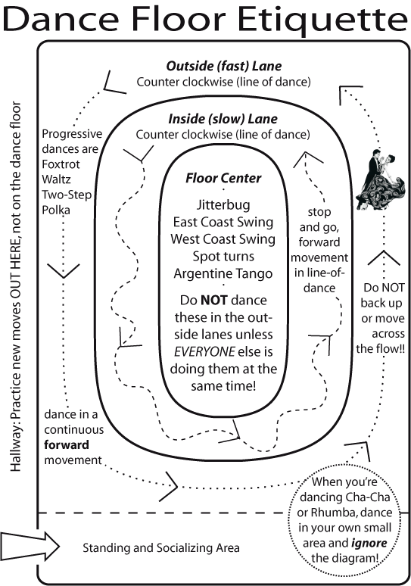

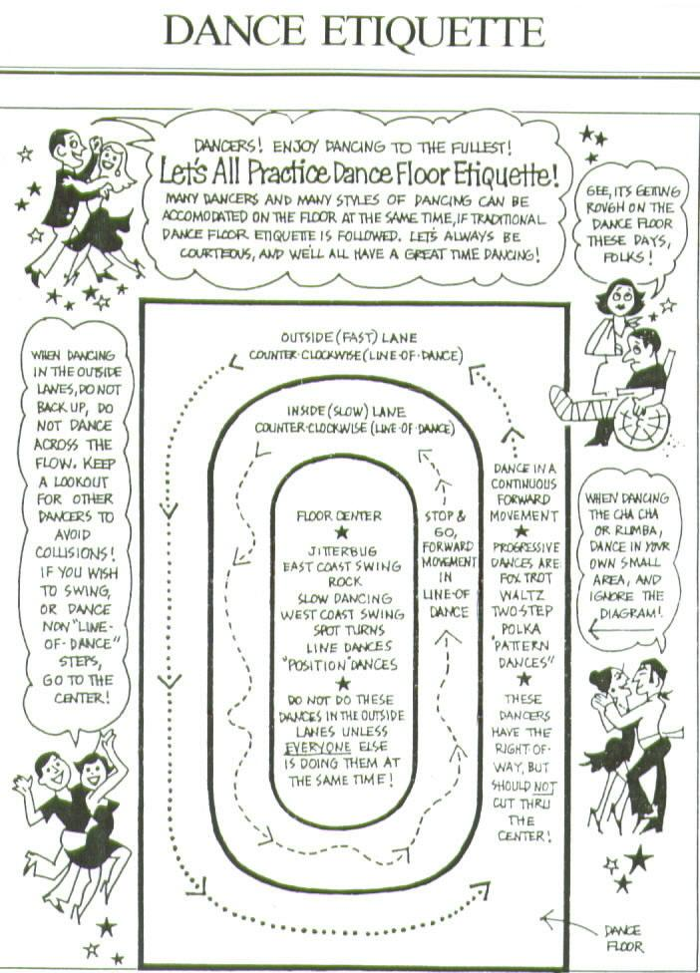

III. Post-text Exercises.
Exercise 1. Answer the following questions.
- What is it the line of dance?
- Which dance styles do you know?
- How can you characterize a spot dance?
- What does it mean progressive dance?
- Name, please, some of spot and progressive dances.
- Which dances are exceptions in classification of the ballroom dances?
- Why is the line of dance more of a rectangle than a circle?
- How many distinct areas in the line of dance do you know?
- What do the dancers do in the centre of the room?

Exercise 2. Find the equivalents in your native language to the following.
- imaginary line
- dance floor
- minimize collisions
- every dance style
- general area of the floor
- dancers travel continuously
- travel around the line of dance
- dance toward the corner
- travel exactly along the line of dance
- overall movement
- depend on many factors
- floor size
- number of dancers
- change direction
- stationary figures and lines
- flow of traffic
Exercise 3. Match synonyms from both columns.
traveling dance |  | kind
movement |  | flow
contain |  | traffic
describe |  | progressive dance
smooth |  | comprise
style |  | classify

Exercise 4. Match antonyms from both columns.
rule |  | traveling dance
stationary |  | roughly
spot dance |  | corner of the room
weave in |  | flow
exactly |  | exception
centre of the room |  | weave out

Exercise 5. Agree or disagree with the following.
- The line of dance is a real line on the floor.
- During traveling dance the dancers move in a counterclockwise direction.
- Every dance style can be characterized as either a spot dance or a progressive dance.
- During spot dance the dancers travel continuously.
- During progressive dance the dancers remain in one general area of the floor.
- Samba and Paso Doble are Latin dances that travel around the line of dance.
- The line of dance is more of a circle than a rectangle.
- The line of dance is divided into 4 areas.
- It is best to use the sides of the room to travel.
- When the corner is reached, you change direction.

Exercise 6. Complete the sentences and translate them into your native language.
- The line of dance represents the counterclockwise flow of …
- During traveling dances such as Waltz and Tango all dancers will move…
- Every dance style can be either …
- At spot dances the dancers remain in…
- At progressive dances the dancers travel…
- Spot dances are…
- Progressive dances are…
- Samba and Paso Doble are the only Latin…
- The line of dance is more of …
- The line of dance is divided into 2…
- Some movements travel across the line of dance, or even move…
- It is best to use…
- At the corners you can change…
- Stationary figures, lines, and poses should…

Exercise 7. Retell the text.

Unit 6. SLOW WALTZ
I. Pre-text Exercises.
Exercise 1. Study the active vocabulary.
 | English | Ukrainian | Russian
 | smooth | плавний | плавный
 | rise | підйом | подъём
 | fall | спуск | спуск
 | graceful | граціозний | грациозный
 | effortlessly | без зусиль | без усилий
 | measure | такт (муз.) | такт (муз.)
 | quality | якість | качество
 | invite | сприяти | способствовать
 | powerful | міцний | мощный
 | introduce | вводити | вводить
 | denounce | осуджувати | осуждать
 | outrageous | обурливий | возмутительный
 | folk dance | народний танець | народный танец
 | suburb | передмістя | пригород
 | spread | розповсюджувати | распространять
 | demand | вимога | требование
 | average dancer | звичайний танцюрист | обычный танцор
 | evolve | еволюціонувати | происходить
 | gliding movement | плавний рух | скользящее движение
 | fade away | зникати | исчезать
 | refine | удосконалювати | усовершенствовать
 | codify | систематизувати | систематизировать

Exercise 2. Read and translate without using the dictionary.
Elegant, per minute, tempo, music, dynamic movement, vulgarity, immorality, popularity, composers, style, stimulate, technique.

II. Read and Translate the Text:
SLOW WALTZ
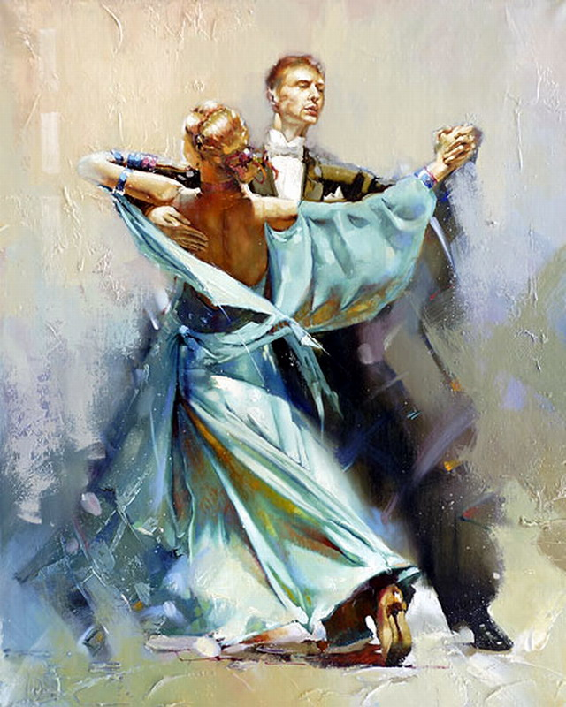
Waltz is a smooth progressive dance characterized by long, flowing movements, continuous turns, rise and fall. Graceful and elegant, Waltz dancers glide around the floor almost effortlessly. At 28-30 measures per minute, the tempo is slow at best, but the expressive quality of the music often invites very powerful and dynamic movement from dancers.
History
When first introduced into the English ballrooms in the early 1800`s, the Waltz was denounced by both church and state for its vulgarity and immorality... this was, after all, the first time society had seen this outrageous dance position, with the man holding the lady so close to his body.
Throughout its history, the Waltz has undergone many changes. Even before its introduction into society as a ballroom dance, it was a country folk dance born in the seventeenth century in the suburbs of Austria and Bavaria. By the middle of the eighteenth century, the dance had grown in popularity and spread throughout Europe.
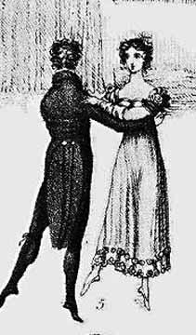
The Waltz was introduced into the United States in the mid-1800`s. The standard Waltz tempo at this time was still very fast and quite demanding to the average dancer, and before long, composers were writing music which was much slower. From this music evolved a style of Waltz called the Boston, with slower turns, and more longer, gliding movements. While the Boston eventually faded away, it did stimulate the development of what we now know as Slow Waltz. Throughout the twentieth century, the English refined the movements and codified the technique into the competitive International style Slow Waltz.

III. Post-text Exercises.
Exercise 1. Answer the following questions.
- How can you characterize Waltz?
- How many measures per minute does Waltz have?
- How does music tempo influence the dancers?
- When was the Waltz introduced into the English ballrooms?
- What was the attitude to that dance by the church and the state?
- What was Waltz before its introduction info society as a ballroom dance?
- When had Waltz grown in popularity and spread throughout Europe?
- What was standard Waltz tempo in the mid 1800’s?
- How is the Boston Waltz called now?
- Were the movements of Slow Waltz refined?

Exercise 2. Find the equivalents in your native language to the following.
- smooth progressive dance
- continuous turn
- graceful and elegant dance
- dancers glide around the floor
- tempo is slow at best
- powerful and dynamic movements
- denounce for vulgarity and immorality
- Waltz has undergone many changes
- country folk dance
- spread throughout Europe
- standard Waltz tempo
- very fast to the average dancer
- slower turns
- more longer, gliding movements
- codify the technique into the competitive style

Exercise 3. Match synonyms from both columns.
smooth movement |  | easy
effortless |  | strong
close |  | flow movement
powerful |  | near
refine |  | improve
invite |  | stimulate

Exercise 4. Match antonyms from both columns.
rise |  | before
slow |  | unknown
after |  | quick
popular |  | ballroom dance
folk dance |  | fall
average dancer |  | top-class dancer

Exercise 5. Agree or disagree with the following.
- Waltz is a quick spot dance with powerful and dynamic movements.
- Waltz tempo is slow, 28-30 measures per minute.
- When first introduced in the early 1800’s, the Waltz was cheered by both church and state.
- Waltz had no changes throughout its history.
- It was a country folk dance in the suburbs of Austria and Bavaria.
- The Waltz was introduced into the United States and because of slow music was called Boston Waltz.
- The Boston Waltz stimulated the development of Tango.
- The Americans refined the movements and codified the technique into the competitive International style Slow Waltz.

Exercise 6. Complete the sentences and translate them into your native language.
- Waltz is a smooth progressive dance characterized by…
- Graceful and elegant, Waltz dancers…
- When first introduced into the English ballrooms the Waltz was denounced by…
- Throughout its history, the Waltz has…
- Waltz was a country folk dance born in…
- In the 18th century the dance had grown in…
- The Waltz was introduced into …
- The standard Waltz tempo was very fast…
- From slow music evolved a style...
- Throughout the 20th century, the English refined…

Exercise 7. Retell the text.

Unit 7. MOVEMENT IN SLOW WALTZ
I. Pre-text Exercises.
Exercise 1. Study the active vocabulary.
 | English | Ukrainian | Russian
 | footwork | робота ніг | робота ног
 | lower | опускати | опускать
 | define | визначати | определять
 | beat | удар | удар
 | lowest point | найнижча точка | самая нижняя точка
 | i.e. (that is) | тобто | то есть
 | occur | відбуватися | происходить
 | highest point | найвища точка | самая высокая точка
 | commence | починати | начинать
 | sway | свей | свей
 | inclination | нахил | наклон
 | accompany | супроводжувати | сопровождать
 | closed position hold | закрита позиція | закрытая позиция
 | semi-closed hold | напівзакрита позиція | полузакрытая позиция
 | although | хоча | хоть
 | learning purpose | навчальна мета | учебная цель
 | offset | зміщуватися | смещаться
 | join | з’єднувати | соединять
 | frame | структура | структура
 | sturdy | міцний | крепкий
 | relaxed | менш напружений | не скованный

Exercise 2. Read and translate without using the dictionary.
Normally, contact, typically, standard, position, style, social, situation, man, lady, absent, characteristic.

II. Read and Translate the Text:
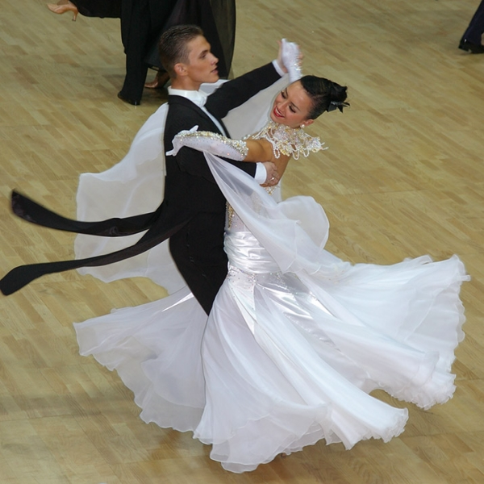
MOVEMENT IN SLOW WALTZ

Footwork: Forward walking steps are normally taken with the heel first in contact with the floor, with the toe lowering as the body moves over it. Backward walks are taken with the toe first, with the heel lowering as the body moves over it. At the same time, the toe of the forward foot is released from the floor as the body moves away. Side steps normally use the toe first.
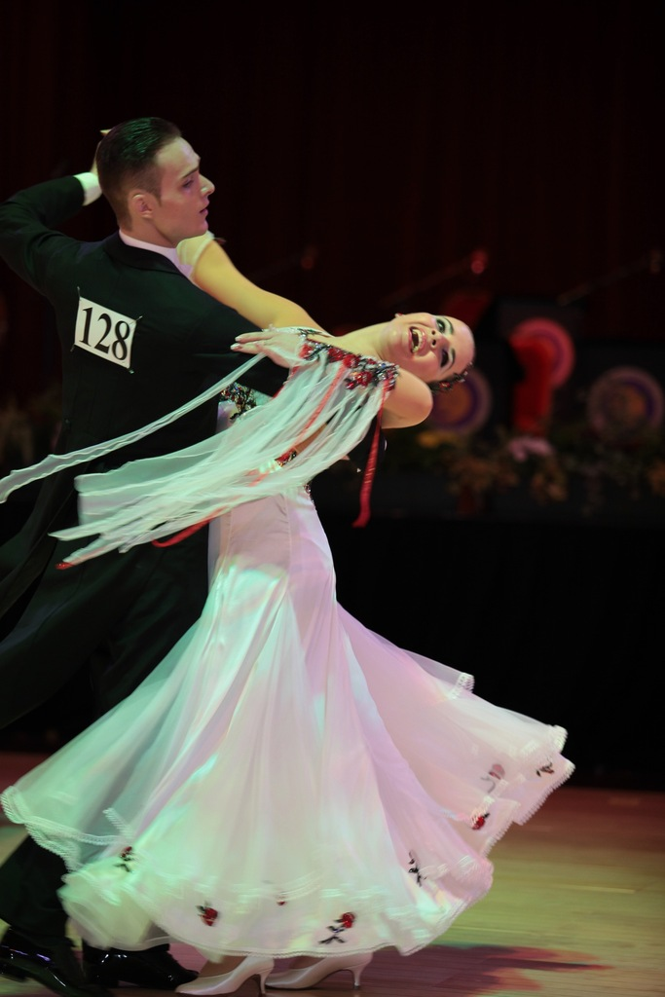
Rise & Fall: Rise & Fall is a defining characteristic of Slow Waltz. Each cycle of rising and lowering typically takes place over 1 measure (3 beats) of Waltz music. The lowest point in the cycle (i.e. the point at which the knees are the most bent) occurs when the foot is placed at the beginning of the first beat in the measure. The highest point in the cycle (i.e. when the body is elevated to its highest on toes) occurs at the beginning of the third beat in the measure.
Contra-Body Movement is typical of the smooth and standard ballroom dances. Contra-body movement is used to commence most turning movements.
Sway is defined as the inclination of the body to the left or right, usually accompanying movements to the side. Sway is present in most figures of Slow Waltz.
Dance Position
Slow Waltz is danced using a normal ballroom-style closed position dance hold. This typically includes the use of body contact, although a more relaxed semi-closed hold is often used in social dance situations, or for learning purposes.
In closed position the man and lady stand in front of each other, slightly offset to the left. The lady's right hand and man's left hand are joined in an upper-hand clasp at approximately the lady's eye level. The man's right hand is placed on the lady's shoulder blade, with the lady's left arm resting easily on his right. The resulting dance frame should be held sturdy, but relaxed and absent of tension or strain.
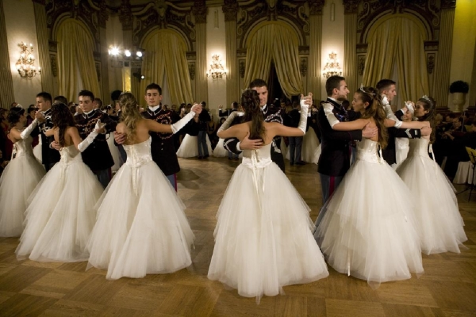
III. Post-text Exercises.
Exercise 1. Answer the following questions.
- What main walking steps are there in Slow Waltz?
- How must you move forward?
- Describe, please, backward walks.
- What do side steps use first?
- What is a defining characteristic of Slow Waltz?
- When does the lowest point in the footwork cycle occur?
- When does the highest point in the footwork cycle take place?
- Which movement is typical of the smooth and standard ballroom dances?
- How can you define “sway”?
- What is a normal Slow Waltz dance position?
- How does closed dance position differ from semi-closed position?
- How do the partners stand in closed position?
- Describe, please, the placement of man’s hands in closed position.
- What can you tell about lady’s arms and hands?
- Should the dance frame be held sturdy in Slow Waltz?

Exercise 2. Find the equivalents in your native language to the following.
- forward walking steps
- in contact with the floor
- toe is lowering
- foot releases from the floor
- cycle of rising and lowering
- first (third) beat in the measure
- inclination of the body
- standard ballroom dance
- accompany movements to the side
- stand in front of each other
- at approximately the lady’s eye level
- left arm is resting easily on man’s right
- absent of tension or strain

Exercise 3. Match synonyms from both columns.
normally |  | move
slightly |  | take place
contact |  | elevate
lift |  | touch
occur |  | usually
walk |  | a little

Exercise 4. Match antonyms from both columns.
heel |  | to be absent
contact |  | lowest point
first |  | fall
rise |  | last
highest point |  | release
to be present |  | toe

Exercise 5. Agree or disagree with the following.
- Forward walking steps are normally taken with the toe first in contact with the floor.
- Backward walks are taken with the heel lowering as the body moves over it.
- Rise and fall is a defining characteristic of Slow Waltz.
- The lowest point in the cycle is the point when the body is elevated to the highest on toes.
- The highest point in the cycle is the point at which the knees are the most beat.
- Each cycle of rising and lowering typically takes place over 2 measures.
- Sway is defined as the inclination of the body.
- Slow Waltz is danced using semi-closed hold.
- In closed position the man and lady stand in front of each other.
- The resulting dance frame should be held sturdy.

Exercise 6. Complete the sentences and translate them into your native language.
- In forward walking steps the heel is first in…
- In backward walks the toe is the first in contact…
- Side steps normally used …
- Rise and fall is a defining …
- Each cycle of rising and lowering…
- The lowest point in the cycle occurs…
- The highest point in the cycle occurs…
- Contra-body movement is…
- Sway is defined as …
- Slow Waltz is danced using a normal…
- A more relaxed semi-closed hold is often…
- In closed position the man and lady stand…
- The lady’s right hand and man’s left hand are…
- The man’s right hand is placed…
- The resulting dance frame should be…

Exercise 7. Retell the text.
Unit 8. VIENNESE WALTZ
I. Pre-text Exercises.
Exercise 1. Study the active vocabulary.
 | English | Ukrainian | Russian
 | genre | жанр | жанр
 | varied | різний | различный
 | notorious | загальновідомий | общеизвестный
 | close change | закрита зміна | закрытая перемена
 | figure | фігура | фигура
 | transition | перехід | переход
 | consecutively | послідовно | последовательно
 | pattern | комбінація | комбинация
 | continue | продовжувати | продолжать
 | close | робити приставку | делать приставку
 | opposite | навпаки | наоборот

Exercise 2. Read and translate without using the dictionary.
Traditionally, name, specific, instrumental, musical, orchestra, composer, the Blue Danube, Tales from the Vienna Woods, progress, gentlemen, floor.

II. Read and Translate the Text:
VIENNESE WALTZ

Style: Intl Standard (Ballroom)
Music: Fast music in 3/4 or 6/8 time, often classical such as Strauss Waltzes.
Meter: 3/4 or 6/8
Tempo: 174 - 180 beats per minute
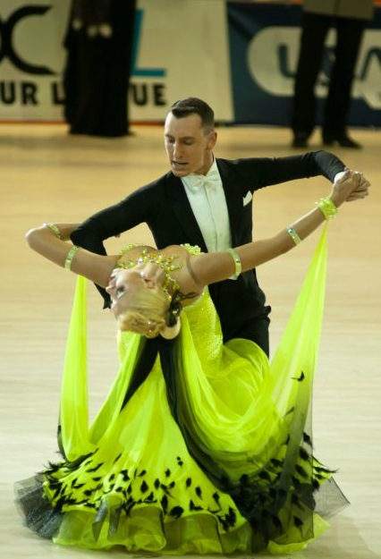
Basic Rhythm: 123 123 (strong accent on 1)

Music
Traditionally, the name Viennese Waltz refers to a very specific musical genre. The music is usually written in 6/8 time at a tempo of 29-30 measures per minute, although it is sometimes written as a fast 3/4 at 58-60 measures per minute. It is almost always instrumental, written for orchestras of varying sizes. The most well-known of all composers of Viennese Waltz music is Johann Strauss, responsible for such notorious works as the Blue Danube and Tales From the Vienna Woods.

Closed Changes in Viennese Waltz
Closed Changes are figures that consist of three steps and are generally used to transition from Reverse Turns to Natural Turns. They can also be used consecutively to progress down the floor.
a. Closed Change - Natural to Reverse
This figure is typically used to transition from a Natural Turn to a Reverse Turn. It can also be followed by the Reverse to Natural Closed Change. By repeating this pattern, the two steps can be used to continue progressing down the floor.
The gentleman begins forward on the right foot and takes three steps, forward, side and slightly forward, closed, to end with his left foot free to begin either the Reverse Turn or the Reverse to Natural Closed Change.
The lady has the natural opposite.
b. Closed Change - Reverse to Natural
This figure is typically used to transition from a Reverse Turn to a Natural Turn. It can also be followed by the Natural to Reverse Closed Change. By repeating this pattern, the two steps can be used to continue progressing down the floor.
The gentleman begins forward on the left foot and takes three steps, forward, side and slightly forward, closed, to end with his right foot free to begin either the Natural Turn or the Natural to Reverse Closed Change.
The lady has the natural opposite.

III. Post-text Exercises.
Exercise 1. Answer the following questions.
- What can you say about music for Viennese Waltz?
- Who is the composer of Viennese Waltz?
- What are his notorious works?
- Why do the dancers use closed changes?
- How many steps does the figure consist of?
- Describe, please, the natural closed change.
- When do the dancers use a reverse turn to a natural turn?
- How is the reverse turn to a natural turn performed?
- Are the movements of the lady the same as the movements of the gentleman?

Exercise 2. Find the equivalents in your native language to the following.
- specific musical genre
- measure per minute
- music written for orchestras
- composer of notorious works
- figure consists of 3 steps
- transition from reverse turn to natural turn
- continue progressing down the floor
- take 3 steps forward
- step aside and slightly forward
- left foot is used to transition
- repeat the pattern
- lady has the natural opposite.

Exercise 3. Match synonyms from both columns.
pattern |  | move
continue |  | popular
notorious |  | from time to time
step |  | to start
sometimes |  | model
to begin |  | go on

Exercise 4. Match antonyms from both columns.
closed |  | gentleman
natural |  | ordinary
specific |  | occupied
lady |  | stop
free |  | opened
progress |  | reverse

Exercise 5. Agree or disagree with the following.
- The Viennese Waltz music is written in 6/8 time at a tempo of 29-30 measures per minute.
- A. Mozart is a composer of such works as the Blue Danube and Tales from the Vienna Woods.
- Closed changes are used to transition from reverse turns to natural turns.
- In the natural turn to the reverse turn the gentleman begins forward on the left foot.
- In the reverse turn to the natural turn the gentleman begins forward on the right foot and takes 5 steps.
- The lady has the natural opposite.
- The 2 steps can be used to continue progressing down the floor.

Exercise 6. Complete the sentences and translate them into your native language.
- Traditionally, the name Viennese Waltz refers…
- The music is usually…
- It is almost always instrumental…
- Closed changes are figures…
- They can also be used to progress…
- Closed change-natural to reverse is used to…
- By repeating this pattern…
- The gentleman begins forward…
- Closed change-reverse to natural is typically used to…
- The gentleman begins forward on …
- The lady has…

Exercise 7. Retell the text.

Unit 9. TANGO
I. Pre-text Exercises.
Exercise 1. Study the active vocabulary.
 | English | Ukrainian | Russian
 | transient | тимчасовий мешканець (транзитер) | временно проживающий (транзитер)
 | lonely | самостійний | одинокий
 | habitat | середовище | среда обитания
 | forlorn | нещасний | несчастный
 | entertainment | розвага | развлечение
 | distract | розвіювати | развеять
 | guess | догадуватися | догадываться
 | dub | давати прізвисько | давать прозвище
 | argue | сперечатися | спорить
 | drum | барабан | барабан
 | outpouring | вилив почуттів | излияние чувств
 | suggestive | непристойний | непристойный
 | gyration | кругові рухи тазом | круговые движения тазом
 | crude | грубий | грубый
 | obscene | безсоромний | неприличный
 | passionate | пристрасний | страстный
 | powerful dance | міцний танець | мощный танец
 | dramatic gesture | драматичний жест | драматический жест
 | snap of the head | різкий поворот голови | резкий поворот головы
 | incorporate | об’єднувати | объединять
 | apart from | осторонь від… | в стороне от…

Exercise 2. Read and translate without using the dictionary.
Immigrant, naturally, temporary, friendship, depressed feeling, culture, new style of music, beat, popular music, pampas, pantomime, improvisation, choreography, melancholy, symbolize, evolution, emotion, character.

II. Read and Translate the Text:
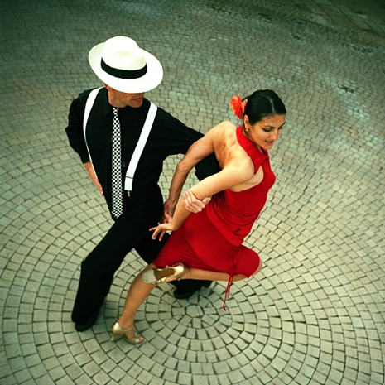
TANGO
Style: Standard (Ballroom)
Music: Medium tempo orchestral, often march-like.
Meter: 4/4
Tempo: 128 - 132 beats per minute
Basic Rhythm: Quick-Quick-Slow
History
In the late 19th century, Buenos Aires was filled with immigrants and transients from Europe and Africa, many of whom found themselves lonely and looking for companionship in their new foreign habitat. Naturally, these forlorn people found their way to the seeking drinks to drown their sorrows, temporary friendship, and any entertainment to help distract their depressed feelings. The variety of cultures combined to bring about a new style of music, formed from African beats, Indian rhythms, Latin influences, and the popular music of the pampas (flatlands) in Argentina.
As you may guess, this new music was dubbed Tango. Historians argue the name comes from the African drum beat known as "tan-go", or possibly from Latin word tangere (to touch). The dance began as a pantomime of communication between two people. The improvisation was filled with emotional outpouring and suggestive gyration. This sexual choreography was accented by the melancholy of a German instrument very similar to the accordion.
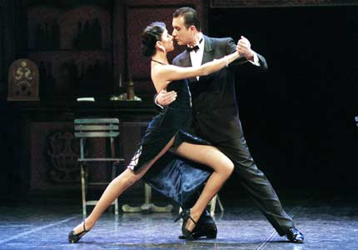
This crude beginning developed into less obscene style that symbolized the lower class of Argentina through the turn of the century. Throughout Tango`s evolution, two things remained constant: the background music and the passionate translation of emotions into dance.
International Style
As they did with many other dances, the Europeans (most notably the English) adopted Tango and made it their own. A very powerful dance was the result, with big movements, dramatic gestures, and quick snaps of the head from one position to another. Grouped together in competitive events with the smooth ballroom dances, the International Tango incorporated many of the patterns characteristics of Waltz and Foxtrot. But it still mantains a very unique character which sets it apart from all of the other ballroom dances.
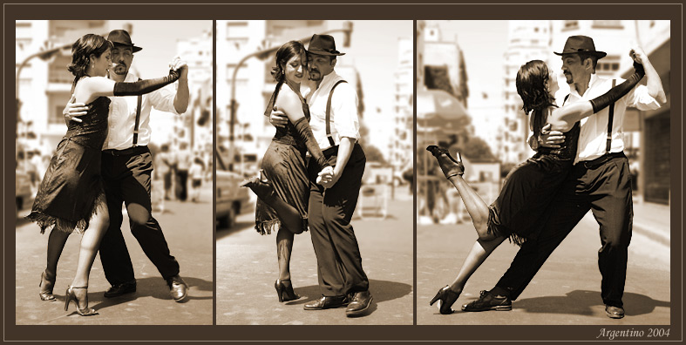

I. Post-text Exercises.
Exercise 1. Answer the following questions.
- What is the homeland of Tango?
- Why did this dance appear?
- What does Tango combine?
- Why do historians argue about Tango?
- How did Tango begin?
- Which instrument accented the melancholy?
- What did Tango symbolize at the beginning?
- Which two things remained constant in Tango?
- What did the Europeans do with Tango?
- How can you characterize this dance?
- Did the international Tango incorporate many of the patterns of Waltz and Foxtrot?
- Is Tango apart from all of the other ballroom dances?

Exercise 2. Find the equivalents in your native language to the following.
- transients from Europe and Africa
- found themselves lonely
- new foreign habitat
- forlorn people were seeking entertainment
- variety of cultures
- new style of music
- the name comes from
- pantomime of communication
- improvisation was filled with emotional outpouring
- instrument very similar to the accordion
- symbolized the lower class of the country
- big movements
- dramatic gestures
- quick snaps of the head
- Tango maintains a very unique character

Exercise 3. Match synonyms from both columns.
forlorn |  | model
to incorporate |  | rough
pattern |  | to seek
crude |  | different
to look for |  | unhappy
various |  | to include
evolution |  | development

Exercise 4. Match antonyms from both columns.
temporary |  | weak
passionate |  | polite
foreign |  | emotionless
crude |  | higher class
powerful |  | domestic
lower class |  | constant

Exercise 5. Agree or disagree with the following.
- In the early 18th century, Buenos Aires was filled with immigrants and transients from Europe and Africa.
- They feel quite comfortable and happy in Argentina.
- The variety of cultures combined to bring a new style of music.
- The dance Tango began as a pantomime of communication between two people.
- Throughout Tango’s evolution only background music remained constant.
- The Ukrainians adopted Tango and made it their own.
- Tango has a unique character with big movements, dramatic gestures, and quick snaps of the head.
- Waltz incorporated many patterns of Tango and Samba.
- Tango sets apart from all of the other ballroom dances.

Exercise 6. Complete the sentences and translate them into your native language.
- Many immigrants found themselves…
- These forlorn people found their way…
- The new style of music formed from…
- The name Tango comes from the African…
- The improvisation was filled with…
- This sexual choreography was accented by…
- Two Tango things remained constant…
- The Europeans adopted Tango and…
- A very powerful dance was the result…
- The International Tango incorporated many…
- But still Tango sets it apart…

Exercise 7. Retell the text.

Unit 10. SLOW FOXTROT
I. Pre-text Exercises.
Exercise 1. Study the active vocabulary.
 | English | Ukrainian | Russian
 | continuous | тривалий, безперервний | длительный, непрерывный
 | flowing movement | плавний рух | плавное движение
 | ultimately | в решті решт | в конце концов
 | lasting dance | танок, що міцно закріпився | прочно укрепившийся танец
 | original Foxtrot | справжній, оригінальний фокстрот | подлинный, оригинальный фокстрот
 | moderately | помірно | умеренно
 | unrefined | грубий | грубый
 | stem | походити | происходить
 | versatility | універсальність, різнобічність | универсальность, многосторонность
 | quality | якість | качество
 | exiting Latin dance | захоплюючі латиноамериканські танці | волнующие латиноамериканские танцы
 | evolve | розвиватися | развиваться
 | approximately | приблизно | приблизительно
 | absent of tension | без напруги | без напряжения

Exercise 2. Read and translate without using the dictionary.
Jazz, basic rhythm, smooth progressive dance, history, popular dance, stylistic change, standard, variation, in contrast, technical basis, dance position.

II. Read and Translate the Text:
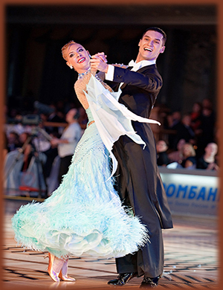
SLOW FOXTROT
Style: Intl Standard (Ballroom)
Music: Medium-slow jazz/swing music.
Meter: 4/4
Tempo: 112 - 120 beats per minute
Basic Rhythm: Slow-Quick-Quick
Foxtrot is a smooth progressive dance characterized by long, continuous flowing movements across the dance floor.
History
Foxtrot was introduced into the mainstream in 1913 by a man named Harry Fox. It ultimately became the most popular and lasting dance of the twentieth century, but not before going through many stylistic changes.
Compared with today's standards, the original Foxtrot was moderately fast, simple and unrefined, not unlike the music of the time. The popularity of the dance stemmed from its overall versatility and rhythmic variation (Foxtrot is noted for being the first dance to introduce the "Slow" count, before which time the popular dances such as Waltz and One-Step had only a single-count rhythm). But it wasn't until the early 30's that Foxtrot began to take on a smoother and more flowing quality in contrast to the new and exciting Latin dances hitting the scene.
A modified version called Slow Foxtrot was evolved by the English, and is the technical basis for the version we now have.
Dance Position
Foxtrot is danced using a normal ballroom-style closed position dance hold. This typically includes the use of body contact, although a more relaxed semi-closed hold is often used in social dance situations, or for learning purposes.
In closed position the man and lady stand in front of each other, slightly offset to the left. The lady's right hand and man's left hand are joined in an upper-hand clasp at approximately the lady's eye level. The man's right hand is placed on the lady's shoulder blade, with the lady's left arm resting easily on his right. The resulting dance "frame" should be held sturdy, but relaxed and absent of tension or strain.
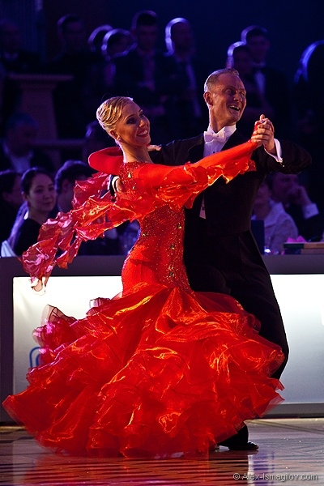
III. Post-text Exercises.
Exercise 1. Answer the following questions.
- How can you characterize Foxtrot?
- When was Foxtrot introduced?
- Who was the inventor of Foxtrot?
- When did this dance become popular and lasting?
- Did the original Foxtrot differ from today’s standard?
- Why was this dance so popular?
- When did Foxtrot begin take on a smoother and more flowing quality?
- Who evolved Slow Foxtrot?
- What position is used in Foxtrot?
- Is it possible to use a relaxed semi closed hold?
- How do the partners stand?
- What should the resulting dance “frame” be?

Exercise 2. Find the equivalents in your native language to the following.
- smooth progressive dance
- flowing movements
- popular and lasting dance of the XXth century
- overall versatility of Foxtrot
- popular dance with a single-count rhythm
- new and exiting Latin dances
- technical basis for the new version
- normal ballroom style
- closed position dance hold
- partners stand in front of each other
- lady’s right hand
- gentleman’s right hand is on the lady’s shoulder blade
- resulting dance frame should be sturdy

Exercise 3. Match synonyms from both columns.
was introduced |  | well-known
ultimately |  | quick
popular |  | at long last
fast |  | easy
simple |  | was founded
evolve |  | develop
normal |  | strain
tension |  | standard

Exercise 4. Match antonyms from both columns.
long |  | fast
flowing |  | relaxed
slow |  | sharp
sturdy |  | quantity
quality |  | short
closed |  | move
rest |  | opened

Exercise 5. Agree or disagree with the following.
- Foxtrot is an exciting Latin dance with quick emotional movements.
- Harry Fox introduced Foxtrot in 1950.
- This dance became very popular in the XIXth century.
- The original Foxtrot was moderately fast, simple and unrefined.
- It wasn’t until the early 30’s that Foxtrot began to take on a smoother and more flowing quality.
- Slow Foxtrot was evolved by the Americans.
- Foxtrot is danced using relaxed position.
- The resulting dance frame should be of tension and strain.
- Lady’s right hand is placed on the gentleman’s shoulder blade.
- Gentleman’s left arm is resting easily on lady’s right.
- Semi-closed hold is often used for learning purposes.

Exercise 6. Complete the sentences and translate them into your native language.
- Slow Foxtrot music is …
- Basic rhythm is …
- Foxtrot is characterized by …
- This dance was introduced …
- The original Foxtrot was …
- The popularity of the dance …
- In early 30’s Foxtrot began to take …
- A modified version called Slow …
- Foxtrot is danced using …
- This typically includes the use of …
- In closed position the man and lady …
- The resulting dance “frame” should be …

Exercise 7. Retell the text.

Unit 11. Samba

I. Pre-text Exercises.
Exercise 1. Study the active vocabulary.
 | English | Ukrainian | Russian
 | music with strong downbeat | музика з сильним відбиванням такту | музыка с сильной долей такта
 | alternate | чергувати | чередовать
 | bounce motion | коливальний рух | колебательное движение
 | facilitate | сприяти | способствовать
 | gradual | поступовий | постепенный
 | combination | поєднання | сочетание
 | mirror image | дзеркальне відображення | зеркальное отражение

Exercise 2. Read and translate without using the dictionary.
International, Brazilian, accent on, natural basic movement, forward and backward steps, turn left and right, diagonally, move progressively, line of dance.

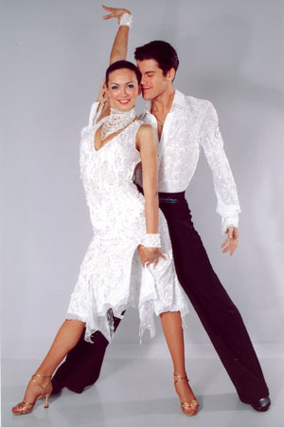
II. Read and Translate the Texts:
SAMBA
Style: International Latin
Music: Medium tempo Brazilian Latin music with strong downbeat.
Meter: 2/4
Tempo: 100 beats per minute
Basic Rhythm: 1 a2 1 a2 (accent on downbeat)
Natural Basic Movement
The Samba Basic Movements consist of a series of alternating forward and backward steps taken in closed position, using the characteristic Samba bounce motion. The Natural Basic Movement is taken with the right foot forward and left foot back, facilitating a gradual turn to the right.
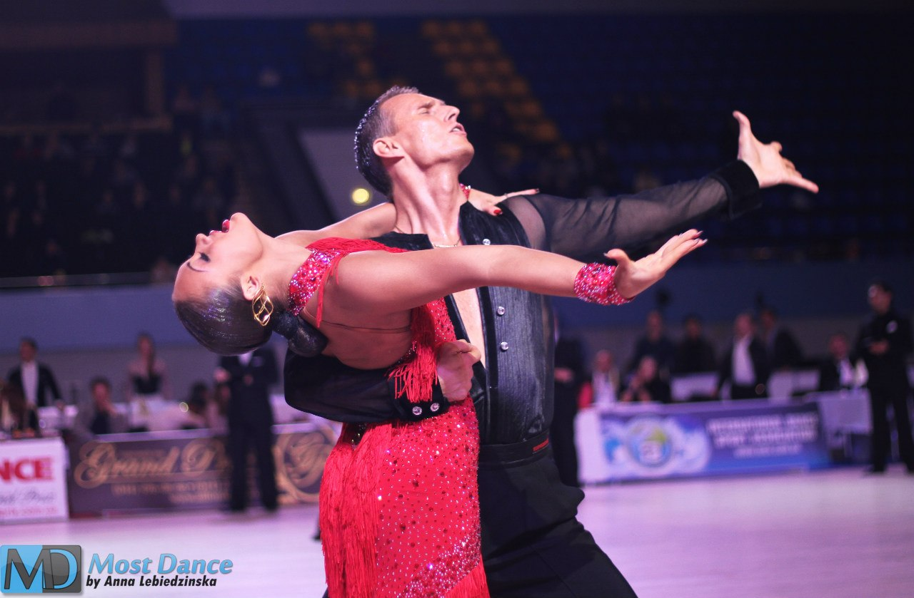
The Reverse Basic Movement is taken with the left foot forward and right foot back, facilitating a gradual turn to the left.
Basic Movement to Side
The Samba Basic Movements to Side (or Side Basic) are a similar action to the Natural and Reverse Basics, but taken sideways to the left and right, rather than forward or back. They are danced using the normal Samba bounce motion, and can be taken without turn, or turned gradually to the right or left.
Progressive Basic Movement
The Progressive Basic is a combination of basic movements, alternating between one measure of the Natural Basic (man forward on right foot) and one measure of the Side Basic. When repeated with man facing diagonally toward the wall, this combination allows the dancers to move progressively along the line of dance.
The mirror image of this can be danced with man facing diagonally to the center, alternating between one measure of Reverse Basic (man forward on left foot) and one measure of Side Basic.

III. Post-text Exercises.
Exercise 1. Answer the following questions.
- What style of dance is Samba?
- What can you tell about music for Samba?
- What do the Samba basic movements consist of?
- How is the natural basic movement taken?
- Which foot do you begin the reverse basic movement with?
- How is Samba side basic danced?
- What do you know about progressive basic movement in Samba?
- What combination allows the dancers move progressively along the line of dance?
- How can the mirror image of Samba be danced?

Exercise 2. Find the equivalents in your native language to the following.
- medium tempo
- accent on downbeat
- natural basic movement
- reverse basic movement
- Samba side basic
- progressive basic movement
- right foot forward
- left foot back
- gradual turn to the left
- alternating forward and backward steps
- move progressively along the line of dance
- facing diagonally to the centre / to the wall
- one measure of reverse basic
- one measure of side basic

Exercise 3. Match synonyms from both columns.
accent |  | activity
similar |  | dancers
movement |  | change
action |  | motion
partners |  | pay attention to
alternate |  | equal

Exercise 4. Match antonyms from both columns.
international |  | corner
turn to left |  | stop
step forward |  | turn to right
centre |  | slow tempo
move |  | step backward
fast tempo |  | domestic/national

Exercise 5. Agree or disagree with the following.
- Samba is a standard ballroom dance.
- Brazilian Latin music with strong downbeat is used for Samba.
- Basic movements consist of a series of alternating forward and backward steps.
- The reverse basic movement is taken with right foot forward.
- Side basic is a similar action to the natural and reverse basic.
- No bounce motions are used in Samba.
- Progressive basic is a combination of basic movements.
- When man is facing diagonally along the wall, it allows the dancers to move to the centre of the room.
- The mirror image can be danced with man facing diagonally to the centre.

Exercise 6. Complete the sentences and translate them into your native language.
- Samba style is …
- Music for Samba is of …
- The natural basic movements consist of …
- The natural basic movement is taken with …
- The reverse basic movement is taken with …
- Samba movements to side are a similar …
- They are danced using …
- The progressive basic is a combination …
- When man is facing diagonally to the wall …
- The mirror image can be danced with …

Exercise 7. Retell the text.

Unit 12. Paso Doble
I. Pre-text Exercises.
Exercise 1. Study the active vocabulary.
 | English | Ukrainian | Russian
 | frequently | часто | часто
 | entitle | під назвою | под названием
 | consecutive | послідовний | последовательный
 | with strong pressure | з сильним натисканням | с сильным нажимом
 | ball of the foot | подушечка стопи | подушечка стопы
 | suspend | призупиняти | приостанавливать
 | measurable length of time | не дуже довго | не надолго
 | barely | ледве | чуть-чуть
 | immediately | негайно | немедленно
 | remainder | залишок | остаток
 | turn sur place | поворот на місці | поворот на месте
 | chasse | шассе´ (фігура у танці) | шассе´ (фигура в танце)
 | preferred shape | краща форма/модель | предпочтительная форма/модель
 | promenade | променад | променад

Exercise 2. Read and translate without using the dictionary.
Dramatic, bullfight, marching step, one beat of music, actual, elevation, heel of the foot, touch the floor, gradually rising, lift, partner.

II. Read and Translate the Text:
PASO DOBLE
Style: International Latin
Music: Dramatic Latin "Bullfight" music; Frequently a song entitled Espana Cani.
Meter: 2/4
Tempo: 120 - 124 beats per minute
Basic Rhythm: March (one step per beat)

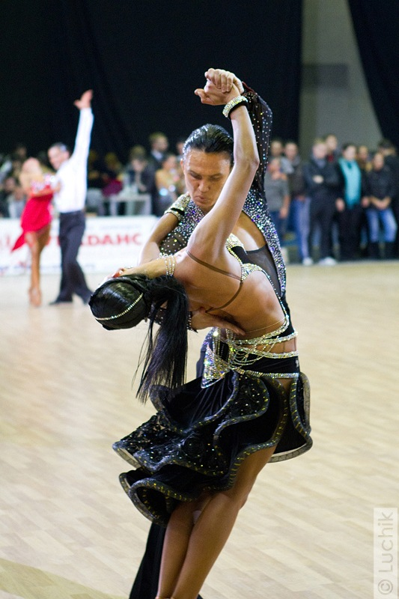
Sur Place
Sur Place is a series of consecutive "marching" steps taken in place, each step taking one beat of music. It is normally danced in closed or semi-closed hold, and can be taken with or without turn.
Steps are normally taken with strong pressure on the balls of the feet, although the actual amount of elevation is variable. One can dance lowered, with heels nearly touching the floor, high on the balls of the feet, or gradually rising or lowering.
On each step, the free foot should not be lifted high off the floor or suspended for any measurable length of time; rather, it should be lifted barely above the floor and immediately replaced with pressure into the ball of the foot at the beginning of the beat. The remainder of the beat will be spent with both feet in contact with the floor.
When turning Sur Place to the left or right, one partner will take steps turning in place while the other partner dances a small chasse around the outside of turn.
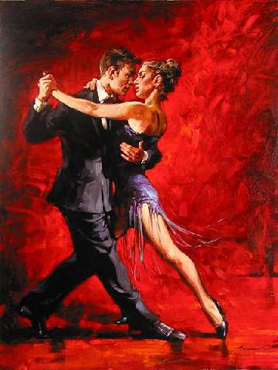
Turning Sur Place can be taken with or without shape. The preferred shape for turning to the left is promenade, and to the right is counter-promenade.

III. Post-text Exercises.
Exercise 1. Answer the following questions.
- What music is typical for dancing Paso Doble?
- What does the term “Sur Place” mean?
- How is Paso Doble normally danced?
- Which variants of this dance are possible?
- What are specific steps in Paso Doble?
- How many steps per beat are there in this dance?
- How is turning sur place done?
- Which turns do the partners perform?
- What does the dancer do while the partner takes steps turning in place?
- What is the preferred shape for turning to the left/right?

Exercise 2. Find the equivalents in your native language to the following.
- dramatic Latin music
- series of consecutive “marching” steps
- dance in closed or semi-closed hold
- with or without turn
- with heels nearly touching the floor
- high on the balls of the feet
- lift high off the floor
- lift barely above the floor
- at the beginning of the beat
- both feet in contact with the floor
- turning sur place
- dance a small chasse
- shape for turning to the left is promenade
- shape for turning to the right is counter-promenade

Exercise 3. Match synonyms from both columns.
frequently |  | lift
consecutive |  | at once
elevate |  | form
immediately |  | slightly
shape |  | following
barely |  | often

Exercise 4. Match antonyms from both columns.
promenade |  | under
above |  | seldom
high |  | light pressure
frequently |  | inside
strong pressure |  | counter-promenade
outside |  | low

Exercise 5. Agree or disagree with the following.
- Paso Doble style is international standard dance.
- The basic musical rhythm is march.
- Sur place is a series of sliding long steps along the dance line.
- Paso Doble is danced in closed or semi-closed hold.
- The actual amount of elevation is constant.
- On each step, the free foot should be lifted as high off the floor as possible.
- When turning sur place to the left the preferred shape is promenade.
- One partner takes steps turning in place and another dances a small shasse.
- The beat of the step is spent with one feet in contact with the floor.
- Turning sur place to the right the dancers use counter-promenade.

Exercise 6. Complete the sentences and translate them into your native language.
- Paso Doble music is a dramatic …
- Sur place is a series of …
- It is normally danced in …
- Steps are normally taken with strong …
- One can dance lowered, with …
- The foot should be lifted barely …
- The remainder of the beat will be …
- When turning sur place, one partner …
- Turning in place can be taken with …
- Shape for turning to the left is …
- Shape for turning to the right is …

Exercise 7. Retell the text.

Unit 13. Cha Cha Cha
I. Pre-text Exercises.
Exercise 1. Study the active vocabulary.
 | English | Ukrainian | Russian
 | transfer | переносити | переносить
 | release | звільняти | освобождать
 | bend | згинати | сгибать
 | straighten | випрямляти | выпрямлять
 | weighted leg | опорна нога | опорная нога
 | free leg | вільна нога | свободная нога
 | settle into | зміщатися у … | смещаться в …
 | instant | на мить | на мгновение
 | compact | щільний | плотный
 | slightly apart | злегка осторонь | слегка обособленно
 | well connected | добре з’єднаний | хорошо соединённый

Exercise 2. Read and translate without using the dictionary.
Medium-tempo music, footwork, hip movement, international style, dance position, basic hold, right hand, eye level, dance frame.

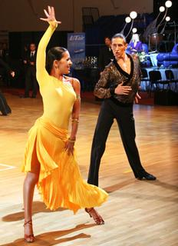
II. Read and Translate the Text:
CHA CHA CHA
Style: International Latin
Music: Medium-tempo Latin music.
Meter: 4/4
Tempo: 128 beats per minute
Basic Rhythm: 2, 3, 4&1, 2, 3, 4&1 (accent on count 1)

Movement
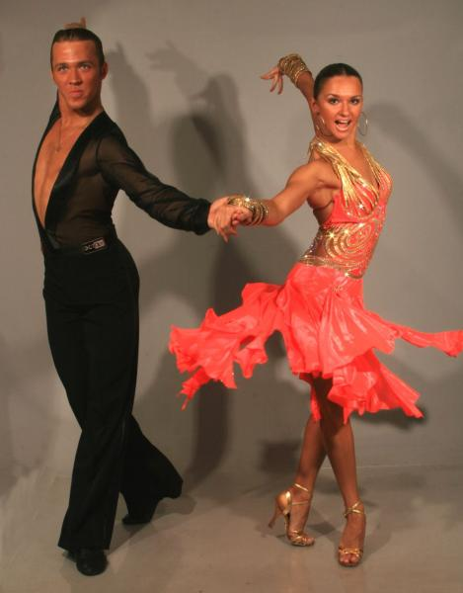
Footwork: Steps in all directions should be taken first with the ball of the foot in contact with the floor, and then with the heel lowering when the weight is fully transferred. When weight is released from a foot, the heel should release first, allowing the toe to maintain contact with the floor.
Hip Movement: Latin Hip movement is achieved through the alternate bending and straightening action of the knees. In the International Latin style, the weighted leg should be straight. The free leg will bend, allowing the hips to naturally settle into the direction of the weighted leg. As a step is taken, a free leg will straighten the instant before it receives weight. It should then remain straight until it is completely free of weight again.
Dance Position
When dancing Latin, stand upright with weight held forward towards the balls of the feet. The basic Latin hold is compact, with partners standing slightly apart. The lady's right hand and man's left hand are joined in an upper-hand clasp at approximately the lady's eye level. The man's right hand is placed on the lady's shoulder blade, with the lady's left arm resting easily on his right. The resulting dance "frame" should be sturdy and well connected.

I. Post-text Exercises.
Exercise 1. Answer the following questions.
- What can you tell about the style of Cha-Cha-Cha?
- What music do the dancers choose for Cha-Cha-Cha?
- How should the steps be taken in this dance?
- Which part of the leg should release first?
- How is hip movement achieved?
- Which leg should be straight?
- Which leg should be bent?
- Describe the dance position, please.
- What is the basic Cha-Cha-Cha hold?
- What can you say about the dance frame?

Exercise 2. Find the equivalents in your native language to the following.
- medium-tempo Latin music
- accent on count 1
- first with the ball of the foot
- weight is fully transferred
- heel should release first
- maintain contact with the floor
- alternate bending and straightening action
- weighted leg should be straight
- free leg will bend
- as a step is taken
- before it receives weight
- basic hold is compact
- approximately at the eye level

Exercise 3. Match synonyms from both columns.
be in contact |  | hold
achieve |  | straight
connect |  | once more
maintain |  | join
upright |  | maintain contact
again |  | reach

Exercise 4. Match antonyms from both columns.
bend |  | receive
weighted leg |  | together
before |  | divide
transfer |  | straighten
apart |  | after
connect |  | free leg

Exercise 5. Agree or disagree with the following.
- Steps in all directions should be taken first with the ball of the foot in contact with the floor.
- When weight is released from a foot, the ball of the foot should release first.
- Hip movement is achieved through the alternate bending and straightening action of the knees.
- In the international Latin style, the weighted leg should be bent.
- The free leg will straighten.
- As a step is taken, a free leg will straighten the instant before it receives weight.
- The basic hold is closed.
- The resulting dance “frame” should be relaxed.
Exercise 6. Complete the sentences and translate them into your native language.
- Cha-Cha-Cha is danced to medium tempo …
- Steps in all directions should be taken …
- When weight is released from a foot …
- Hip movement is achieved through …
- In the international Latin style, the weighted leg …
- The free leg will …
- As a step is taken, a free leg will …
- When dancing Latin, stand upright …
- The basic Latin hold is compact …
- The resulting dance frame should …
Exercise 7. Retell the text.
Unit 14. Salsa
I. Pre-text Exercises.
Exercise 1. Study the active vocabulary.
 | English | Ukrainian | Russian
 | subtle | витончений | утончённый
 | in general | взагалі | в основном
 | deliberately positioned | навмисно вибрана позиція | сознательно выбранная позиция
 | wave around | надмірне розмахування | чрезмерное размахивание
 | contrive | вигаданий | придуманный
 | react | реагувати | реагировать
 | underhand | за спиною | за спиной
 | it should be noted | треба відзначити | следует заметить
 | considerably | значно | значительно

Exercise 2. Read and translate without using the dictionary.
Social, nightclub, Latin music, tempo, footwork, direction, relax, arms, result, dance position, forward, partners, freedom.

II. Read and Translate the Texts:
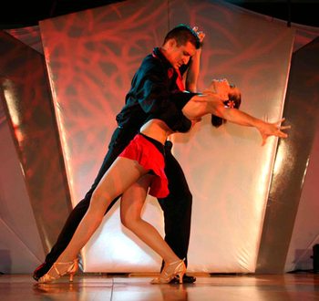
SALSA
Style: Social / Nightclub Latin
Music: Up-tempo Latin music
Meter: 4/4
Tempo: 160 - 220 beats per minute
Basic Rhythm: Quick-Quick-Slow

Movement
Footwork: Steps in all directions are normally taken first with the ball of the foot in contact with the floor, and then with the heel lowering when the weight is fully transferred.
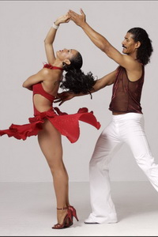
Hip Movement: In Salsa, the hip action is usually relaxed and subtle, especially for men. Weight is normally placed onto a slightly bent knee.
Arm Styling: In general, arms are held at or slightly above waist level. Arm movements should always be a natural result of the movement of the rest of the body. When arms are deliberately positioned or waved around, they look contrived and unnatural. Always allow the arms to react naturally to body movement.
Dance Position
When dancing Salsa, stand upright with weight held forward towards the balls of the feet. Like the basic Latin hold, the Salsa hold is compact, with partners standing slightly apart. The lady's right hand and man's left hand can be joined either in an upper-hand clasp, or with man underhand. The man's right hand is either placed on the lady's left shoulder blade or on her hip. The lady's left arm is rested lightly on his right arm. It should be noted that the Salsa hold is considerably more relaxed than the basic Latin hold, allowing for more freedom of arm movement.

III. Post-text Exercises.
Exercise 1. Answer the following questions.
- What style of dance is Salsa?
- What is the basic rhythm of Salsa?
- How are steps taken in this dance?
- Does hip movement in Salsa differ from other dances?
- How are arms held in Salsa?
- Why should arms be natural?
- How must arms react to body movement?
- How must you stand when dancing Salsa?
- What can you say about the basic hold in Salsa?
- Why is the hold in Salsa more relaxed?

Exercise 2. Find the equivalents in your native language to the following.
- steps in all directions
- heel is lowering
- weight is fully transferred
- hip movement
- especially for men
- slightly bent knee
- arm styling
- above waist level
- they look unnatural
- when dancing Salsa
- the balls of the feet
- stand upright
- slightly apart
- with man underhand
- basic Latin hold
- allow more freedom of arm movement
Exercise 3. Match synonyms from both columns.
allow |  | manner
normally |  | dancers
basic |  | swing
wave |  | main
partners |  | usually
style |  | permit
Exercise 4. Match antonyms from both columns.
quick |  | last
natural |  | move
always |  | considerable
barely |  | never
stand |  | unnatural
first |  | slow

Exercise 5. Agree or disagree with the following.
- Salsa is a standard ballroom dance with classical music.
- Steps are taken first with the ball of the foot in contact with the floor.
- In Salsa the hip action is usually achieved by a series of marching steps.
- Weight is normally placed onto a slightly bent knee.
- Arms are above the head and the dancer waves them around.
- In Salsa you must stand upright with weight on the balls of the feet.
- Salsa hold is closed.
- The hold in Salsa allows more freedom of arm movement.

Exercise 6. Complete the sentences and translate them into your native language.
- Style in Salsa is social …
- In Salsa steps in all directions are …
- The hip action is relaxed and …
- Arms are held at or slightly …
- Arm movements should always be …
- Always allow the arms to …
- Stand upright with weight held …
- Salsa hold is …
- Salsa hold is more …
- This relaxed hold allows more …

Exercise 7. Retell the text.
Texts for Self-Independent Student’s Work
Quickstep
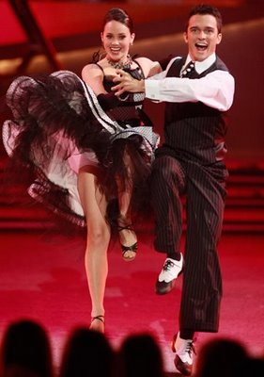
Quickstep is a light-hearted member of the standard ballroom dances. The movement of the dance is fast and powerfully flowing and sprinkled with syncopations. Quickstep was developed in the twenties in New York and was first danced by Caribbean and African dancers. Its origins are in combination of Slow Foxtrot combined with the Charleston, a dance which was one of the precursors to what today is called swing dancing.
Quickstep evolved in the 1920s from a combination of Foxtrot, Chase G Chug, Charleston, Shag, Peabody, and One-Step. The dance is English in origin, and was standardized in 1927. While it evolved from Foxtrot, Quickstep now is quite separate. Three characteristic dance figures of Quickstep are the chassés, where the feet are brought together, the quarter turns, and the lock step.
This dance gradually evolved into a very dynamic one with a lot of movement on the dance floor, with many advanced patterns including hops, runs, quick steps with a lot of momentum, and rotation. The tempo of Quickstep dance is rather brisk as it was developed to ragtime era jazz music which is fast-paced when compared to other dance music.
By the end of the 20th century the complexity of Quickstep as done by advanced dancers had increased, due to the extensive use of syncopated steps with eighth note durations.
Quickstep is elegant like Foxtrot, and should be smooth and glamorous. The dancers should appear to be very light on their feet. It is very energetic and form-intensive.

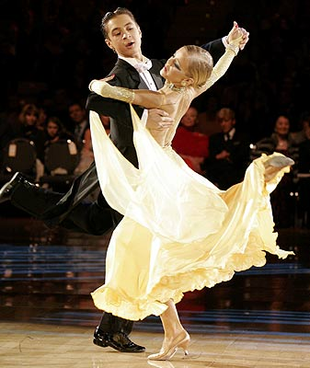

Exercise 1 Define the main idea of the text.
Exercise 2 Express your attitude to the facts from the text.

Jive
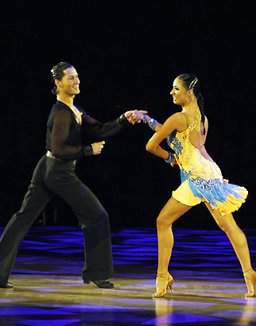
Jive is an exciting partner dance similar to Salsa but without the difficult footwork. It’s fun, easy to learn, playful and energetic in nature. Because it's a very fast, energy-consuming dance, it's also an excellent form of exercise. Plus, it looks great on a dance floor.
Jive is the faster version of the swing. It's a very boppy dance where dancers use more bouncy movements, lifting the knees and bending or rocking the hips. A lot of kicks are used. It's one the most energetic of all the dances.
Jive evolved in the early 1940s from a dance called Jitterbug, a form of Swing dance. It shares many figures with Swing, such as underarm turns, swivels, etc. The Ballroom Jive is one of the five International Latin dances.
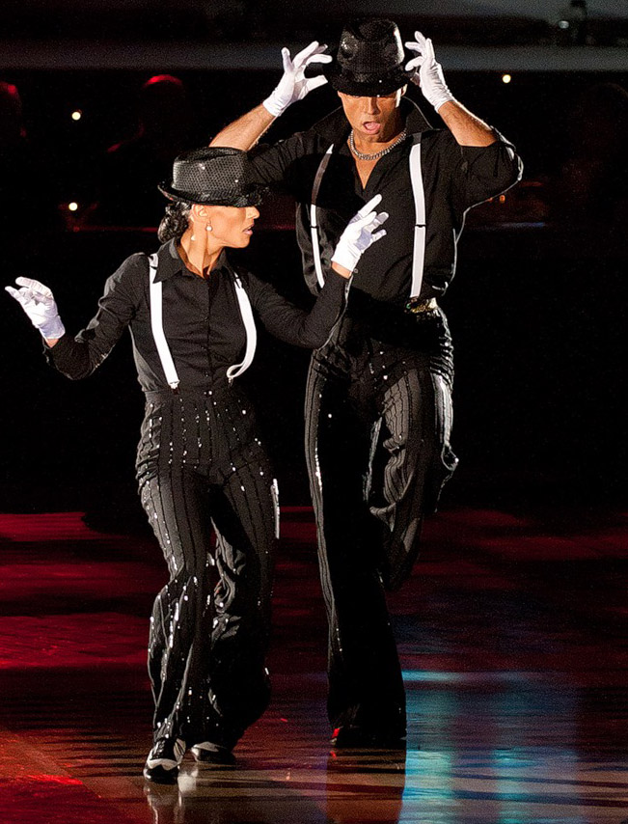
Jive is generally danced to a music in 4/4 time in a wide variety of tempos from slow to very fast. The great thing about it is that it can be danced to all sorts of music - old, new, Swing, Rocknroll, Country, Electronic, Pop...
Jive is a fun dance and certainly one of the most fantastic ways to get and stay in shape.
Jive first gained national popularity in the United States in the 1930s, though it was danced in African-American communities for many years before. In the early 1940s, American soldiers stationed overseas introduced the dance to Europe, where it quickly gained an international following. Since then, jive has remained popular across the Western world.

Exercise 1 Define the main idea of the text.
Exercise 2 Express your attitude to the facts from the text.

Rumba
Rumba, or sometimes "Rhumba", is a slow, romantic and flirtatious dance. Due to its slow rhythm and sexual movements, some call Rumba the most erotic and passionate dance there is. The steamy, sexual nature of movements create the ultimate intimate expression of Latin romance.
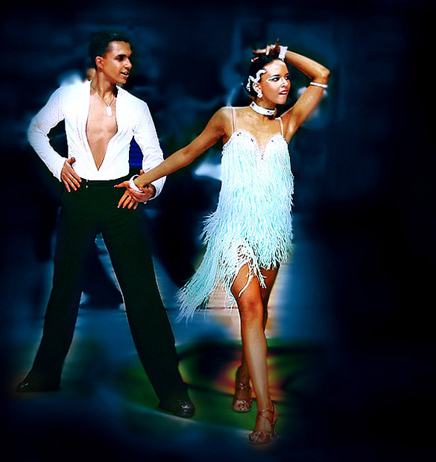
Learning Rumba is not difficult. The ease of learning is actually one of the main reasons why Rumba is more popular today than most other Latin dances (except perhaps Salsa). Once you learn the simple steps, the music does the rest!
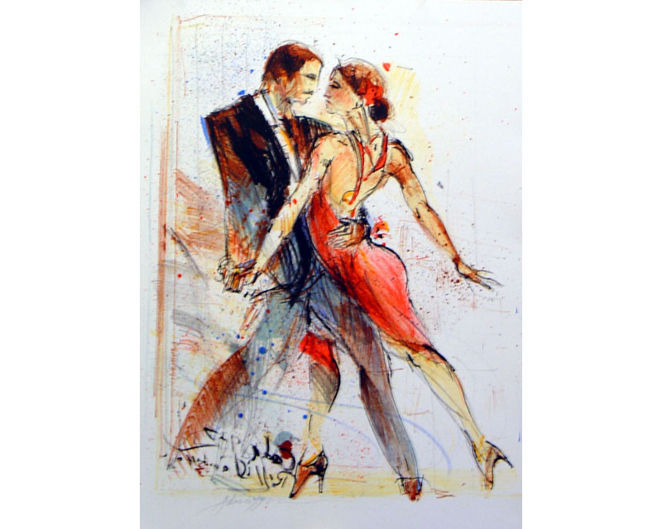
Rumba is usually danced to music written in 4/4 time, with four beats to each measure. The basic steps are counted Slow, Quick, Quick. Quick steps last for 1 beat, while slow steps last for 2 beats. Steps are taken on beats 2, 3, and 4. A full basic Rumba step takes 2 bars of music to complete.

Always remember - practice is the key to learning how to dance Rumba. So why wait, start now! It's easy and it feels great.

Exercise 1 Define the main idea of the text.
Exercise 2 Express your attitude to the facts from the text.
The Principles of Communication
What is a Connection?
Definition > | A connection is any physical point of contact between two partners in a dance position.
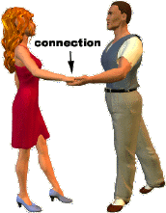
According to this definition, a connection can be any point where you actually touch your partner. While this is technically correct, it's not entirely accurate. Normally, when we think of a connection, we think of a point through which you lead or follow your partner. So it's not enough to simply touch your partner or hold the hand. In order to lead or follow, your connections must do more. For example:
A connection must have TONE.
In order to function properly as a transmitter of signals, the connected body parts should maintain a certain degree of muscle tone. If the connection is limp or weak, the lead-and-follow signals will not run through it.
A connection must be ACTIVE.
A working connection is a living, breathing thing. It must be alive, responsive to the situation, and ready to transmit and receive signals. In addition to being toned, it must also be flexible, and ready to change to accommodate any situation.
A connection must be MUTUAL.
It takes two to have a conversation. Both partners must do their part to maintain the connection. When one person falls short, the conversation dies, no matter how much the other may try to compensate.

Exercise 1 Define the main idea of the text.
Exercise 2 Express your attitude to the facts from the text.

The Basic One-Hand Connection
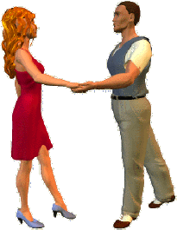
To illustrate the basic technique, we will use a very simple one-hand connection, where the man holds the lady's right hand in his left, at approximately waist level. Once learned, this technique can be applied to almost any other hand-to-hand connection.
The elbow should be held low, slightly in front of and outward from the hip. The forearm should extend straight forward from the elbow, roughly parallel to the floor. Leader's palm should be turned upward; follower's palm turned downward. The connection is sturdy but not heavy, without any squeezing or gripping of the partner's hand.
There are many reasons why we use this specific positioning of the arms and hands. Most importantly:
1. The point directly between each partner's center of balance is the point of maximum leverage. Placing the hand connection in this area improves the partners' sensitivity to each others' movement.
2. At waist level (or slightly above), the forearm is roughly parallel to the floor. Both forearms are aimed directly into one another, so that the energy moves straight down the middle of the connection, without deflecting out to an angle.
Let's take a closer look:
STRONG. Energy directed straight through the middle of the connection. | WEAK. Energy deflected off to an angle.
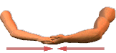 | 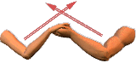
Balance – баланс – баланс

Exercise 1 Define the main idea of the text.
Exercise 2 Express your attitude to the facts from the text.
Hand Positioning
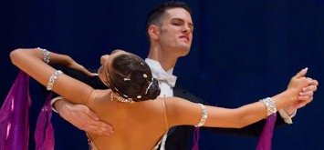
In the basic one-hand connection, the man's hand is extended with the palm turned upward, while the lady's hand extends with the palm turned downward. Both hands should be very lightly cupped, with the fingers held together (not spread apart).
Tips
- Don't grab or squeeze your partner's hand. Not only are your fingers very poor transmitters of lead and follow signals, they're actually distractions. The more you squeeze, the more you muddy up the connection, and the more difficult it is to communicate with your partner. Besides, it hurts!
- For similar reasons, don't press down on your partner's hand with your thumb.
- Don't spread the fingers apart, or stick them out in various directions. The thumb can be held loosely apart from the fingers, but the fingers themselves should stick together, as though you were wearing mittens.
- Keep the hand loosely cupped. This creates just enough friction to hold the connection together when tension is applied through push or pull, without the need for a grasp. Don't allow your hand to flatten-out completely, as it may cause you to slip and lose the connection with your partner.

Exercise 1 Define the main idea of the text.
Exercise 2 Express your attitude to the facts from the text.

The Concept of "Push & Pull"
Definition > | Push & Pull: Tension applied to a connection through the direction of body weight toward it (Push) or away from it (Pull).
Do not be fooled by the slightly misleading terms... Push and pull have very little to do with an actual pushing or pulling action of the hands and arms. As the definition suggests the concept of Push & Pull center around the direction of body weight, either toward or away from a connection.
PUSH | PULL
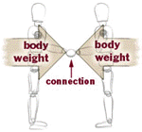 | 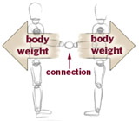
When both partners shift the body weight towards each other at the same time, the result is a tension which creates a "pushing" sensation through the connection. | When both partners shift the body weight away from each other at the same time, the result is a tension which creates a "pulling" sensation through the connection.
"Push"
To achieve the feeling of "push", you and your partner should shift your weight towards each other to the point that you can feel each other's body weight working into the connection. This will create a natural tension through the connected hands.
"Pull"
To achieve the feeling of "pull", you and your partner should shift your weight away from each other to the point that you can feel each other's body weight working away from the connection. This will create a natural tension through the connected hands.

Exercise 1 Define the main idea of the text.
Exercise 2 Express your attitude to the facts from the text.

Leading Directional Movement
In a closed position dance hold, leading directional movement is a relatively simple process: Since the partners are directly connected at the center, the leader simply moves in a direction, and the follower will (hopefully) automatically respond with equal movement.
In open position, leading directional movement is just as easy, as long as the weight connection has been established, first.
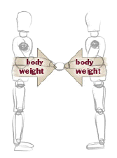
<Step 1: Connect body weight using a body weight connection -- either push or pull.
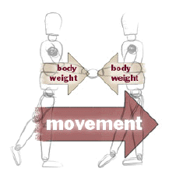

Step 2: Move body weight in a direction. No physical pushing or pulling is necessary. >
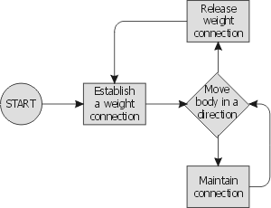
The tension applied to a connection gives the leader a means by which he can communicate the direction of his movement. Once either push or pull has been established, the connection has been effectively "switched on", and the leading or following of directional movement can begin. With the tension in place, the leader does not need to do any additional pushing or pulling through the arms; He only needs to move his body in one direction or another. The follower will automatically feel and respond to his movement through the active connection.
As illustrated by this incredibly complicated looking flowchart, the connection is first established, and then the body moves. The connection can then be maintained or released. If the weight connection is released, another connection can be established in a new direction.

Exercise 1 Define the main idea of the text.
Exercise 2 Express your attitude to the facts from the text.

Study the active vocabulary

English | Ukrainian | Russian
achieve | досягати | достигать
across | через, впоперек | через, поперёк
afford | давати змогу | предоставить возможность
alignment | поєднання | соединение
along | вздовж | вдоль
alternate | змінювати, чергувати | чередовать
angle | кут | угол
apart | окремо | врозь
apply | застосовувати | применять
approach | наближатися | приближаться
approximately | приблизно | приблизительно
assume | сприймати | воспринимать
at the same time | одночасно | одновременно
average dancer | звичайний танцюрист | обычный танцор
ball of the foot | подушечка стопи | подушечка стопы
barely | ледве | чуть-чуть
beat | удар | удар
bend | згинати | сгибать
bounce motion | коливальний рух | колебательное движение
breakdown | розбивка | разбивка
careful | обережний | осторожный
cause | змушувати | заставлять
CBMP (Contra Body Movement) | позиція проти руху корпусу | позиция противо-движения корпуса
chasse | шассе´ (фігура у танці) | шассе´ (фигура в танце)
circle | коло | круг
close | робити приставку | делать приставку
close change | закрита переміна | закрытая перемена
closed position dance hold | закрита танцювальна позиція | закрытая танцевальная позиция
codify | систематизувати | систематизировать
combination | поєднання | сочетание
commence | починати | начинать
compact | щільний | плотный
compression | стиснення, відхилення | сжатие, отклонение
consecutively | поступово | последовательно
considerably | значно | значительно
continue | продовжувати | продолжать
continuously | безперервно | постоянно, непрерывно
counterclockwise direction | напрямок проти годинникової стрілки | движение против часовой стрелки
curve | вигин | изгиб
define | визначати | определять
degree | градус | градус
deliberately positioned | навмисно вибрана позиція | сознательно выбранная позиция
desirable | бажаний | желаемый
distinguish | відрізняти | отличать
distract | розвіювати | развеять
distribution | розподіл | распределение
dramatic gesture | драматичний жест | драматический жест
drum | барабан | барабан
effortlessly | без зусиль | легко
environment | оточення | окружающая среда
equally | однаково | одинаково
essential | суттєвий | существенный
establish | установлювати | устанавливать
evolve | розвиватися | развиваться
exactly | точно | точно
exception | виняток | исключение
excessive | надмірно | чрезмерно
exiting Latin dance | захоплюючі латиноамериканські танці | волнующие латиноамериканские танцы
explanation | пояснення | объяснение
extension | продовження, випростання | продолжение, выпрямление
facilitate | сприяти | способствовать
fade away | зникати | исчезать, угасать
fall | спуск (зниження) | спуск
figure | фігура | фигура
flex | зігнутий | согнутый
flow of traffic | плавність ліній руху | плавность линии движения
flowing movement | плавний рух | плавное движение
folk dance | народний танець | народный танец
follow behind | іти слідом за | следовать за
follow-through | завершення | завершение
foot positioning | позиція стоп | позиция стоп
footwork | робота ніг | робота ног
frame | будова, структура | строение, структура
free leg | вільна нога | свободная нога
frequently | часто | часто
full | повністю | полностью
genre | жанр | жанр
gliding movement | плавний рух | скользящее движение
graceful | граціозний | грациозный
gradual | поступовий | постепенный
gyration | коливальні рухи тазом | круговые движения тазом
highest point | найвища точка | самая высокая точка
hybrid | змішаний | смешанный
imaginary | уявний, уявлюваний | воображаемый
immediately | негайно | немедленно
improve | покращити | улучшить
in general | взагалі | в основном
in order to | для того, щоб | для того, чтобы
inclination | нахил | наклон
include | включати | включать
incorporate | об’єднувати | объединять
instant | на мить | на мгновение
introduce | вводити | вводить
involve | включати в себе | включать в себя
join | з’єднувати | соединять
lasting dance | танок, що міцно закріпився | прочно укрепившийся танец
learning purpose | навчальна мета | учебная цель
lengthen | розтягувати | вытягивать
line of dance | лінія танцю | линия танца
lonely | самостійний | одинокий
lower | опускатися | опускаться
lowest point | найнижча точка | самая нижняя точка
majority | більшість | большинство
measurable length of time | не дуже довго | не надолго
measure | такт (муз.) | такт (муз.)
mid-stride | середина кроку | середина шага
mirror image | дзеркальне відображення | зеркальное отражение
moderately | помірно | умеренно
music with strong downbeat | музика з сильним відбиванням такту | музыка с сильной долей такта
narrow track | вузький напрямок | узкое направление
novice dancer | танцюрист-початківець | танцор-новичок
obscene | безсоромний | неприличный
occur | відбуватися | происходить
offset | зміщуватися | смещаться
opposite | протилежне | противоположное
original Foxtrot | справжній, оригінальний фокстрот | подлинный, оригинальный фокстрот
outpouring | вилив почуттів | излияние чувств
particular | особливий | особый
passionate | пристрасний | страстный
pattern | комбінація | комбинация
pelvis | таз | таз
placement | розміщення | расположение
posture | позиція; постава | позиция; осанка
powerful | сильний, могутній | мощный
powerful dance | міцний танець | мощный танец
preferred shape | найкраща форма/модель | предпочтительная форма/модель
primary direction | основний напрямок | основное направление
promenade | променад | променад
pronounced | виразний | резко выраженный
proper | відповідний | соответствующий
quality | якість | качество
range | простягатися | простираться
reach | досягати | достигать
react | реагувати | реагировать
rectangle | прямокутник | прямоугольник
refer to | стосуватися | относиться к
refine | удосконалювати, поліпшувати | усовершенствовать, улучшать
relative | відносний | относительный
relaxed | менш напружений, пом’якшений | не скованный, смягчённый
release | звільняти | освобождать
remain | залишатися | оставаться
remainder | залишок | остаток
represent | представляти | представлять
require | вимагати | требовать
reserve | залишати | запасать, оставлять
rib cage | грудна клітина | грудная клетка
rise | підйом | подъём
rotate | обертання | вращение
roughly = approximately | приблизно | приблизительно
semi-closed hold | напівзакрита танцювальна позиція | полузакрытая танцевальная позиция
separate | окремий | отдельный
settle into | зміщатися у … | смещаться в …
shorten | скорочуватися | сокращаться
simultaneously | одночасно | одновременно
slightly apart | злегка осторонь | слегка обособленно
slowly | повільно | медленно
smooth | гладенький, плавний | гладкий, плавный
snap of the head | різкий поворот голови | резкий поворот головы
spot dance | танець на місці | танец на месте
standing foot | опорна нога | опорная нога
starting position | вихідне положення | исходное положение
straighten | випрямляти | выпрямлять
strive | прагнути | стремиться
sturdy | твердий, міцний | твёрдый, крепкий
subtle | витончений | утончённый
suggestive | непристойний | неприличный
suspend | призупиняти | приостанавливать
sway | свей | свей
swing forward | повертатись уперед | поворачиваться вперед
take on | набувати | приобретать
the latter | останній | последний
thrust | виштовхувати | выталкивать
toward | у напрямку | в направлении
transfer | переносити | переносить
transition | перехід | переход
traveling dance = progressive dance | танець з пересуванням | танец с перемещением
turn sur place | поворот на місці | поворот на месте
turnout | розгортати | разворачивать
ultimately | в решті решт | в конце концов
underhand | за спиною | за спиной
upright | прямо | прямо
various | різний | различный
wave around | надмірне розмахування | чрезмерное размахивание
weave in/out | відхилятися туди-сюди | отклоняться туда-сюда
weighted leg | опорна нога | опорная нога
well connected | добре з’єднаний | хорошо соединённый
whole | увесь, весь | весь, вся
wiggle | перехід | переход
with strong pressure | з сильним натисканням | с сильным нажимом
Література

- The Ballroom Technique / The Imperial Society of Teachers of Dancing Imperial House. – London, 1994. – 134 p.
- Clippinger, K. Dance anatomy and kinesiology : principles and exercises for improving technique and avoiding common injuries / K. Clippinger. – Champaign : Human Kinetics, 2007. – X, 534 p.
- Franklin, E. Conditioning for dance / E. Franklin. – Champaign : Human Kinetics, 2004. – VIII, 240 p.
- Hokelmann, A. The mental association of a dance and effects on physical functions / A. Hokelmann, P. Blaser // Современный олимпийский спорт и спорт для всех : материалы 8 Международного научного конгресса: в 2 т. / Казахская академия спорта и туризма. – Алматы, 2004. – Т. 1. – P. 248-250.
- Howard, G. Technique of ballroom dancing / G. Howard. – England: International Dance Publication Limited of Bennet Road, 1998. – 131 p.
- Kaufmann, K. A. Inclusive creative movement and dance / K. A. Kaufmann. – Champaign : Human Kinetics, 2006. – XII, 156 p.
- Laird, W. The Laird Technique of Latin Dancing / W. Laird. – England : International Dance Publication Limited of Bennet Road, 2006. – 216 p.
- World Dance Sport Magazine [Електронний ресурс] / / World Dance Sport Magazine – 2012. –№ 1. – 12 p. – Режим доступу до журн. : http://www.worlddancesport.org/Media/Magazine

